Low Cost Mobile Embedded System for Air Quality Monitoring
Air quality real-time monitoring in order to preserve citizens’ health

Adrian Florea
Computer Science and Electrical Engineering Department
‘Lucian Blaga’ University of Sibiu
Sibiu, Romania
email: adrian.florea@ulbsibiu.ro
Lasse Berntzen, Marius Rohde Johannessen
Department of Business, History and Social Sciences
University College of Southeast Norway
Kongsberg, Norway
email: {lasse.berntzen, marius.johannessen}@usn.no
Daniela Stoica, Ionel Stelian Naicu
National Environmental Protection Agency
Sibiu, Romania
email: danastoica68@yahoo.com
Vlad Cazan
Civic Alert
Bucharest, Romania
email: vlad.cazan @civicalert.ro

Abstract - This paper reports on a case study using a mobile platform for air-quality monitoring. This case study was done in Sibiu, Romania, and includes a description of related work, a survey, a summary of existing results regarding air quality, a description of the mobile air quality monitoring platform, and the results of trials done in February 2017. The aim of the case study is to pave the road for further studies of using mobile low-cost units for air quality monitoring.
Keywords-air quality monitoring; environmental monitoring; sensor platform; traffic optimization; crowdsensing.

Introduction
This paper reports on a case study using a mobile platform for air-quality monitoring as part of a research project jointly conducted by the “Lucian Blaga” University of Sibiu, Romania and University College of Southeast Norway. The case study was done in Sibiu, Romania. Sibiu experience air quality problems caused by traffic. The design and development of the platform has been described in an earlier paper [1], and will only be briefly described here. The aim is to show how the platform is used, and to compare with other studies. The case study includes a survey among university students and employees to investigate their concerns about air quality.

Background
Europe and the rest of the world face severe societal challenges, especially related to energy consumption, environment and security. Air quality has become an important issue in most industrialized and urban areas. Use of fossil fuels for cars, ships and production of energy, heavy traffic and inefficient modes of transport, waste burning, and industrial activities degrades air quality [2][3]. Information and communication technologies contribute around 2% of the global CO₂ emissions and approximately 8% of the EU’s use of electricity [4]. Contamination of the air is both a global and a local problem. On a global level the emissions of CO₂ and NO_{X} influences climate and global warming. On local level air pollution (detectable particles from smoke, ash, dust, spore, pollen and mildew) has an important impact on human health, causing health issues like asthma, allergies and bronchitis. According to World Health Organization (WHO) report from September 2016, 3 million deaths a year are linked with exposure to outdoor air pollution [5]. Air pollution may also reduce the value of properties in exposed areas.
Many cities, including London, Madrid and Paris, experience severe problems with air quality, especially during the winter season. Air pollution on cold days affects may citizens, and forces them to make quick decisions to avoid exposure, either to stay inside or choose an alternative route.
Even Norwegian cities such as Oslo and Bergen suffer due to climatic conditions, as the polluted air doesn’t get warm enough to escape the cities surrounded by hills or mountains. When pollution levels are high, the cities of Bergen and Paris restricts the use of cars based on the last digit of the number plates. In January 2017, Oslo was closed for diesel cars for a short period. The city council considers raising traffic tolls on days with high pollution levels. Air pollution is a top priority for citizens especially in megacities from all around the globe [6]. More than that, each flight Paris-New York is melting 3 cube meter of icecap. If the trend continues, the Arctic ice cap will disappear in 30 years [7].
According to information presented by Dr. L. Roman from Autohaus Huber SRL (Sibiu), in a workshop organized as part of the project, the pollution levels caused by automobiles change (to the worse) depending on several factors such as:
- Road traffic contributing to particle pollution both because of car tires wearing down the asphalt surface, and due to incomplete combustion.
- Quality of the fuels and lubricants.
- State of wear of the mechanical components of the engine and its auxiliary installations.
- State of wear of electrical and electronic components.
- Running distance on which the vehicle is used daily.
- Quality of car maintenance.
- Driving quality (skill) of the vehicle users.
- Political decisions of reducing taxes on importing second hand cars.
In most cases, it is no quick fix for air pollution. To shut down power stations or industries polluting the air is normally long-term projects. The use of filters and catalyzers may reduce the output of pollution. However, small projects may help reducing local pollution. One example is to provide passages for pedestrians under or above heavily trafficked roads [8], and building viaducts over railroads. This can increase the flow of vehicles and reduce the pollution caused by still-standing cars.
To combat air pollution, it is necessary to have objective air-quality measurements. Today, most of the air quality monitoring is done by a relatively small number of expensive stationary units. This causes a problem with granularity. A stationary unit collects data from a single geographical point and the data may not be representative for a larger area.
One strategy to improve air quality is to reduce traffic, and optimize the remaining traffic. This can be done in multitude of ways: Increasing traffic toll, improving public transport, introducing smart parking systems that direct the driver to an available parking spot, and by disallowing certain types of cars to be used. In Oslo, cars need to pay a special tax if the car uses winter tires with spikes, to encourage car owners to choose more environmentally-friendly tires. (The spikes wear down the asphalt and creates dust particles.)
The cities may implement different regulatory measures to reduce the emission of pollutants. For example, the mayors of Paris, Madrid, Athens and Mexico City have announced that trucks will not be allowed to enter their city centers from 2025. Also, diesel cars will be banned and the city councils are considering raising tolls on days with high pollution levels [9]. Walking and cycling will be encouraged and citizens will be provided incentives for the use of electric or hybrid vehicles [10].
The aim of this paper is to present a project to measure air quality by using a mobile platform for monitoring. This platform can provide more accurate information on air quality issues. Such monitoring can help raise awareness of air quality problems, their causes, and their impact, and thereby contribute to better decision making.
The project goals are:
- Give citizens a real image of the air quality in cities by making the mobile monitoring platform collect information from sensors, and send the data to a server for further analysis and visualization.
- Improve the quality of environmental monitoring by designing and developing a low cost "proof of concept" prototype for use in cars.
- Cars host the mobile environmental monitoring platform. Whenever the car is parked, the platform will start monitoring the environment around itself, and forward this information to the server. (The platform can also be used when the car is moving).
- The platform may perform some preprocessing of data to reduce the data traffic generated. Instead of sending data at fixed intervals, the platform can send alerts when changes happen. This can improve the scalability of the solution.

The rest of the paper is organized into four sections, where Section II briefly review some state of the art papers related to this study. Section III presents the Sibiu case study, including the survey, some existing studies from the Romanian National Network of Air Quality Monitoring, and information from traffic and roads administration. Section IV describes the research design - the mobile platform for environmental monitoring - both from hardware and software point of view, including some obtained results. Finally, in Section V, we provide implications and conclusions.

Related Work
Air quality monitoring has been around for many years, but has mostly been done by public authorities responsible for environmental monitoring. In most cases the monitoring is done by expensive monitoring platforms in fixed locations. The aim of our project was to investigate alternative ways of obtaining measurement results to improve the granularity of measurements.

Hand-held units connected to smartphones
One approach is to use hand-held units to be carried around by citizens. Such units normally connect to a smart phone, and uses the smartphone to obtain access to the internet.
Leonardi, Cappellotto, Caraviello, Lepri and Antonelli [11] developed an air quality monitoring unit to be carried around by citizens. An important reason for developing the mobile unit was: “Official authorities use to monitor and publish air quality data collected by networks of static measurement stations. However, this approach is often costly, hard to maintain and not scalable in the long term.” They also argue that fixed station provides “a lack of accuracy in the intra-urban air pollution maps”. The authors collected data from 80 persons in Trento, Italy. The unit, called “SecondNose”, measures temperature, light, humidity, altitude, pressure and two air pollution parameters: carbon-monoxide (CO) and nitrogen-dioxide (NO₂). The unit communicates with an app installed in an Android smartphone through Bluetooth. The unit weighs only 28 grams, and has a battery capacity of five days.
Dutta, Chowdhury, Roy, Middya and Gazi [12] developed “AirSense”, a monitoring platform based on Arduino Nano equipped with two sensors, one for air quality (MQ135) and one for carbon-monoxide (MQ7). The platform connects to an Android smartphone through Bluetooth, and weighs around 60 grams. The authors cited inadequate number of fixed monitoring stations as the reason for developing “AirSense”.
CITI-SENSE, an EU-funded project, developed a hand-held sensory unit to be carried around [13]. The “Little Environmental Observatory” (LEO) is a portable sensor pack. It measures NO, NO₂ and O₃ using electrochemical sensors. It also provides information about the current temperature and relative humidity. LEO connects to an Android smartphone through Bluetooth. CITI-SENSE also developed an app to let citizens report their own perception of air quality. CITI-SENSE ran from 2012 to 2016.
AIRALERT [14] is a service recently launched by the Romanian NGO CivicAlert. The service obtains data from a handheld sensor platform “AirBeam” with Bluetooth connection to an Android smartphone. Their idea is to collect data by issuing units to volunteer bicyclists. AIRALERT is using an existing visualization package to display results.
Z. Pan, H. Yu, C. Miao and C. Leung [15] used a somewhat different approach, by using smartphone cameras to detect air pollution through artificial intelligence techniques to determine particle pollution. This solution requires humans to actively do measurements.

Units equiped with GSM communication
Another approach is to equip the monitoring platform with built-in GSM communication capabilities.
C. Migliore [16] developed a platform mounted on a bike, “SwarmBike”, to measure air pollution. The unit has a GPS-receiver, a GSM module to handle communication, and sensors for barometric pressure, temperature, humidity and a CO sensor. His thesis describes other types of sensors for measuring air quality.
The projects OpenSense and OpenSense II [17] installed air quality measurement units on trams in Zurich and buses in Lausanne, Switzerland. The sensor platform measures ozone (O₃), nitrogen-dioxide (NO₂), carbon-monoxide (CO) and ultra-fine particles (UFP). The platform has a GPS-receiver, and transmits data to a server using GSM. A sensor was also installed in a Citroen C-Zero.

Related work compared to our platform
The problem with hand-held units is that someone must carry them around. Several solutions require Android smartphones. This excludes the large number of Apple iPhone users. Users may also be reluctant to provide access through their own phones. It seems that most of the projects described above lasted for a limited period.
Leonardi, Cappellotto, Caraviello, Lepri and Antonelli [11]reported that usage of “SecondNose” declined over time. Users said they were curious in the beginning, but soon learnt the characteristics of the places they measured. This may partially explain the non-sustainability of the projects using hand-held sensors.
Our unit is autonomous. No human is needed to carry it or turn it on or off. It uses a GSM module, and does not need smart phone for communication. It also has a built-in GPS. Insert a SIM-card and connect to car battery, and it is operating (plug-and-play).
The hand-held units described above seem to be more expensive. The sensor used by Leonardi, Cappellotto, Caraviello, Lepri and Antonelli [11] (SensorDrone) costs around USD 200. It only contains sensors and Bluetooth. The components for our unit costs around Euro 130, including sensors, GSM module and GPS.

The OpenSense platform [17] closely resembles our platform, but collects data from trams and buses on the move. This brings some uncertainty caused by trucks being close to the measurement platform.
Our novel approach is to use parked cars. Parked cars provide the possibility to measure from one location over time. It is neither dependent on human intervention to make the measurements. A city always owns cars used to provide services. But it is also possible to call on volunteers to host the platform in their cars.

Shared characteristics of monitoring platforms
Environmental monitoring platforms might be used by the municipality to create another layer in the city map (transparent for citizens), like layers showing networks of water, gas and electric cables, the sewer network, telephone and cable TV networks etc. Such layers may easily be implemented in a GIS system and can be used for increased transparency, sustainable regional development and innovative applications visualizing the pollution levels.
By collecting data from city and surroundings areas, platforms can identify the city’s pollution hotspots (from air quality viewpoint), suggesting alternative positions for fixed stations or the need to introduce new ones. Such data will be valuable for the authorities responsible for air quality monitoring (National Environmental Protection Agency).
Platforms, like the ones described above, may provide real-time monitoring to preserve citizens’ health and warn them when permissible level of pollution are exceeded. Platforms equipped with particle detectors may warn citizens about increasing levels of pollen or dust (producing allergies). In such situations, it may advise people to avoid areas that could be dangerous for health conditions and choose another detour and locate the closest pharmacies where antihistamine pills can be bought.

Sibiu Case Study
This section presents the case study done as part of a research project conducted jointly by the “Lucian Blaga” University of Sibiu and University College of Southeast Norway and financed by EEA grants [18]. The focus is on a specific case for air quality monitoring: the city of Sibiu, Romania. The city is in Transylvania, and has a permanent population of approximately 155.000, and up to 25.000 students and temporary inhabitants. The traffic is high since two national roads, one south-north and one west-east, are meeting in the city. According to technical data obtained from Romanian National Company of Road Infrastructure Management, more than 70,000 cars are crossing Sibiu city every day.

Survey about air quality perception of people
Before starting our project implementation, we developed a survey regarding air quality perception by people, to see the relevance of air quality monitoring in Sibiu its and surroundings. We requested feedback from people working / studying / living in Sibiu (66% being in their twenties, 10% being between 30 and 45, and 24% being older than 45), most of them being students at the Faculty of Engineering. 200 participants were surveyed, 54% men, 46% women. 81% of respondents have secondary level education, 19% have higher education (Bachelor, Master, PhD). In the following we present the most important questions and the answers we received.

- Survey Questions and Results
Q1:  A1: | How interested are you in air quality in general?  The citizens of Sibiu have high interest (>85%) in air quality and pollution level
Q2:  A21:  A22:  A23: | How would you describe the air quality in Sibiu in general?  The air quality in Sibiu is rather good (70%)  The air quality in Sibiu is poor (21%).  Uncertain: 9%.  Arguments of respondents for “good air quality” consist in:  - The air is clean and fresh due to relatively small distance to Carpathians mountains (Păltiniș).  - There are enough green spaces in and outside the city („Sub Arini” large park and „Dumbrava” forest – as known as „the city lung”).  - The industrial areas are placed outside, rather to isolate the city by generated pollution.  - Sibiu is a small town with relatively small number of inhabitants.  - The Sibiu ring road reduced the traffic and contributed to diminish the noxious cars’ emissions, even on highly travelled boulevards.  Arguments for “poor air quality” are the followings:  - The transformation of green spaces in residential districts.  - The inefficient modes of transport and traffic.  - There are many cars that pollute the air.  - 31% of persons over 18 from Sibiu County have own cars (117.663 of 378.382), according to the Public Community Service for Driving License and Vehicle Registration Sibiu.  - The number of cars has risen quite much lately: 6.14% from 2015 to 2016.
Q3:  A3: | To what extent do you think that the air quality in Sibiu affects your health?  Most subjects (76%) believe that air quality in Sibiu might be an important factor that can influence their health.
Q4:  A4: | Do you consider air quality when moving around in Sibiu (e.g. avoid cycling in busy roads or exercising outdoors if air quality is bad)?  About one third (35%) think they should avoid activities when pollution levels are high.
Q5:  A5: | What do you think about accessibility to air quality information in Sibiu? Or “How often do you consciously look at air quality information (e.g. via television, newspapers, Internet)?”  Consciously, people are rarely seeking information on air quality (About once a month 18%).  Although interest in environmental quality exists and usefulness of such information is obvious, the biggest problem lies in finding them.
Q6: A6: | Who can improve air quality in Sibiu? And How?  The top three groups which can contribute to air quality improvement are:  The municipality (e.g., city council):  - By not allowing deforestation in the whole county, except dry/sick wood, which should be replaced by other freshly planted trees.  - Protecting parks and forests, and developing new green spaces.  - Introduction of electric public transport.  - Optimize traffic in order to avoid congestion and useless fuel consumption.  Industry and commerce:  - Industry and commerce can find ways to pollute less by controlling their activities (dematerialization of economy).  - Proper management of waste.  People who spend most of their time in the city (e.g., residents, workers, students):  - Students could participate as volunteers to plant trees in deforested areas.  - Large scale use of public transportation or other alternatives (e.g. bicycle)  Other groups were regional agencies or research scientists:  - Regional and central government agencies must take responsibility to respect the law regarding the maximum level of air pollution, and if this level is overrun by any industrial company take appropriate measures.  - Proposing legislation to reduce urban pollution.  - Research scientists can contribute by finding new ways to stop air pollution.
Q7:  A7: | What steps do you think you would personally take to help improve air quality in Sibiu?  The large majority of the respondents are willing to:  - use more environmentally-friendly means of transportation (electric bus, bicycle, etc).  - involvement in public policy making, of social polls and participating to citizen advisory committees.  - use greener systems at home such as renewables energy and electric heating to the detriment of burning wood.
Q8:  A8: | In which format would you prefer to receive air quality information?  Subjects suggested that an application for mobile phone would be most appropriate since they live in the "Internet of Things" and, nowadays over half of them use such easy accessible technology. Smartphones have excellent processing and storage capabilities and people carry them in their daily lives.  Alternative, information might be exhibited on panels in main public places, in public transport but also using social networks where information dissemination can be done very easily.  Websites, TV and radio were also mentioned as alternatives.
Q9: | If you could have an application mobile phone app to inform you about air quality, how important would it be to have the following features?
A9: | See table II.
Q10:  A10: | In relation with the previous question, are there any other features you would like to have in a mobile app to be informed about air quality?  In addition to the numerical information about concentrations of air pollutants it would be useful that each pollutant to be accompanied by immediate and long-term effects on health.  Possibility to select decongested routes to move in the city

Table II lists the possible features of a mobile app to inform about air quality. The most important feature sought was information on how to protect own health. The second important feature sought was information about current air quality, followed by air quality

Earlier Studies
In Romania, air quality from ambient environment is legislated in accordance with European laws by the Air Act (no. 104/2011) [19], which establishes that the responsibility for air quality monitoring is undertaken by the National Environmental Protection Agency, through the National Network for Monitoring Air Quality [3]. Unfortunately, the number of air quality monitoring stations from Romania is rather small (142 fixed & 17 mobile units). This network includes four fixed stations in Sibiu County, which continuously monitor the air quality (Two are located in Sibiu, one in Mediaş and one in Copşa Mică).
The results presented in figure 1 and figure 2 were obtained from the two stationary units located in Sibiu city: SB1 – urban residential station and SB2 – industrial-type station.
- Survey Results (Q9)
No. | Feature | Priority
 |  | High | Med. | Low | Not a priority
1. | Air quality in your immediate vicinity | 58.5 | 29.3 | 11 | 1.2
2. | Numeric information on pollutant | 40.2 | 41.5 | 14.6 | 3.7
3. | An air quality index indicating if the air quality is poor or good | 72 | 23.2 | 3.7 | 1.2
4. | Ability to report what you think the air quality is like | 28 | 45.1 | 22 | 4.9
5. | Ability to see what other users have reported | 18.3 | 42.7 | 26.8 | 12.2
6. | Information on past air quality | 36.6 | 34.1 | 22 | 7.3
7. | Information on current air quality | 75.6 | 20.7 | 3.7 | 0
8. | Information on forecasted air quality | 43.9 | 42.7 | 11 | 2.4
9. | Information on what to do to protect your health | 84 | 14.8 | 1.2 | 0
10. | Notifications in case of increased air pollution | 65.9 | 29.3 | 4.9 | 0
11. | Possibility to see the air quality levels in the routes you move around the city | 59.8 | 26.8 | 12.2 | 1.2
12. | Possibility to select cleaner routes to move in the city | 59.8 | 25.6 | 11 | 3.7

The figures show CO and NO₂ concentration levels, for 2016. The agency has also on occasions used mobile units. The monitored parameters are: Sulphur dioxide (SO₂), nitrogen oxides (NO_{X}), carbon monoxide (CO), ozone (O₃), particles (PM 10 and PM 2.5), benzene (C₆H₆) and lead (Pb).

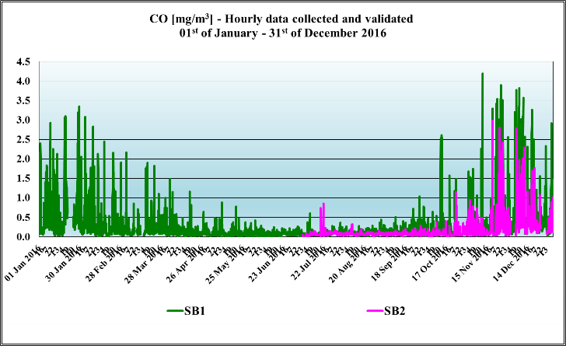
- CO concentration levels in 2016

The evolution of values for CO concentration between 1st of January to 31st of December 2016 show that there were no exceedances of the daily limit value for health, taking into account that the daily maximum of averages at each 8 hours is 10 mg/m³, according to the Air Act 104/2011.

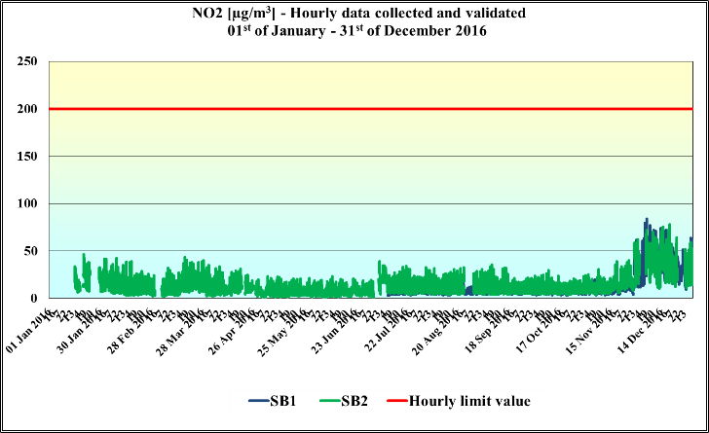
- NO2 concentration levels in 2016

The NO₂ pollution indicator have not revealed breaches of the hourly limit of 200 µg/m³ (the maximum number of exceedings allowed by Air Act 104/2011 is 18 times yearly / station).

- Particle concentration levels (PM10) in 2016

The particles (PM 10) pollution indicator is measured at SB1 station both automatically and manually. In 2016, the SB1 station reported 8 overruns of daily limit (50 µg/m³) but which is still acceptable considering that the limit set by Air Act is 35 times yearly / station. Measurement results indicate that particle pollution is mainly caused by heavy traffic. The maximum (60.28 µg/m3) was recorded in a heavily transited location at the entrance to the city where several hypermarkets are in the same area, while in Sub Arini Park (the largest park in the city) the recorded value of 13.93 µg/m3 was far below the daily limit value.
Explanations for this situation are: Apparently, in Sibiu the air quality is rather good, but the results might be pseudo true. The two fixed stations are situated as follows: SB1 is placed in an area where the traffic is relatively low and, SB2 is placed in an area which, on its deployment, in 2007, was heavily industrialized. Today, most industry has relocated (outside the city). Air pollution contributes to climate changes and to the emergence of urban heat islands (higher temperatures concentrated in urban areas densely populated and built) which causes temperature increases by up to 5 degrees compared with unaffected areas.

Project Description
The main objectives of the mobile air quality monitoring platform project were to:
- Develop a low-cost mobile platform for air quality monitoring where data is collected through crowdsensing.
- Test the platform in the City of Sibiu, Romania (and other locations) and compare collected data with already existing data, to verify results and extend the number of measurements being made.
- Make the necessary groundwork for establishing a larger project on air quality monitoring, this time with focus on analysis, prediction and visualization.

The Platform
The platform has been described in an earlier paper [1]. Shortly summarized the platform consists of a processor unit (LinkedIt Smart Duo 7688 - an open development board with two processors, one running Linux, the other compatible with Arduino), a combined GPS/GSM unit for location and communication, a gas sensor for measuring CO₂ and NO_{X} (SainSmart MQ135 Sensor Air Quality Sensor and Hazardous Gas Detection Module), a particle sensor measuring PM 10 (Grove Dust Particle Concentration Detection Sensor), and sensors for temperature (DS18B20 Temperature Sensor) and barometric pressure (BMP085 Digital Barometric Pressure Measurement Sensor). The technologies used are: Eagle (for printing the PCB) and Custom Electronic Shields, ASP.NET and Microsoft Azure (for database and cloud), C/C++ (for LinkedIt 8266 programming). 16 prototypes were built for experiments.

Hardware and Software Architecture
On the client side, the software will detect when the car is parked, and then start data collection from the sensors at regular intervals. The data is stamped with time and location (both retrieved from the GPS receiver) and sent to a server using a GSM data connection. Figure 4 and 5 shows the hardware design of printed circuit board holding the sensors (except the particle sensor which is connected by a wire).

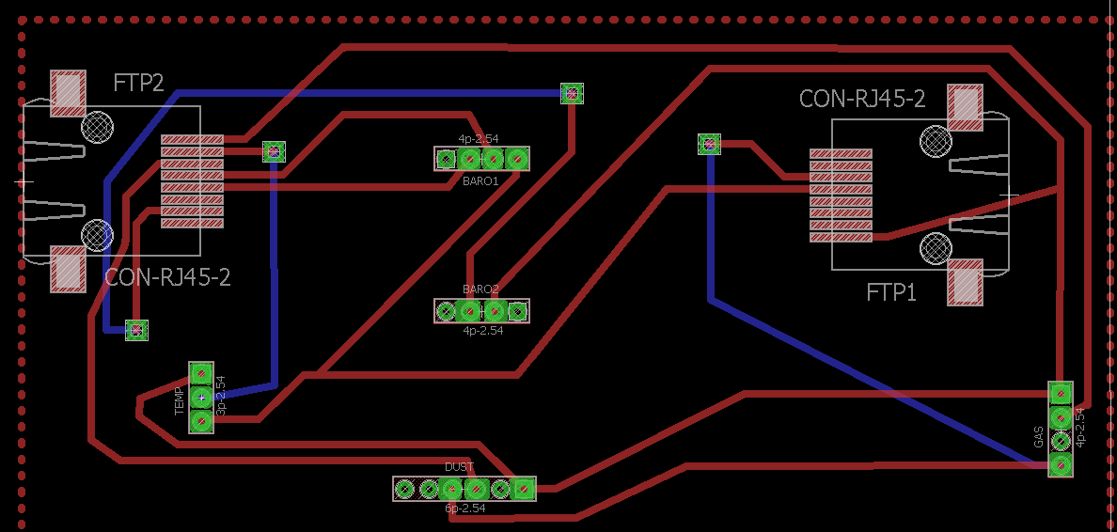
- The hardware design of prototype

On the server side, the data is stored in a database for further analysis. Location of active cars is shown on a map (Google maps) with the possibility to click on one specific car to see latest data.

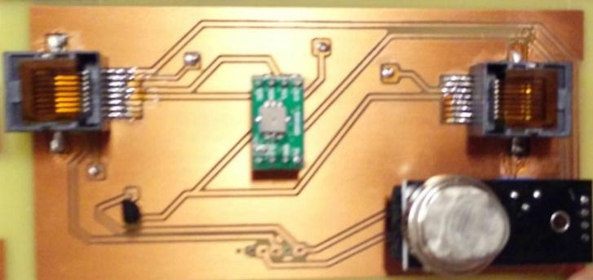
- Sensor printed circuit board

Visualizing data.
By clicking on each point from the map, information from each sensor is disclosed. The map is shown in figure 5.

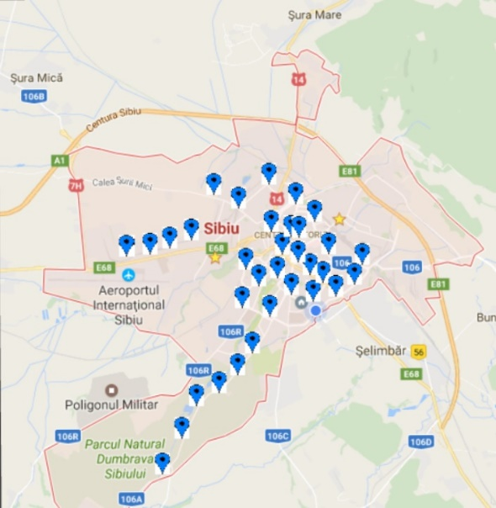
- Clickable Google Maps

The Test
The platform was used for air-quality monitoring in Sibiu first weeks of February 2017. Data was collected from four units, each installed within a car. The data collected generally corresponds to earlier data collected by the National Environmental Protection Agency. At the same time, we showed that granularity has been improved since we could measure from many more locations. Some data was collected from cars driving the same route on different times.

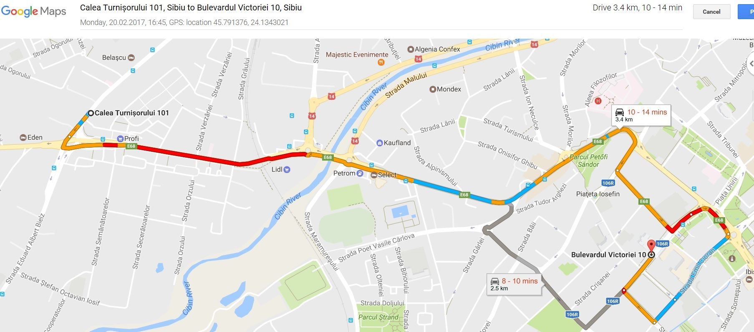
- Data collection in Sibiu (moving cars).

Figure 7 illustrates a Google Maps snapshot with the route on which the data were collected at 5 pm when many people return from work. The red color shows heavy traffic, this route is connecting the Airport with the city center and represents the single entrance in the city from west side. In figure 8 we present the chart with CO₂ variation during the route that takes around 16 minutes. The measurements were done with MQ135 gas sensor set up for CO₂ and the results are exhibited in parts per million (PPM). Regarding the MQ135 sensor and its detection capability, the researchers consider that the general sensitivity is roughly the same for all the gases sensed [14]. Since CO₂ is the fourth most abundant trace gas in the earth’s atmosphere they recommend that it is safe to assume that in a normal atmosphere the MQ 135 sensor mostly detects CO₂. The values from figure 8 somewhat faithfully follows the route from Figure 7, namely, where there is heavy traffic, CO₂ values are higher than 230 PPM. However, the maximum value obtained (277 PPM) is under the highest-ever daily average at planet level (409.44 PPM) reached in 9 of April 2016.

- CO₂ values [PPM] collected with MQ 135 gas sensor from a heavy traffic boulevard from Sibiu

Table III presents the range where are situated the measured parameters (gas, temperature, dust and humidity). From a temperature point of view is observed how the heavy traffic produces higher temperature with approximatively 2 degrees compared with unaffected areas (urban heat islands effect).
- parameters variation
 | CO2 | Temperature | Dust | Humidity
 | [PPM] | [Celsius degree] | [mg/m³] | [%]
Maximum | 277 | 2 | 0.35 | 87
Average | 207.92 | 1 | 0.33 | 87
Minimum | 141 | 0 | 0.32 | 87

Measurements were also made from parked cars in an densely populated area close to a major road, and here CO₂ values varied between 200 to 500, depending on the time of the day.

Making Groundwork for a New Project
EU Research & Innovation program H2020 allocated 80 billion Euros funding for initiatives related to environmental sustainability and energy efficiency [20]. In a follow-up project, we intend to focus on further developing analytics, prediction algorithms and visualization. By collecting data over a longer period, we will be able to predict when pollution levels reach certain levels. Such information will be useful for decision-making.

Conclusions
As mentioned earlier, several cities around the world are restricting car use when air pollution levels are too high. The use of stationary units provides low granularity of measurements, and are expensive. This project has shown that data can be collected by means of crowdsensing, either by using cars of the municipality or calling upon volunteers to accommodate units in their cars.
Largely the obtained results are consistent with measurements from fixed stations. However, our solution provides much higher granularity of the measurements.
In a longer perspective, our aim is to further develop our platform as part of a system for smart-cities with the purpose of providing insights about people and environmental conditions, and disseminate such information to the public through multiple channels. Such a system will be important for decision making related to environmental issues, and be a measure to increase the transparency of the cities.

Acknowledgment
This work was partially supported by a grant from Iceland, Liechtenstein and Norway, contract type „Small size bilateral cooperation projects”, „Scholarships and interinstitutional cooperation” program - RO15, EEA Financial Mechanism 2009-2014, the Romanian National Agency for Community Programs in the Field of Education and Vocational Training, Contract Nos. 3/07.07.2016, COD: 16-SEE-PCB-RO SIBIU01 / 01.
The authors would like to thank Iosif Băncioiu and Ovidiu Hodorogea, students in the Computer Science and Electrical Engineering Department at “Lucian Blaga” University of Sibiu for providing useful technical help in the hardware and software implementation of the prototypes. We want to express our sincere gratitude to Mr. Liviu Crețu, the Chief of Sibiu National Roads Department, for providing useful information regarding the traffic level in Sibiu County. Last but not the least, our sincere thanks goes to Dr. Lucian Roman from SC AutoHaus Huber SRL Sibiu, which has given some relevant insights regarding the influence of fuels and vehicles’ operating parameters on air pollution.
The authors also thank the reviewers for constructive comments to improve this paper.

References
- L. Berntzen, M. Rohde Johannessen, and A. Florea, “Smart Cities: Challenges and a Sensor-based Solution,” International Journal on Advances in Intelligent Systems 9 (3 & 4), 579-588, IARIA, 2016.
- Air Pollution: Current and Future Challenges, United States Environmental Protection Agency, https://www.epa.gov/clean-air-act-overview/air-pollution-current-and-future-challenges, accesed 25 February 2017.
- Romanian National Network of Air Quality Monitoring http://www.calitateaer.ro/structura.php, accesed 25 February 2017.
- Ericsson (2013) Ericsson energy, carbon report. On the impact of the networked society. http://www.ericsson.com/res/docs/2013/ericsson-energy-and-carbon-report.pdf
- http://www.who.int/mediacentre/news/releases/2016/air-pollution-estimates/en/, accesed 25 February 2017.
- http://www.2oceansvibe.com/2017/01/26/london-pollution-levels-are-now-higher-than-beijing/#ixzz4WwSJ2ZUt, accesed 25 February 2017.
- Foxcrawl, Arctic Ocean could melt in 30 years, 7 November 2016, http://www.foxcrawl.com/2016/11/07/arctic-ocean-thawing-ice-cap-melting-30-years/, accesed 20 February 2017.
- Inta M., Muntean A., Purcar C., Badescu M., The Study of Traffic Decongestion In A Crowded Intersection, ANNALS OF THE ORADEA UNIVERSITY. Fascicle of Management and Technological Engineering, Volume XII(XXII), ISSN 2285-3278, pp. 367-370, Oradea 2013.
- M. Holder, “Paris, Mexico City, Madrid and Athens to ban diesel vehicles by 2025,” BusinessGreen, [Online]. Available from: http://www.businessgreen.com/bg/news/3000622/paris-mexico-city-madrid-and-athens-to-ban-diesel-vehicles-by-2025, accessed 31 January 2017.
- A European Strategy for low-emission mobility, European Commission - Fact Sheet, Brussels, 20 July 2016, http://europa.eu/rapid/press-release_MEMO-16-2497_en.htm, accessed 27 February 2017.
- C. Leonardi, A. Cappellotto, M. Caraviello, B. Lepri, and F. Antonelli “SecondNose: an air quality mobile crowdsensing system,” In Proceedings of the 8th Nordic Conference on Human-Computer Interaction: Fun, Fast, Foundational (NordiCHI '14). ACM, New York, NY, USA, 1051-1054. DOI: http://dx.doi.org/10.1145/2639189.2670273, 2014.
- J. Dutta, C. Chowdhury, S. Roy, A.I. Middya, and F. Gazi, “Towards Smart City: Sensing Air Quality in City based on Opportunistic Crowd-sensing,” In Proceedings of the 18th International Conference on Distributed Computing and Networking (ICDCN '17). ACM, New York, NY, USA, , Article 42 , 6 pages. DOI: https://doi.org/10.1145/3007748.3018286, 2017
- CITI-SENSE Product Informaton Brochure. [Online]. Available from: http://www.citi-sense.eu
- AIRALERT website. [Online]. Available from: http://www.citi-sense.eu
- Z. Pan, H. Yu, H., C. Miao, and C. Leung, “Crowdsensing Air Quality with Camera-Enabled Mobile Devices,” Proceedings of the Twenty-Ninth AAAI Conference on Innovative Applications (IAAI-17))
- C. Migliore, “SwarmBike: an IoT Sensing Platform for Air Pollution,” Tesi di Laurea Magistrale. Politechnico di Torino, 2016.
- OpenSense website. [Online]. Available from: http://opensense.epfl.ch/wiki/index.php/OpenSense_2
- http://eeagrants.org/, accessed 27 of February 2017.
- Air Law, Act no. 104/2011, http://www.anpm.ro/documents/12220/2049969/Lege+104+aer.pdf/d764d447-baca-448a-9f6d-cfea9bc39252 (in Romanian), accessed in 20 February, 2017.
- Atmospheric Levels of CO2, https://www.co2.earth/, accessed 25 February 2017.
- A. Antonic,V. Bilas, M. Marjanovic, and M. Matijasevic, “Urban Crowd Sensing Demonstrator Sense the Zagreb Air,”in Proc. ofIEEE Conf. Software, Telecommunications and Computer Network, Split, Croatia pp. 423-424, Sept. 2014.

