Faculty of Technology, Natural Sciences and Maritime Sciences
Master’s Thesis
Study programme: Master of Environmental Science
Autumn 2023
Francis Agatho-Udochukwu Obieze
Assessing and analyzing the relationship between surface albedo and surface temperature of different vegetation types.
(Blueberry, Lichen, heather, tall grass, short grass, and bare ground)

University of South-Eastern Norway
Faculty of Technology, Natural Sciences and Maritime Sciences
Institute of Natural Sciences and Environmental Health
PO Box 235
NO-3603 Kongsberg, Norway

http://www.usn.no

© 2023 Francis Agatho-Udochukwu Obieze

This thesis is worth 60 study points.

Summary

This study investigates the link between surface albedo and temperature difference (T. diff.: the difference between the actual surface temperature and ambient temperature) for various vegetation types, to ascertain if higher surface albedo corresponds to lower surface temperature and lower surface albedo corresponds to higher surface temperature. This is with particular emphasis on the effects of cloud cover, wind speed, and humidity.

The dataset compiled using albedo application (a reflectance app) for smartphones and BOSCH GTC 400 C handheld thermal camera, contains observations of albedo, temperature difference, cloud cover, humidity, and wind speed that were taken from several plots of blueberry, lichen, heather, tall grass, short grass and bare ground between August 28, and September 15, 2022, in Bø Central Telemark, Norway. The accuracy of the reflectance application for albedo measurements was also considered.

Exploratory analysis reveals variations in albedo and temperature difference among vegetation types. The vegetation types exhibit diverse albedo values with corresponding fluctuating temperature differences viz: Blueberry (95% - 100% cover) albedo values ranging from 0.02 to 0.13, and temperature difference ranging from -1.7 ᵒC and 6.6 ᵒC. Lichen (98% - 100% cover) albedo values range from 0.05 to 0.53, and temperature difference ranges from -4.1 ᵒC to 13.5 ᵒC. Heather (97% - 100% cover) albedo values range from 0.02 to 0.05, and temperature difference ranges from -4.0 ᵒC to 4.8 ᵒC. Tall grass (100% cover) albedo values range from 0.01 to 0.09, and temperature difference ranges from 0.3 ᵒC to 12.8 ᵒC. Short grass (100% cover) albedo values range from 0.02 to 0.1, and temperature difference values ranges from -0.7 ᵒC to 16.3 ᵒC. Whereas bare ground (with mixture of crushed gravel and stones) albedo values range from 0.08 to 0.27, and temperature difference values range from -1.6 ᵒC to 8.8 ᵒC.
In general, contrary to common perception, there is no apparent relationship between albedo and surface temperatures (i.e., higher albedo corresponding to lower canopy or surface temperatures and lower albedo corresponding to higher surface temperatures) in this study. However, for vegetation types (Blueberry and Short Grass), this relationship has been proven to be statistically significant.
Cloud cover appears to play a significant role, as higher values align with decreased albedo and increased temperature differences. Wind speed and humidity demonstrate varying impacts on temperature difference across different vegetation types.
This study, therefore, contributes valuable insights into the complex interplay of albedo, temperature difference, and environmental factors across diverse vegetation types, offering a foundation for further investigations into this climate-related phenomena.

Keywords: Surface albedo, surface temperature, temperature difference, blueberry, lichen, heather, tall and short grass, bare ground, Breisås, USN campus Bø, Central Telemark Norway.

Contents
1 General introduction 8
1.1 Global warming and the enhanced greenhouse effect. 8
1.2 Amplification of warming at high latitudes and high altitudes. 9
1.3 The role of surface albedo in the energy balance. 13
1.4 Factors affecting surface albedo. 16
1.5 Relation between surface albedo and surface temperature. 17
1.6 Methods to measure surface albedo and microclimate. 18
1.7 Objectives of this study 19
2 Methods 21
2.0 Study location……………………………………………………………………………………………21
2.1 Study vegetation types……………………………………………………………………………..25
2.2 Experimental design………………………………………………………………………………….29
2.2.1 Experimental setup…………………………………………………………………………………..29
2.2.2 Albedo………………………………………………………………………………………………………30
2.2.3 Thermography (Surface temperature) ………..……………………………………………31
2.2.4 Cloud cover ………………………………………………………………………………………………32
2.2.5 Wind speed, Ambient temperature, and Humidity …………………………………. 33
2.3 Data analysis …………………………………………………………………………………………….34
2.3.1 Structuring the dataset …………………………………………………………………………….34
2.3.2 Statistical analysis …………………………………………………………………………………….35
3 Results and Discussion 37
3.1 Difference in albedo across vegetation types …………………………………………..37
3.2 Difference in surface temperatures (T. diff.) across vegetation types ………39
3.3 The relationship between surface albedo and surface temperature across
vegetation types ………………………………………………………………………………………41
3.3.1 Interpretation of the correlation coefficients as shown on table 5 …………..41
3.4 The effect of cloud cover on albedo and surface temperature (T. diff.), and
the effect of wind speed, and humidity on surface temperature (T. diff)….49
3.4.1 The impact of cloud cover on albedo and temperature difference (T. diff).50
3.4.2 The impact of wind speed on temperature difference (T. diff) …………………52
3.4.3 The impact of humidity on temperature difference (T. diff) …………………….53
3.5 Further assessment on the effect of cloud cover and wind speed on albedo
and surface temperatures (T. diff), using data subsets created for different
cloud cover categories and scales of wind speed………………………………………54
3.5.1 Effect of clear to partially clear days on albedo and temperature
difference (T. diff)……………………………………………………………………………………..54
3.5.2 Effect of partly cloudy days on albedo and temperature difference………….57
3.5.3 Effect of mostly cloudy to cloudy days (overcast) on albedo and
temperature difference…………………………………………………………………………….60
3.5.4 Effect of wind speed (scale 0.5-0.9m/s) on albedo and temperature
difference………………………………………………………………………………………………….63
3.5.5 Effect of wind speed (scale 1.0-2.9m/s) on albedo and temperature
difference…………………………………………………………………………………………………66
3.5.6 Effect of wind speed (scale 3.0-4.9m/s) on albedo and temperature
difference………………………………………………………………………………………………….69
3.6 Comparison between albedo measurements collected using albedo app.
(a reflectance app) and albedo measurements collected using high-tech
device………………………………………………………………………………………………………..73
4 Conclusion 76
5 References………………………………………………………………………………………………….79
6 List of Tables……………………………………………………………………………………………….87
7 List of Figures………………………………………………………………………………………………88
8 Annexes………………………………………………………………………………………………………93

Acknowledgment

I want to thank God for the gift of life and good health, and the opportunity to study at this prestigious university (University of Southeastern Norway, USN). May I use this medium to express my sincere gratitude to Hans Renssen (Professor) for his invaluable guidance and supervision throughout the process of this thesis. His expertise, encouragement, and commitment have been instrumental in shaping my research and enhancing the quality of this work. I am truly thankful for the support and mentorship provided by him, which has contributed significantly to the successful completion of this thesis. I would also like to thank Roland Pape and Steffanie Reinhardt for their contributions, and not to forget the management and staff of INHM (Department of Nature, Health, and the Environment) for the opportunity to be one of its students. Many thanks to Mona Sabo (Master program coordinator) for her kind guidance and constructive feedback through my study progression.
May I also acknowledge my dear friend Hira Rehman, who helped me map my study plots and find time to accompany me into the woods for data collection on some occasions.
Many thanks to my family and friends for their support and encouragement, especially at times when I felt like giving up. I am grateful for the love and support.

University of Southeastern Norway, Bø campus, November 2023.
Francis Agatho-Udochukwu Obieze

General introduction

Global warming and the enhanced greenhouse effect.
The climate is warming as evidenced by the increase of global temperature by an average rate of 0.08 degrees Celsius per decade since 1880 according to NOAA’s 2021 Annual Climate Report (NOAA, 2021). Since 1981, the temperature increase has been more than twice as fast per decade at a rate of 0.18°C, with 2022 seeing a warming of about 0.89°C (figure 1). This strong warming has been primarily caused by anthropogenic activities, with the burning of fossil fuels and land use as the primary cause of enhanced emission of greenhouse gases into the atmosphere (United States Environmental Protection Agency, 2023).

Greenhouse gases such as carbon dioxide (CO₂), methane (CH₄), and nitrous oxide (N₂O) act like a heat-absorbing blanket in the atmosphere trapping heat emitted by the Earth surface, preventing it from escaping into space and re-emitting this heat to the surface of the Earth leading to global warming (United States Environmental Protection Agency, 2023).

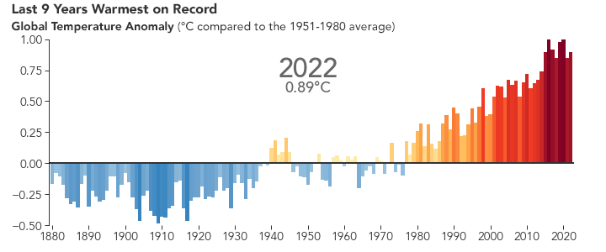
Fig. 1: Global temperature changes from the beginning of global records in 1880 up to the year 2022, according to the NOAA National Centers for Environmental Information Climate Report for 2022.

Amplification of warming at high latitudes and high altitudes.
The Arctic has experienced the most rapid increase in surface temperature (ST), increasing more than twice as rapidly as the global average, a phenomenon termed as 'Arctic amplification' (Li et al., 2023; Screen & Simmonds, 2010; Serreze & Barry, 2011). The warming is most expressed at high latitudes and high altitudes (United States Environmental Protection Agency, 2023). In the colder climates of Arctic and Alpine regions, the vegetation range is expanding pole-ward (Swann et al., 2010), a consequence of climatic warming of >1°C in the last three decades (Miller & Smith, 2012).

Norway’s northern regions, including Svalbard and parts of the Arctic, are experiencing more pronounced effects of global warming due to the Arctic amplification (Arctic Monitoring and Assessment Program (AMAP), 2012). Three times as quickly as the world average, the Arctic is warming. This is primarily due to the albedo effect, which occurs when snow and ice melts and reveals a darker surface, increasing the amount of solar energy absorbed there. The Greenland ice cover, glaciers, and sea ice are all melting because of this major regional warming (Arctic Monitoring and Assessment Program (AMAP), 2012). This is an obvious accelerated warming in the Arctic compared to the global average (Arctic Monitoring and Assessment Program (AMAP), 2012).

The yearly warming trends in the Arctic (0.17 ± 0.031 and 0.14 ± 0.025ᵒ C per decade under the Imax and Imin reconstructions, respectively) are around 1.6-1.8 times the global mean warming trends (0.10 ± 0.008 and 0.09 ± 0.008ᵒ C per decade) between 1900 and 2020. The Imax and Imin are the monthly mean anomalies as shown in the figure below (figure 2). While the Arctic warming trends (0.66 ± 0.100 and 0.55 ± 0.080ᵒ C per decade) increase to 3.1-3.5 times the global warming trend (00.19 ± 0.023 and 0.18 ± 0.023ᵒ C per decade) for Imax and Imin, respectively, indicating that the Arctic amplification effect has significantly increased in recent decades (Li et al., 2023). This strong temperature increase is related to several positive feedback that amplify the warming (so called arctic amplification).

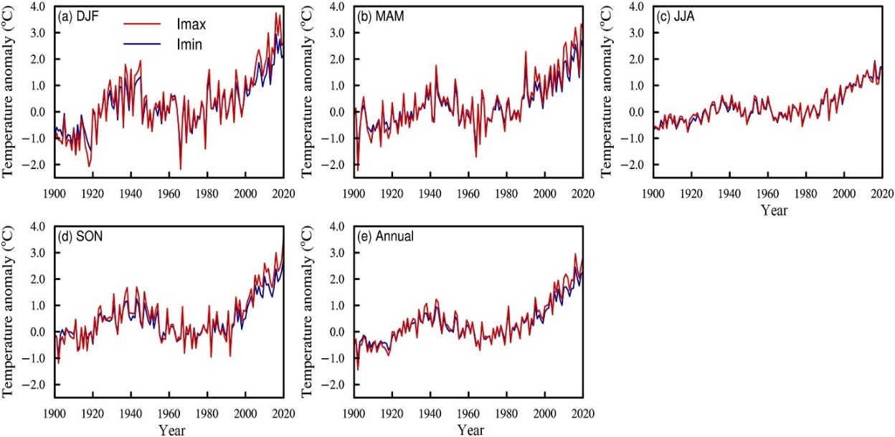
Fig. 2. ST (surface temperature) anomalies series for Imax and Imin in the Arctic for 1900–2020 (relative to 1961–1990), (a) winter, (b) spring, (c) summer, (d) autumn, and (e) annual. (Adapted from Li et al. 2023)

Internal interactions, or feedback, are critical in the climate system (Harding et al., 2002). Negative feedback reduces the influence of an external disturbance, whereas positive feedback amplifies the effect and may result in an unstable system (Harding et al., 2002). Much of the feedback discovered in the climate system is positive; hence, increasing CO2 levels will increase temperature, reduce snow cover, increase radiation absorption, and thus increase temperature even more (Harding et al., 2002).

1.2.1 Snow and ice albedo feedback (SIAF)
Snow and ice albedo feedback (SIAF), a shift in the shortwave radiative energy balance at the edge of the Earth's atmosphere, results from changes in the characteristics and extent of the snow and ice cover in the Polar Regions (Riihelä et al. 2021). The available insolation and atmospheric factors that affect radiative transfer, such as cloudiness, essentially determine the size of this radiative feedback for a specific change in surface albedo (Riihelä et al. 2021). The recent reduction of the Arctic cryosphere has reduced the region's surface albedo, limiting its capacity to reflect solar radiation back to space (Riihelä et al. 2021). The surface albedo reductions caused by continuous post-2000 losses in Arctic snow and ice cover correspond to more positive snow and ice albedo feedback compared to a 1982-1991 baseline period, with a decadal trend of +0.08 ± 0.04 W/m2/dec. between 1992 and 2015 (Riihelä et al. 2021).

1.2.2 The taiga-tundra feedback
When focusing on the taiga-tundra feedback, the contrast in their surface characteristics is considered (Harding et al. 2002). The taiga consists of dense forests dominated by coniferous trees, while tundra is characterized by treeless landscapes with low-lying vegetation (Harding et al. 2002) such as mosses and lichens. The difference, which is arguably the biggest contrast ever seen on a terrestrial surface, is at its height in the winter when the taiga trees poke their heads through the snow cover while the tundra is completely blanketed in snow (Harding et al. 2002). The energy fluxes at the surface and the temperature conditions on the ground and in the atmosphere are drastically altered by this shift. The permafrost, the carbon fluxes, the plant growth, and the water cycle will all undergo significant changes as a result (Harding et al. 2002). Such massive forest disturbances and warming soils result in increased CO₂ release stored in the ecosystem (Hartley, 2014; Li et al., 2022; Zhu et al., 2023), thus creating a feedback loop of climatic warming and greenhouse gases (GHGs).
Furthermore, the boreal forest is expanding northward, and shrub growth is accelerating on the tundra terrain due to warming (Chapin et al., 2005). In the former tundra terrain, the bigger plants absorb more solar radiation, which also adds to positive feedback that is not considered by global climate models (Chapin et al., 2005).

1.2.3 Sea-ice insulation feedback
Sea ice is frozen seawater that hovers on the surface of the ocean. It occurs in both the Arctic and the Antarctic during the winters of each hemisphere; it recedes in the summer but does not totally vanish. This floating ice has a significant impact on the arctic ecosystem, affecting ocean circulation, weather, and regional climate (Scott et al. 2016). Additionally, sea ice forms an insulating layer over the ocean's surface, which lessens heat loss to the atmosphere and evaporation. Thus, the weather over ice-covered places is typically colder and drier than it would be in the absence of ice (Scott et al. 2016).
Due to its high albedo, the white surface reflects significantly more solar radiation back to space than ocean water does. When sea ice starts to melt, a vicious cycle frequently starts (Scott et al. 2016). The water absorbs more solar radiation as more ice melts and reveals more black water. The water is then heated by the sun, melting more ice. This positive feedback cycle (the ice-albedo feedback) has the potential to affect the global climate over several years (Scott et al. 2016).

This abrupt climate warming is striking in many climates, with the rapid ice retreats in the North Atlantic and Nordic Seas (Jansen et al., 2020).
The sea-ice retreat in the Arctic also plays a key role in the ongoing abrupt warming, by being a part of Snow/Ice Albedo Feedback (SIAF) (Thackeray & Hall, 2019). As the sea ice melts resulting in reduced surface albedo, it leads to increased solar radiation absorption amplifying ice meltdown thus feeding the SIAF loop. Hence making it a key player in driving the Arctic climate change (Thackeray & Hall, 2019).

The intense warming at high latitudes and high altitudes has a clear impact on vegetation, with as notable effect the expansion of shrubs at the expense of Lichen and low herb vegetation (Mekonnen et al. 2021). As temperature increases, certain shrub species may benefit from the changing climate conditions, such as longer growing seasons, milder winters, and increased availability of water (U.S. Department of Energy, Environmental System Science Program, 2021; Mekonnen et al., 2021). These favorable conditions can promote the growth and expansion of shrubs into areas where they were historically less dominant (U.S. Department of Energy, Environmental System Science Program, 2021; Mekonnen et al., 2021). This shrubification has an impact on the radiation budget because it modifies the surface albedo (Belke-Brea et al., 2019).

The role of surface albedo in the energy balance.
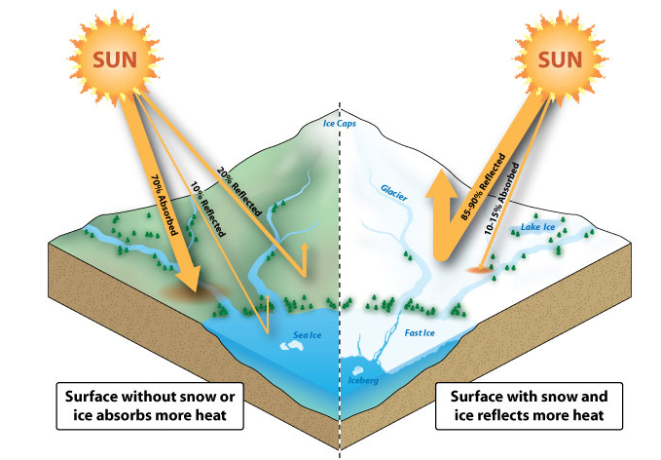
Fig. 3: Representation of two different surfaces: surface without snow or ice and surface with snow and ice. (Adapted from physicalgeography.net)

From the previous sections it has become clear that surface albedo plays an important role in climate change. Therefore, the term “albedo” is commonly used in the context of Earth’s climate and refers specifically to the reflectivity of sunlight from the Earth’s surface (see figure 3). It is defined by Coakley (2003) as the percentage of incident sunlight that a surface reflects, and by Oke (1987) as the ratio of the amount of reflected solar radiation by a body to the total incident upon it. Albedo is an integral part of climatic studies, as it is used by environmental scientists to understand how different surfaces and substances interact with light. Different surfaces have different albedo values (see table 1), which affect the amount of solar radiation absorbed or reflected by the Earth’s surface (Shan et al. 2020).

The albedo equation according to Oke (1987) is given as: $α=\frac{K_{↑}}{K_{↓}}$ Equation 1.1
Where, α is the albedo, K↑ (K_{out}) is the reflected or outgoing shortwave radiation (Wm̵²) and K↓ (K_{in}) is total incident shortwave radiation (Wm̵²). It gives an indirect estimate of the radiation absorbed by the given surface (Minnis et al., 1997), calculated as (1-α) K↓ (K_{in}). The portion of the radiation absorbed by the surface is one of the reasons for surface temperature increase, evaporation, melting of ice and snow, as well as turbulent heat exchange (Coakley, 2003). Table 1 gives a comparison of albedo values of various land surfaces (Oke, 1987), thus describing their respective surface reflectance.

Table 1: Surface albedo of different land surfaces (Adapted from Oke, 1987).
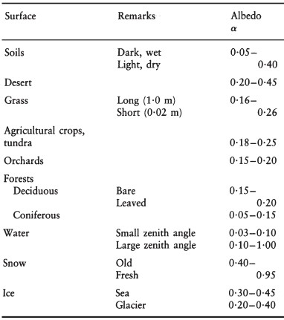

Here it is important to note, however, that albedo is a characteristic of shortwave radiation, which makes up only a portion of the net radiation or net energy budget (Q*) (see figures 4&5) in an environment (Oke, 1987). The whole of Q* in a system is represented as follows:
Q*= K*+ L* Equation 1.2
Q*= (K↓ - K↑) + (L↓ - L↑) Equation 1.3
Where K* is net shortwave radiation given by the difference of incoming and outgoing shortwave radiation,
K* = K↓ - K↑ Equation 1.4
L* is net long wave radiation given by the difference of incoming and outgoing long wave radiation (Fig. 4).
L* = L↓ - L↑ Equation 1.5
L↓ is the incoming long-wave radiation from the atmosphere (Wm̵²) and L↑ is the outgoing long-wave radiation from a surface (Wm̵²) (Oke, 1987).

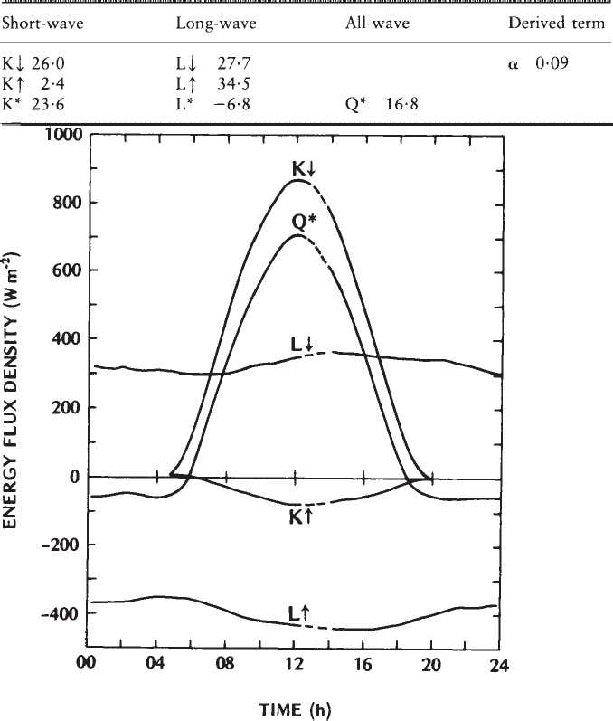
Fig. 4: Component fluxes of the radiation budget of a 28 m stand of Douglas fir at Cedar River, Washington (47ᵒN) on 10 August 1972 (after Gay and Stewart, 1974). (Source: Oke, 1987).

In other words, Q* or the net surface radiation, represents the radiative energy available for the sensible heat flux QH, latent heat flux QE and conduction to or from the soil QG (Oke, 1987). That is,
Q*= QH + QE + QG Equation 1.6
The figure below (Fig. 5) gives an example of a comparison of the variation in the surface energy balance Q* and its components, the latent and sensible heat fluxes, and the conduction over a period of a day (Oke, 1987).

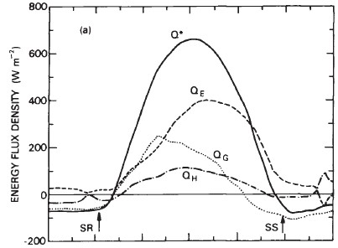
Fig. 5: Components of Energy balance on 30 May 1978, for moist bare soils with cloudless skies in Agassiz, B.C., (45ᵒN) (Source: Oke, 1987).

Factors affecting surface albedo.
The local surface albedo depends on several factors, such as, the type and texture of surface (Reinhardt et al., 2021) and the components of a heterogeneous surface if a larger area is being analyzed (Coakley, 2003), the vegetative cover and its type (Lundholm et al., 2010; Smith et al., 2023). Vegetative cover plays an integral part in influencing the surface energy budgets (Oehri et al., 2022; Z. Wang et al., 2017). However, this influence is robust depending on the geographic location of study (Peng et al., 2014; Shen et al., 2015; Swann et al., 2010), impacting feedback loop of temperature and albedo differently. The vegetative influence is, in turn, also dependent on the type or components of the vegetative covers, whether it is vascular plants, shrubs and lichens, grass cover or crop cover (Lundholm et al., 2010; Smith et al., 2023).

Moreover, it is important to note that albedo forms a feedback loop, whether positive or negative, with all these aforementioned factors instead of a direct one-way reaction channel. A portion of absorbed incident radiation is used to contribute to various components, including surface heating resulting in increased surface temperature, evaporation, and evapotranspiration, melting of ice and snow, which in turn influences the surface albedo (Sultana et al., 2019). The surface temperature is closely tied to the albedo (Sultana et al., 2019), which influences the radiation absorbed by the surface. The changes in surface temperature affect the changes in turbulent boundary layer (Oke, 1987), thus leading to a vertical gradient of temperature in the atmosphere with an apparent diurnal variation. This is established by previous studies that the higher surface albedo is related to cooler surfaces due to lower surface temperatures and vice versa (Alibakhshi, Hovi, & Rautiainen, 2019; Ouyang et al., 2022; Smith et al., 2023; Wang & Davidson, 2007). It should be considered however, that both surface albedo and surface temperature are closely tied to many other intrinsic environmental components.

Relation between surface albedo and surface temperature.
Albedos differ between surfaces (Coakley, 2003), so does surface temperature. The albedo of a surface implies that bright vegetation surfaces with relatively high albedos absorb less solar radiation than dark surfaces with a low albedo. The expectation is thus that such canopy surfaces with a high albedo have a lower surface temperature than vegetation surfaces with a low albedo. The temperature at a location is however also affected by other factors, such as transport of heat to the site by wind (heat advection) and the humidity of the air (affecting evapotranspiration). Equation 1.7 below further explains this phenomenon.

ΔT = ΔTrad + ΔTadv + ΔTturb + ΔTlat + ΔTcond Equation 1.7
ΔTrad is the temperature change due to the radiation balance and is depending on an important part on surface albedo, which determines Kout. ΔTadv is the temperature change due to horizontal transport of heat to the site (heat advection), which means wind transfer. ΔTturb is the temperature change related to vertical sensible heat loss or gain. ΔTlat is the temperature change governed by vertical latent heat loss or gain (mainly evapotranspiration) and ΔTcond is the temperature change due to conduction (negligible here) (Oke, 1987).
As previously assessed, surface albedo is an important factor when it comes to management and planning microclimatic strategies to face climate change. This is because albedo controls the surface’s radiation balance and has an impact on the atmosphere’s surface temperature and boundary-layer structure (Wang & Davidson, 2007).

Methods to measure surface albedo and microclimate.
Over time, albedo and surface temperature studies have used an array of data sources, integrating different spatiotemporal satellite maps, to characterize surface albedo and temperature with focus on their role in global and local climates. However, evaluating models based on local-scale (use of radiometer) observations is difficult because local single-point measurements may not be representative of the large grids used in climate models, especially during the melt season. On the other hand, validations against satellite observations are restricted to cloudless situations, which limits the temporal resolution of satellite-based surface albedo measurements; thus, as a compromise, airborne observations provide data covering different atmospheric conditions on a larger, spatial scale partly resolving the sub-grid variability in a model grid cell (Jäkel, et al., 2023). However, user friendly and low-cost alternatives (albedo mobile application: a reflectance app) for analyzing albedo and surface temperature (handheld thermal camera) should be taken into the picture with the advancement of technology and evolution in cellular devices. Modes of data collection in the field of ecology have been changing as well. For instance, on ground albedo measurements can be made via the use of Albedo mobile application (a reflectance app) for smart phones (Mallen-Cooper et al., 2021). The basic assumption of the application is that it was designed to measure the reflectance of a surface; that the camera of smartphones, used as a photometer can accurately capture and analyze the reflection from a surface and can measure the broadband albedo providing measurements in the spectral bands of red, green, and blue (RGB) color channels of camera (Leeuw, 2015).

The big advantages of albedo app relative to radiometers: it is low-cost and portable, thus allowing for taking a lot of measurements at different places. Combining this data with thermal imagery of vegetation surfaces taken using a handheld thermal camera to capture surface temperatures, and other data including cloud cover, wind speed, ambient temperature, and humidity, could give forth substantial data for assessing microclimatic conditions. Also, this data could be compared with the already available literature in the field, to give forth the accuracy and precision of such applications, when it comes to studying human driven climate change. Standard meteorological surface air temperatures refer to the temperatures of the air slightly above the Earth's surface. These temperatures are typically measured at a height of 20 to 30 centimeters above the ground.

Objectives of this study
This study is aimed at evaluating the relationship between albedo and surface temperature of different vegetation types using low-cost, portable methods. The specific objective of this research was thus to check the accuracy and precision of low-tech/cheap alternative for albedo (albedo app) measurements in relation to high-tech/expensive alternatives and considering their continued usage for future climate studies.
Therefore, to have a clear understanding of the above focal points, the following hypotheses will be tested.
- Vegetation types with high albedo will have lower surface temperatures than vegetation types with lower albedo (High albedo = lower absorption of solar radiation = cool surface; Lower albedo = high absorption of solar radiation = hot surface).
- Albedo: A Reflectance app for smart phones can be used to collect albedo data for climatic studies.

Methods
2.0 Study location:
This study was conducted within Breisås forest (about 330 m.a.s.l) and on the campus of the University of Southeastern Norway (65 m.a.s.l), Bø, Central Telemark, Norway (59.412611⁰N, 9.069938⁰E). The table (table 2) below presents the coordinates for the various plot locations of the different vegetation types mapped for this study and figure 8 displays the map.

Table 2: Coordinates of plot locations.
Vegetation type | Plot ID | Coordinates (Lat⁰, Lon⁰)
Blueberry | BSAT-A | 59.39555N, 9.071161E
 | BSAT-B | 59.39559N, 9.071169E
 | BSAT-C | 59.39552N, 9.071235E
 | BSAT-D | 59.39592N, 9.070652E
 | BSAT-E | 59.39592N, 9.070652E
Lichen | LSAT-A | 59.39592N, 9.070652E
 | LSAT-B | 59.39564N, 9.070966E
 | LSAT-C | 59.39588N, 9.071005E
 | LSAT-D | 59.39749N, 9.072602E
 | LSAT-E | 59.39824N, 9.071221E
Heather | HSAT-A | 59.39583N, 9.071409E
 | HSAT-B | 59.39554N, 9.071007E
 | HSAT-C | 59.39591N, 9.071206E
 | HSAT-D | 59.39836N, 9.071405E
 | HSAT-E | 59.39838N, 9.071853E
Tall grass | TgSAT-A | 59.40771N, 9.057946E
 | TgSAT-B | 59.40697N, 9.056976E
 | TgSAT-C | 59.40702N, 9.056421E
 | TgSAT-D | 59.40888N, 9.056528E
 | TgSAT-E | 59.40923N, 9.05838E
Short grass | SgSAT-A | 59.40776N, 9.057695E
 | SgSAT-B | 59.40791N, 9.058719E
 | SgSAT-C | 59.40814N, 9.057681E
 | SgSAT-D | 59.40841N, 9.058698E
 | SgSAT-E | 59.40825N, 9.059087E
Bare ground | BgSAT-A | 59.40205N, 9.071613E
 | BgSAT-B | 59.40224N, 9.071712E
 | BgSAT-C | 59.40235N, 9.071812E
 | BgSAT-D | 59.40275N, 9.072571E
 | BgSAT-E | 59.40254N, 9.071951E

According to the Köppen climate classification system, Bø experiences a humid continental climate. This is because Bø has a significant seasonal temperature variation, with warm to hot (and often humid) summers and freezing cold winters.

Throughout the year, the temperature as shown in figure 6, normally ranges from -8°C to 21°C, with temperatures rarely falling below -18°C or rising over 27°C. From May 25 to September 5, the warm season lasts 3.4 months, with an average daily high temperature exceeding 17°C. July is the hottest month in Bø, with average highs of 21°C and lows of 10°C. From November 15 to March 14, the cold season (winter) lasts 4.0 months, with an average daily high temperature of less than 3°C. January is the coldest month of the year in Bø, with an average low of -7°C and a high of -1°C (weatherspark.com).

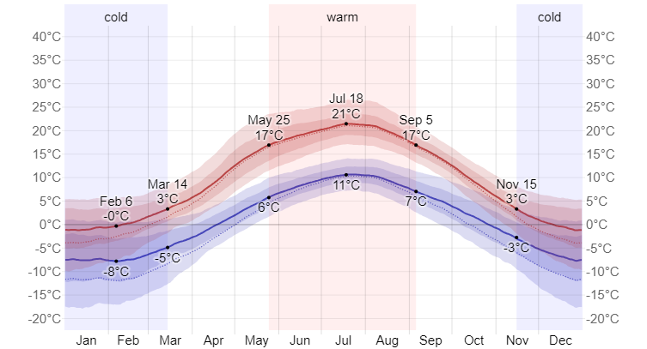
Fig. 6: Average high and low temperature in Bø: The daily average high (red line) and low (blue line) temperature, with 25th to 75th and 10th to 90th percentile bands. The thin dotted lines are the corresponding average perceived temperatures. (Typical weather in Bø, based on a statistical analysis of historical hourly weather reports and model reconstructions from January 1, 1980, to December 31, 2016. Adapted from weatherspark.com).

The likelihood of rainy days in Bø (see figure 7) fluctuates throughout the year. From May 22 to January 9, the wetter season lasts 7.6 months, with a greater than 33% chance of rain on any given day. October has the rainiest days in Bø, with an average of 11.7 days with at least 1.00 millimeters of precipitation. March has the fewest wet days in Bø, with an average of 8.1 days with at least 1.00 millimeters of rain (weatherspark.com). Much of the precipitation in winter falls as snow.

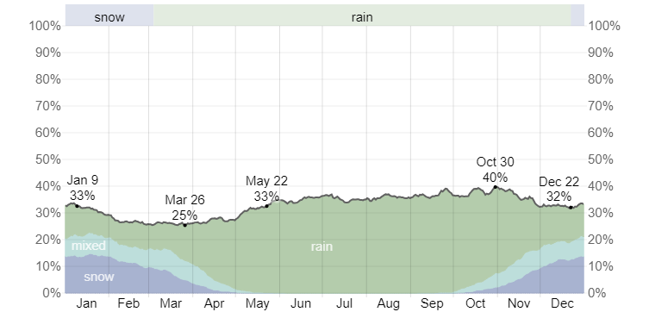
Fig. 7: Daily chance of precipitation in Bø. The percentage of days in which various types of precipitation are observed, excluding trace quantities: rain alone, snow alone, and mixed (both rain and snow fell in the same day). (Typical weather in Bø, based on a statistical analysis of historical hourly weather reports and model reconstructions from January 1, 1980, to December 31, 2016. Adapted from weatherspark.com).

The typical vegetation of the area is made up of grasslands, croplands (as farming is a major source of income in the area), trees, shrubs, and herbs.
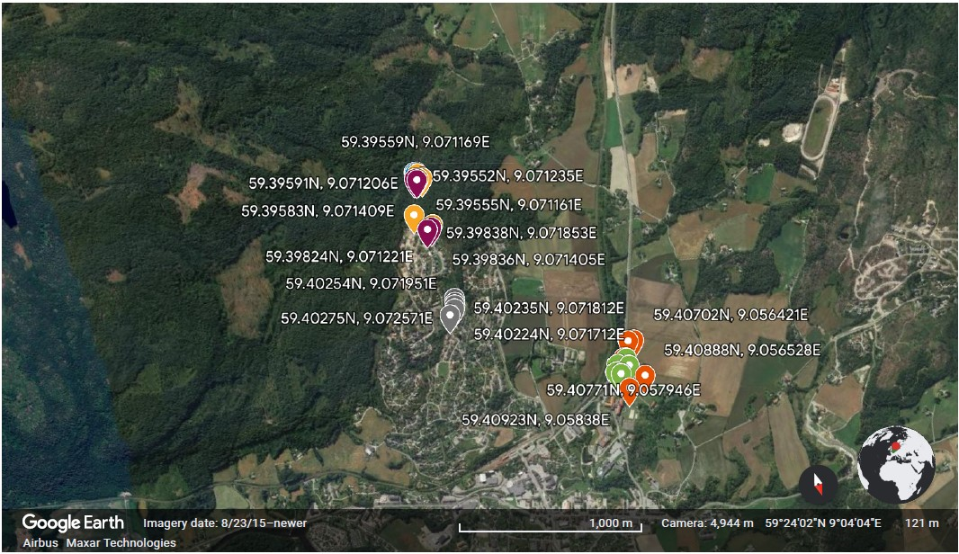
Fig. 8: Map showing study locations.

2.1 Study vegetation types:
For this study, six (6) general vegetation types (blueberry, lichen, heather, tall grass, short grass, and bare ground (non-vegetated surface)) were defined. The distribution of the vegetation types selected for this study differ, as they are important components in their various habitats.

Blueberry, also known as European blueberry (Vaccinium myrtillus) (figure 9) is commonly found in Norwegian forest fields and is dominant in boreal and sub-alpine ecosystems and grows in a variety of conditions with a preference for well-lite habitats, acidic soils, and a cool, moist climate with moderate to high rainfall (Nestby et al., 2017).
The code (Plot ID) used to designate blueberry is given as BSAT with A-E attached to each plot.

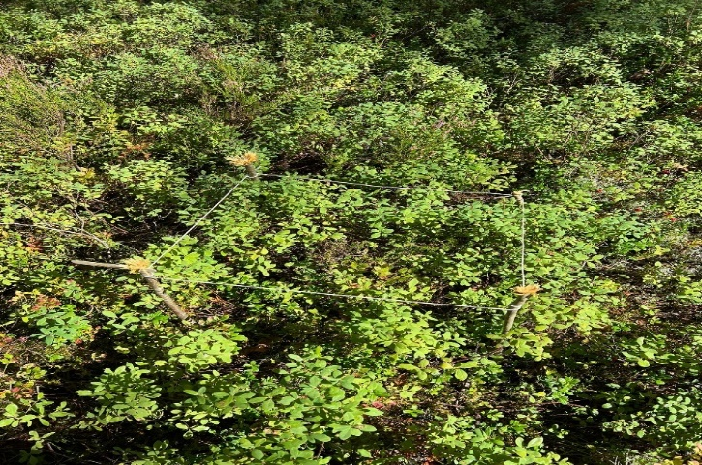
Fig. 9: Plot showing blueberry (Vaccinium myrtillus) vegetation.

Lichens are a complex life form that is the result of a symbiotic relationship between two different creatures, a fungus, and an alga (figure 10). The fungus is the dominant partner, providing the majority of the lichen's traits, from its thallus shape to its fruiting bodies (USDA, 2023). The algae can be either green or blue - green, sometimes known as cyanobacteria (USDA, 2023). Lichens can colonize a variety of surfaces and are commonly seen on tree bark, exposed rock, and as a component of biological soil crust (Encyclopedia Britannica, 2023). They contribute to providing fundamental ecosystem services such as nutrient recycling and water regulation (Petersson et al. 2021). Lichens thrive in humid, calm environments with clean air, are highly adaptable because they can survive in areas where nutrients and occasionally water are low. However, lichens grow quite slowly (Royal Horticultural Society, 2023).

For this study, I focused on terricolous lichens which grow basically on soil and thin soil layers on rock surfaces. Light-colored species such as Cladonia stellaris and Flavocetraria nivalis were focused on for this study but were not distinguished as previous research shows that they both have similar albedo values with reference to Reinhardt et al. (2021). The code (Plot ID) used to designate lichen is given as LSAT with A-E attached to each plot.

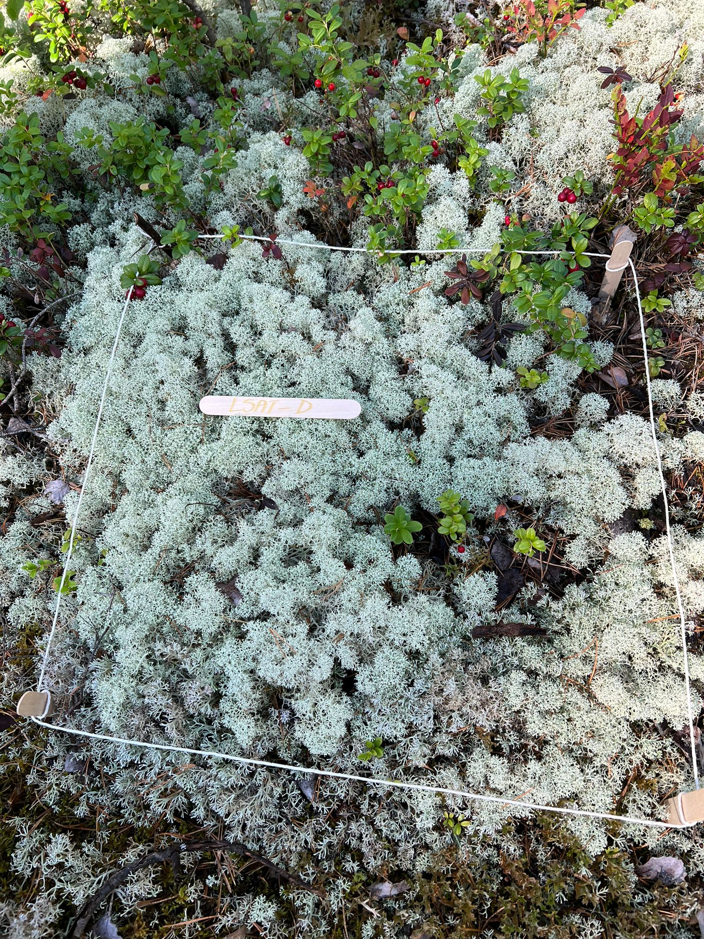
Fig. 10: Plot showing lichen vegetation.

Heather (Calluna vulgaris), shown in figure 11 is found in mature conifer woodlands and surrounding environments throughout mainland Europe, from Northern Scandinavia to the Mediterranean and the Iberian Peninsula, and it is also found in parts of Asia. It grows well in low-nutrient acidic soils, blooms from July to September, and is at its peak in late August (First Nature, 2023). The code (Plot ID) used to designate heather is given as HSAT with A-E attached to each plot.
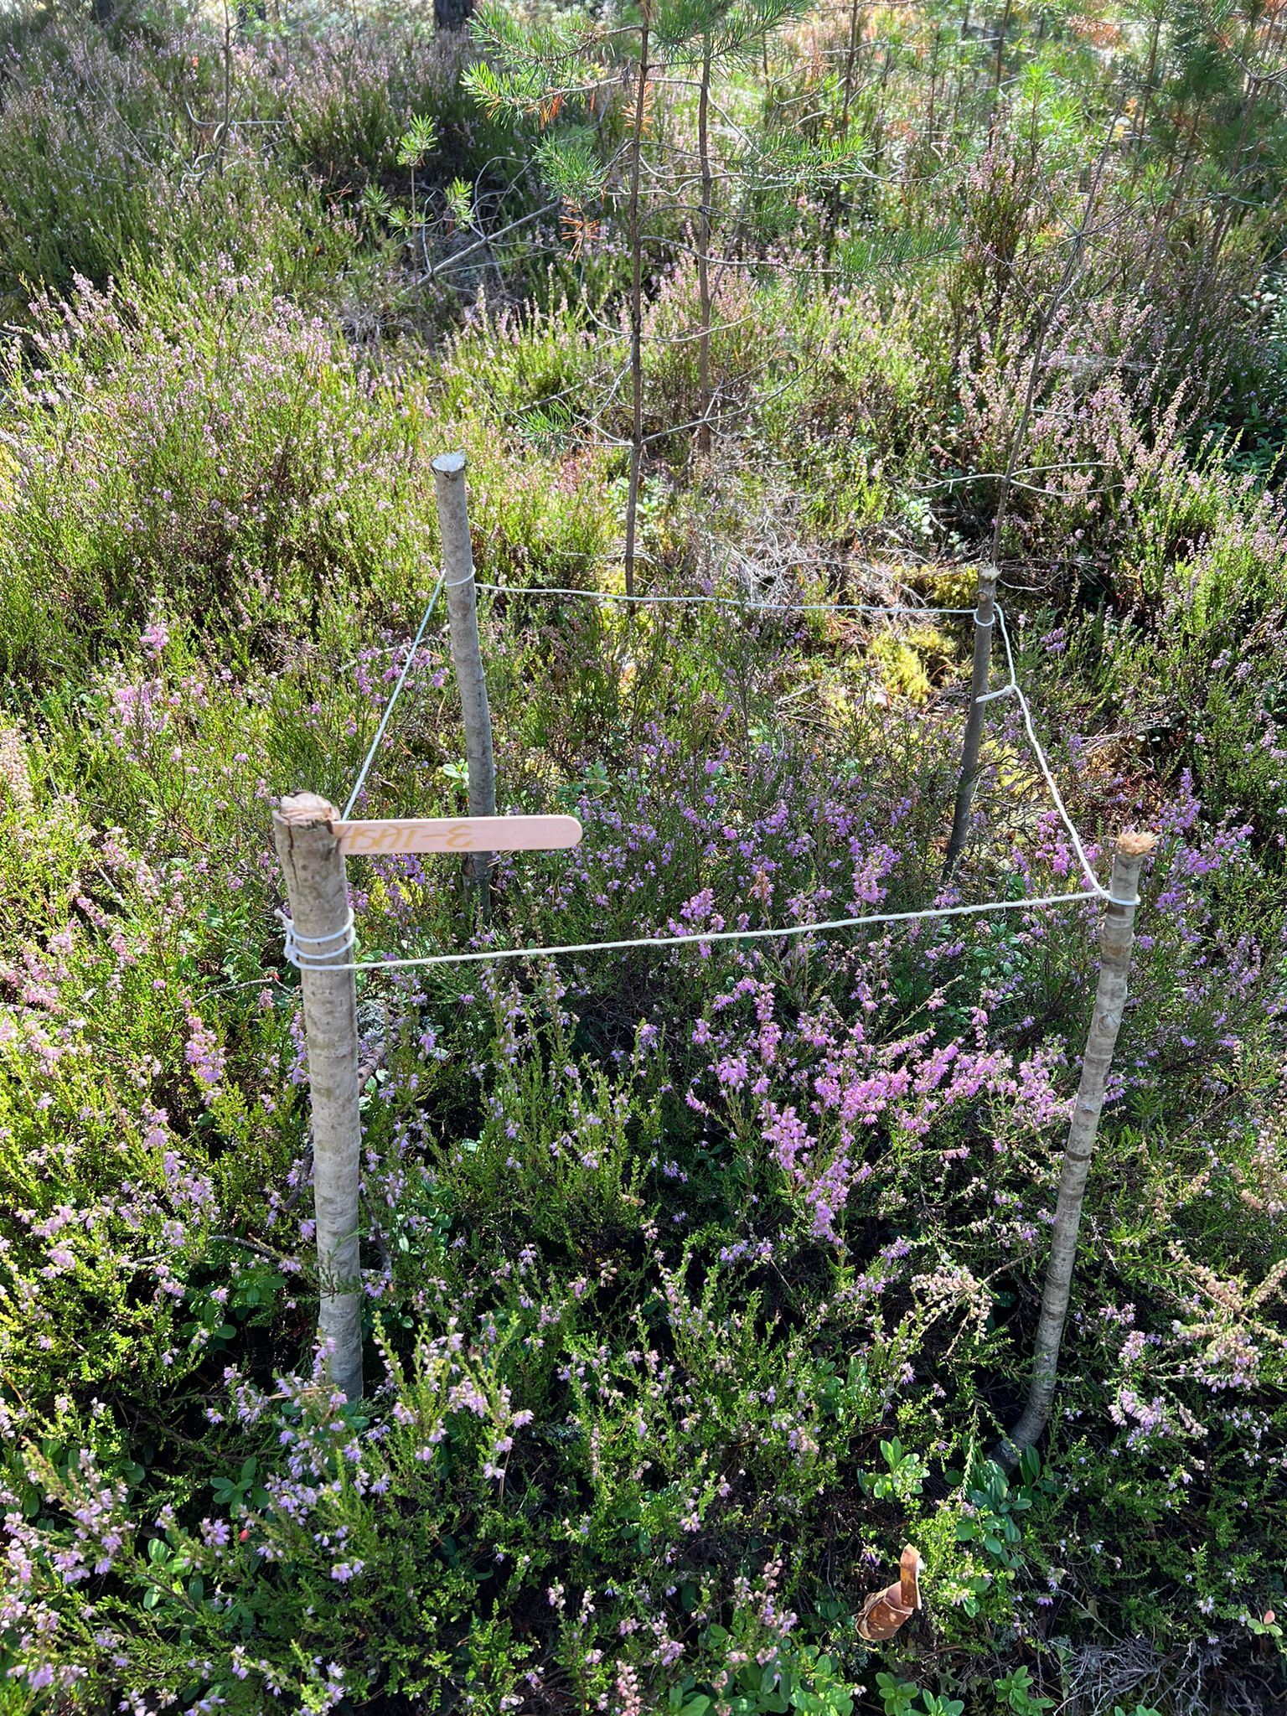
Fig. 11: Plot showing heather vegetation.

Grasslands commonly co-exist and cover roughly 40% of the Earth’s terrestrial landscape and support large communities of herbivores, both vertebrate and invertebrate (Spalinger et al., 2012). The grass found on grasslands vary in length resulting to tall and short grass. Mowed lawns and recreational fields which measured between 1.5cm – 3.0cm in height are examples of grasslands which represented short grass (figure 12A) (SgSAT), while uncut grasslands which measured between 25cm – 78cm in height represented tall grass (figure 12B) (TgSAT).

A B
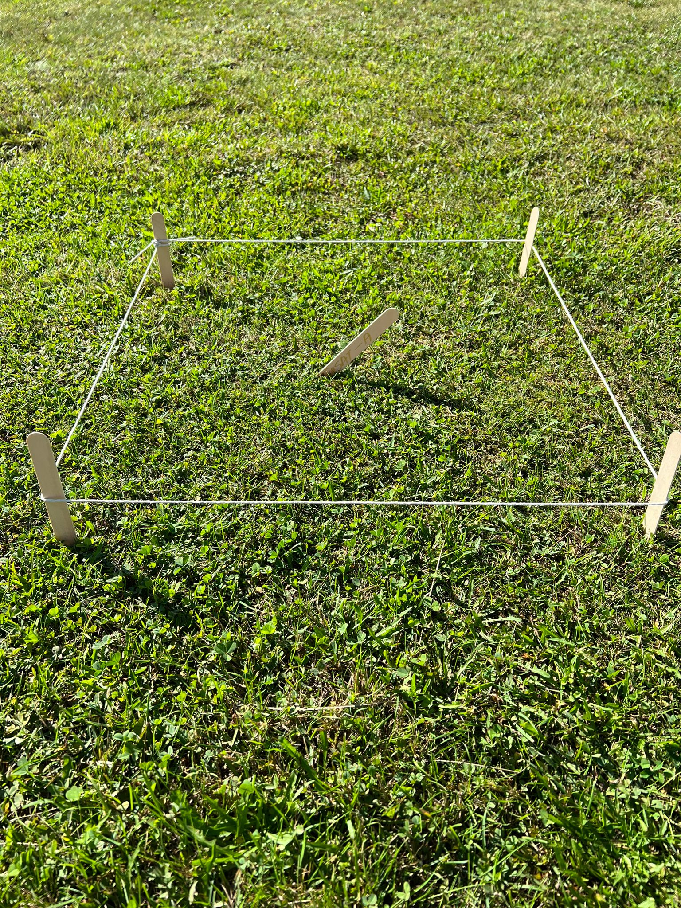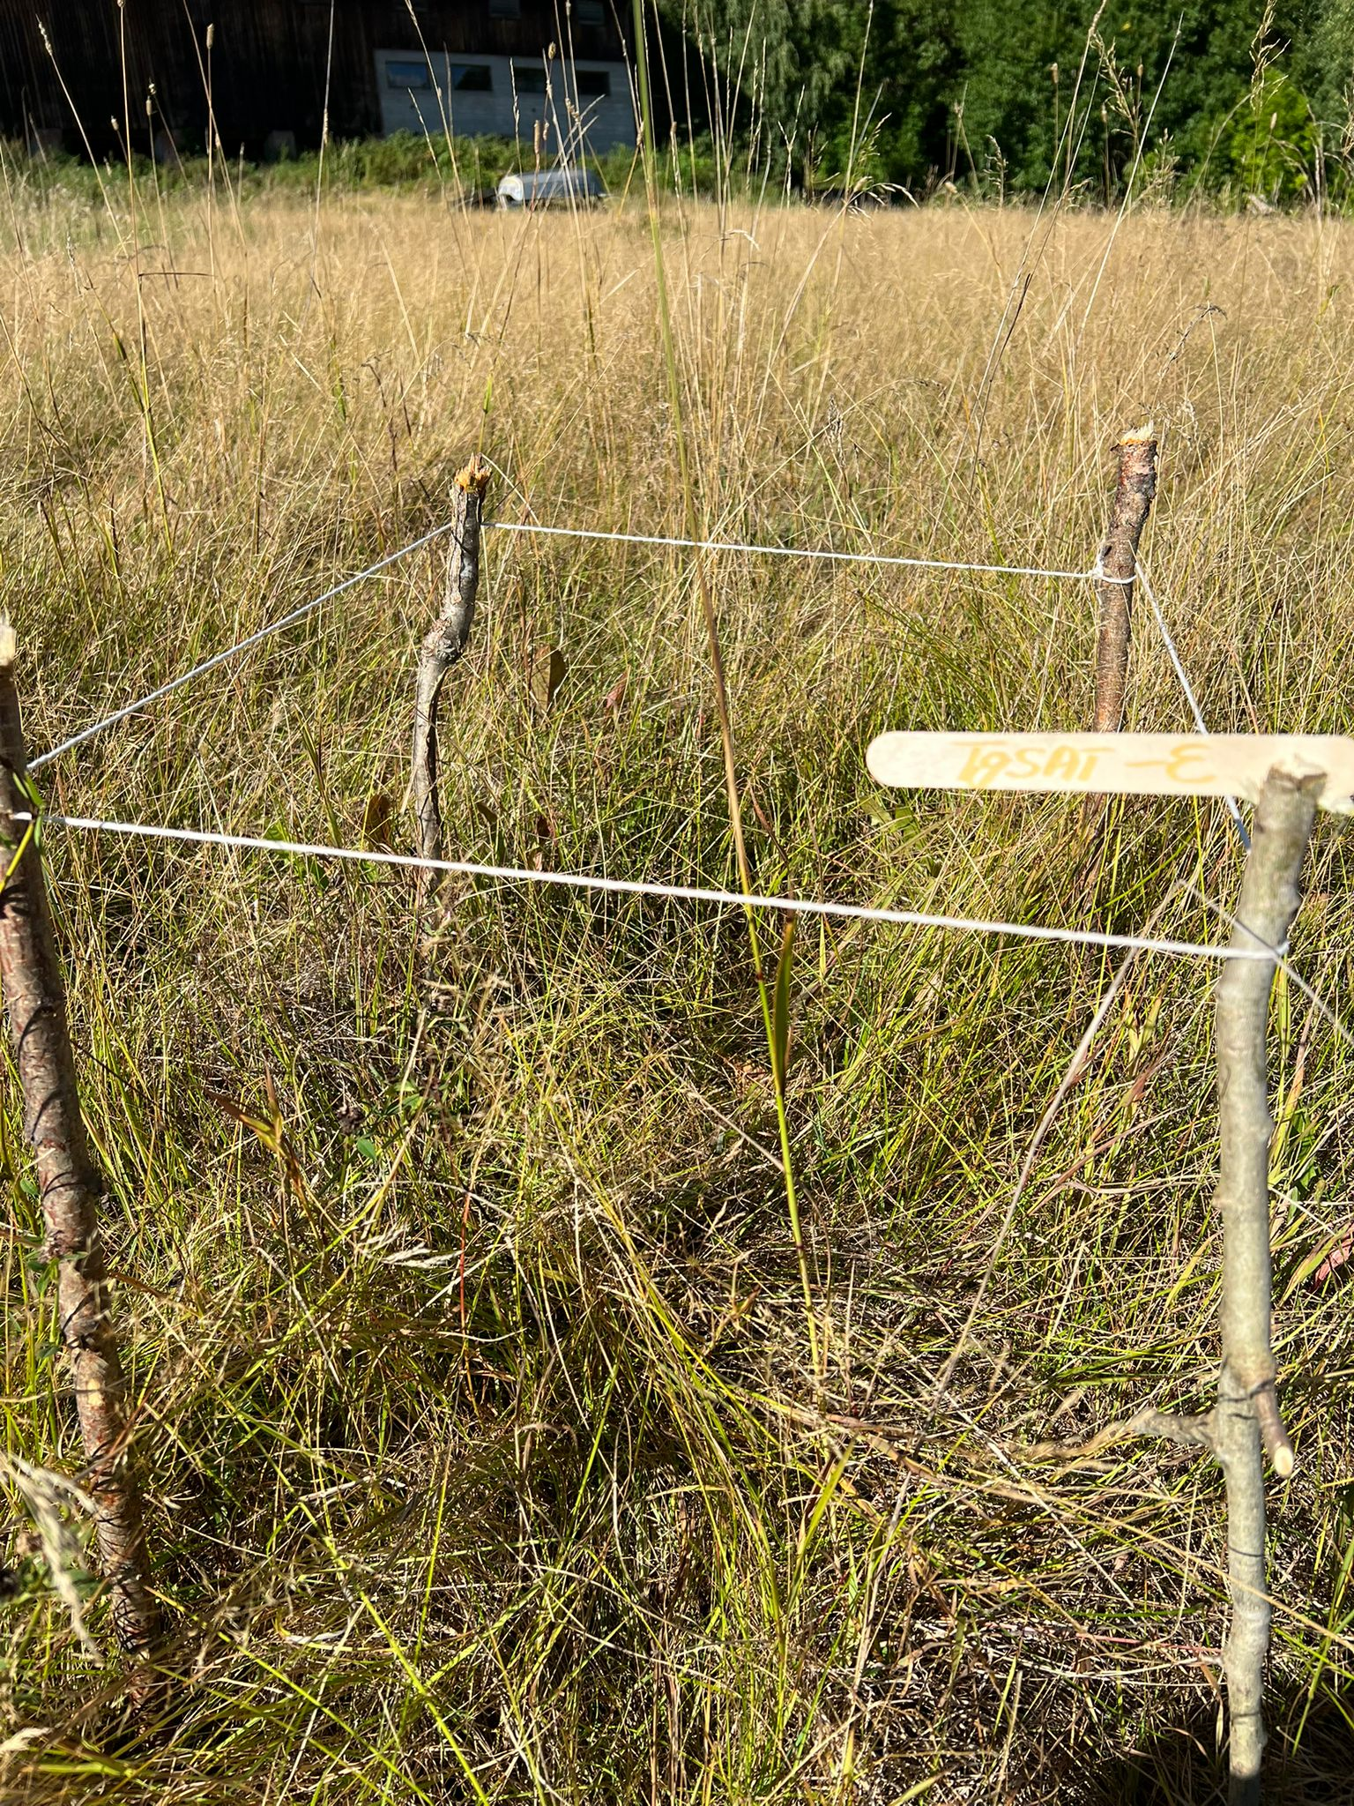
Fig. 12: Plots showing Short (A) and Tall (B) grass vegetation types.

Bare ground (bare soil) otherwise known as non- vegetated surface (figure 13) was also considered for this study as measurements were also collected. The code (Plot ID) used to designate bare ground is given as BgSAT with A-E attached to each plot.

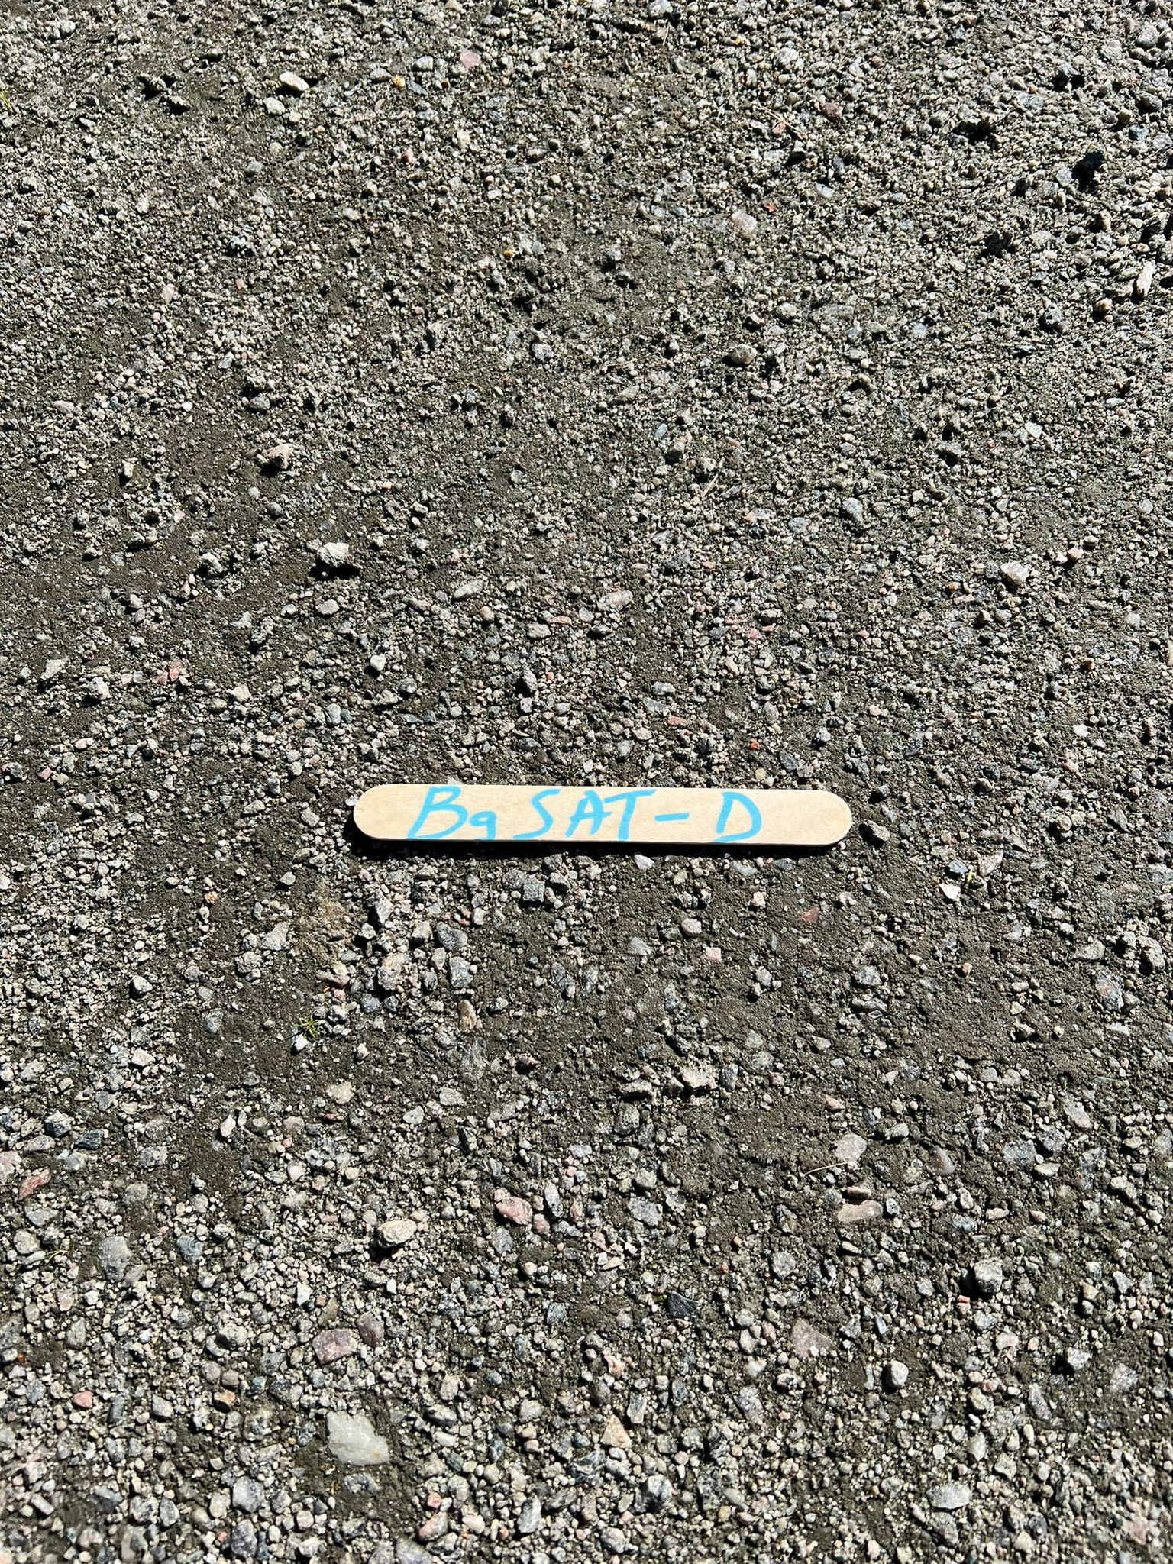
Fig. 13: Bare ground (non-vegetated Surface).

2.2 Experimental design
Surface albedo and surface temperatures of these six pre-defined vegetation surfaces were measured under different light and weather conditions, excluding rainy/wet days. The field measurements lasted for ten (10) days between the 28th of August – 15th September 2022, at the end of summer and growing season. The summer was a particularly wet summer as it rained regularly though not every day (see figure 82 in Annexes). This resulted in the non-consecutive days of data collection as days of rainfall and wetness were avoided.
The blueberry, lichen, and heather vegetation types were sampled within the Breisås forest, and the bare ground was sampled towards the entrance of the forest in Breisås. The tall and short grass vegetation types were sampled around the campus of the University of Southeast Norway, all in Bø, Central Telemark County.
For each of the vegetation types, 5 appropriate measurement locations were mapped and labelled with plot identifications (location codes). The coordinates of the sites were recorded for the purpose of revisit. The plots for each vegetation type were selected on a near to almost horizontal surface to avoid the impact of slope angle and aspect. Measurements for albedo and canopy temperatures were taken for each of the mapped plots during different weather conditions: sunny without clouds, partly and fully clouded. This was necessary to capture the impact of diffusive radiation versus direct radiation.

2.2.1 Experimental setup:
For each of the vegetation types, five (5) plots of 50 x 50 cm were mapped using a meter rule, sticks, rope, and a plot code as the tag. The total number of plots was thus thirty (30) (i.e., 5x6=30) across all vegetation types. Ten (10) measurements were taken for all 30 plots for 10 days avoiding rainy days, using measurement forms which generated a dataset of 300 measurements for each variable.
The 30 plots were described one time using a location form which had the following characteristics taken into consideration: vegetation type, plot ID (location code), vegetation height (cm), vegetation cover (%), plant species present, picture taken? (Y/N), and coordinates (Lat⁰, Lon⁰). Dates and time were also recorded.
The following parameters were recorded within the plots in addition to albedo and surface (canopy) temperatures: Ambient temperature, wind speed, relative humidity, and cloud cover.

2.2.2 Albedo
The surface albedo measurements were taken between 20 – 30cm height above the surface using an albedo mobile application (a reflectance application) for smart phones, designed by Thomas Leeuw (2015) to measure the albedo (or reflectance) of a surface (https://apps.apple.com/us/app/albedo-a-reflectance-app/id989649641). The application (Fig. 14) makes use of the smartphone camera as a photometer and can measure the broadband albedo providing measurements in the spectral bands of red, green, and blue (RGB) color channels of camera (Leeuw, 2015). The camera, however, while using the application must be calibrated using a photographer’s gray card (Fig. 15) (with a known 18% reflectance value) as reference (Leeuw, 2015). The albedo mobile application is actively used in research, as has been used by Mallen-Cooper et al., (2021).

The application has a simple and easy to use interface that walks users through the process of collecting two images: a gray card image and an image of the surface of interest. The images can be analyzed immediately after they are collected. The application calculates the albedo of the surface in the red, green, and blue (RGB) color channels of the camera during image analysis, plotting a graph. The application also makes use of the cellular network, thus providing coordinate data for the imagery.

A B C
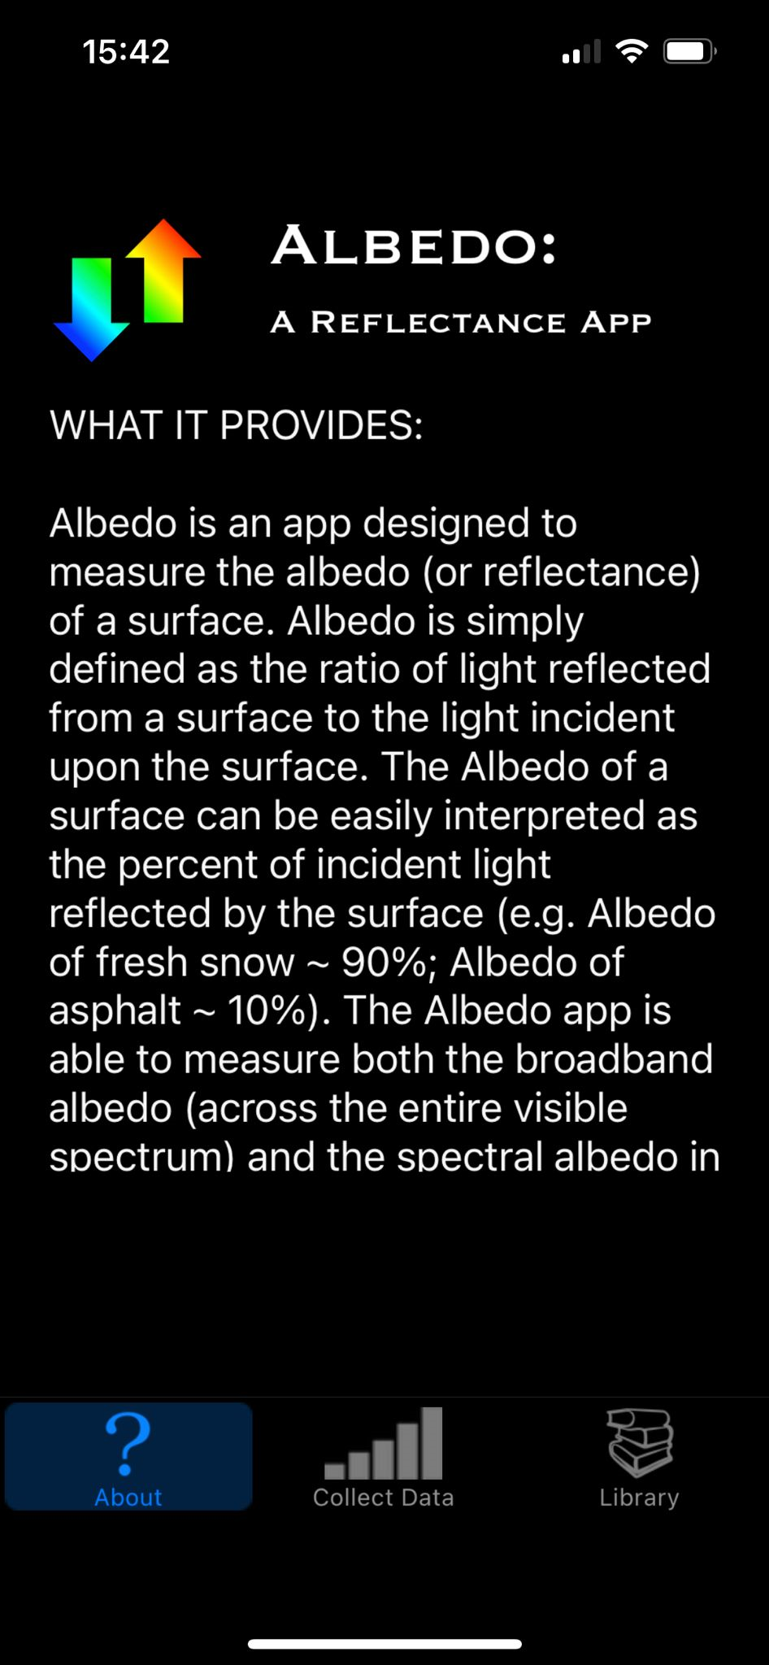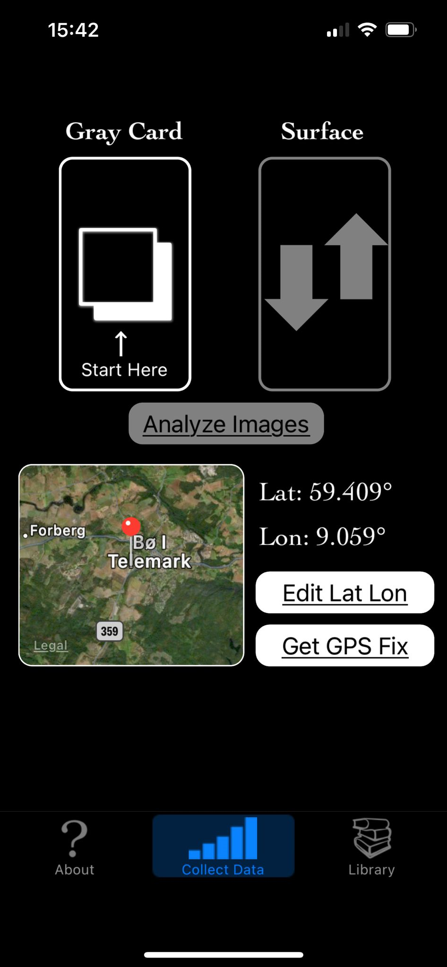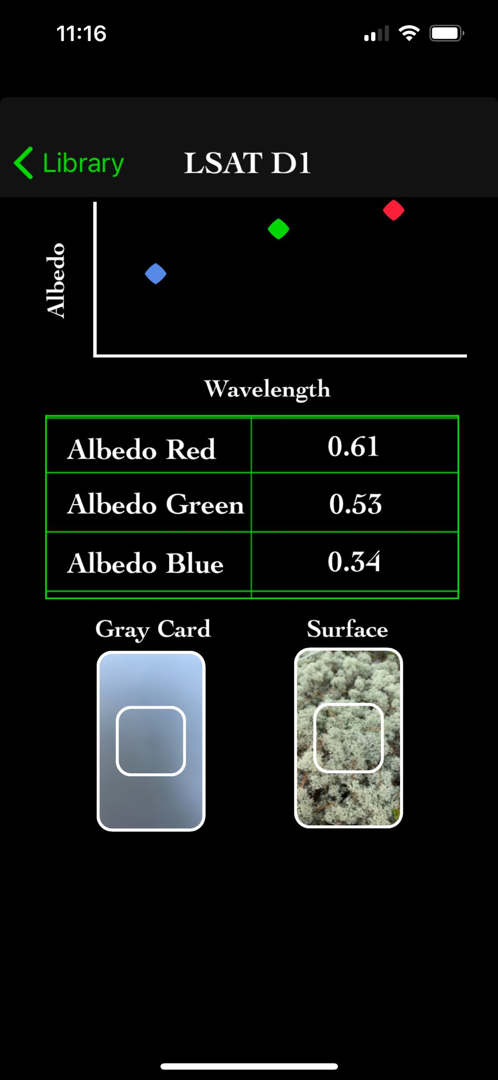
Fig. 14: User friendly interface of the albedo mobile application. (A: introductory interface, B: Data collection interface, C: Result interface).

Fig. 15: A photographer’s gray card otherwise known as calibrite (or color checker), used to calibrate the camera of the mobile phone in use prior to data collection.

2.2.3 Thermography (Surface temperature)
The thermographs, which also took measurements of the surface temperature, were taken using a handheld thermal camera (GTC 400 C), manufactured by BOSCH (Fig. 16A). The surface temperature measurements were taken between 20 – 30cm height above the surface (canopy) of each vegetation type.
The thermal images displayed measurements between the cold spot (CS) (represented with a blue cross) and the hot spot (HS) (represented with a red cross) of a given vegetation surface or canopy and generate an average surface temperature value (represented with a gray cross) at the center of the image (Fig. 16B, C). The default emissivity value of 0.94 was left unadjusted.

A B C
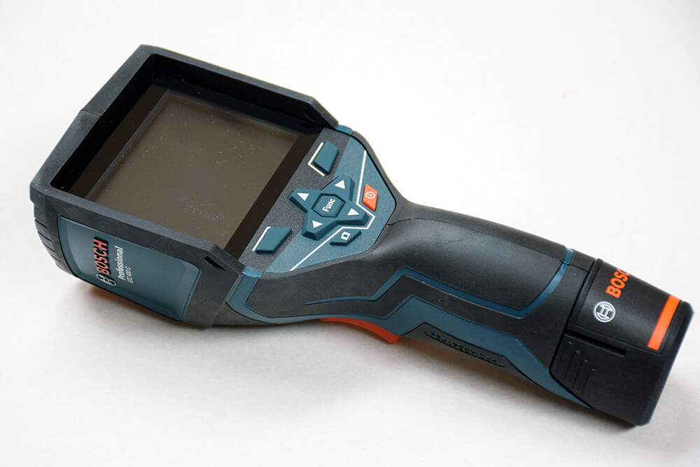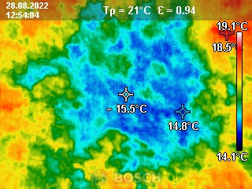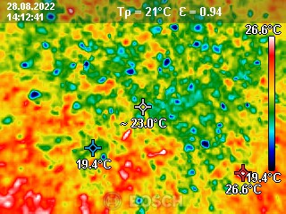
Fig. 16: A: Bosch GTC 400 c thermal camera, B&C: Sample surface temperature measurements taken using the handheld thermal camera.

2.2.4 Cloud cover
Cloud cover was taken into consideration but was based on daily visual observations and was observed only once during each measurement. The cloud observations were categorized based on a meteorological scale from 0 – 8 in okta units known as oktas (8s). As described by the scale, the sky is divided into ¨eights¨ to estimate cloud cover and is represented by the simple equation $n/8$. Where $0/8$ represents no cloud cover (clear day), and full cloud cover (cloudy day) or overcast is represented by $8/8$ (see Fig. 17 for cloud cover categories in Bø).

Cloud cover is considered because of its ability to reflect and disperse solar radiation effectively (Skøyen, 2020; Oke, 1987). This can be quickly altered over brief periods and can be seen as fluctuations in shortwave radiation measurements because of absorbance and reflection by clouds (Skøyen, 2020; Oke, 1987). Hence, cloud cover can shift quickly, and this is not considered in cloud cover observations. Furthermore, observed clouds may not provide shade for incoming sunlight and thus do not reduce the quantity of incoming radiation (Reinhardt et al., 2021).
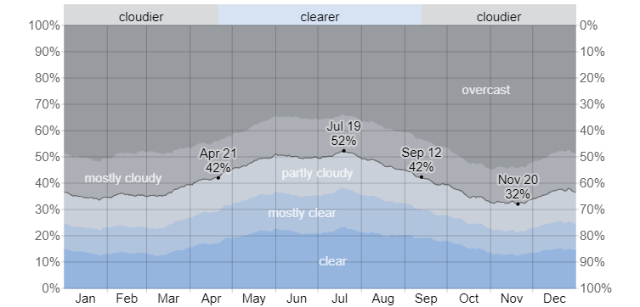
Fig. 17: Cloud cover categories in Bø Midt Telemark. (Typical weather in Bø, based on a statistical analysis of historical hourly weather reports and model reconstructions from January 1, 1980, to December 31, 2016. Adapted from weatherspark.com).

2.2.5 Wind speed, Ambient temperature, and Humidity
These environmental factors were measured using a handheld anemometer. However, the measurements were rejected as they generated unrealistic values when compared to measurements from nearby meteorological stations. Therefore, these manual measurements obtained were considered not useful. Alternatively, measured values for Bø and Gvarv Nes weather stations were downloaded from the internet-based database (https://seklima.met.no/observations). Wind speed measurements from Gvarv Nes weather station were used for this study because Bø weather station has no measurements for wind speed.

The Bø station with ID number SN32240, is 4.8 km – 5.0km away from the plot locations within and around Breisås forest and 2.8 km – 3.0 km from the plot locations around the University campus. The Gvarv Nes station with ID number SN32060, is 12.0 km away from the plot locations within the Breisås forest and 11.0 km from the plot locations around the University campus. Bø and Gvarv Nes stations, are both official meteorological sites and are handled by Nibio and Met.no respectively.

2.3 Data Analysis
2.3.1 Structuring the data set.
In the data analysis for the first research question, all 300 individual measurements for surface albedo, surface temperature, cloud cover, wind speed and humidity, were included in the statistical analysis run in SPSS (Statistical Package for the Social Sciences) to check if a clear relationship exists between albedo (α) and surface temperature (⁰C) across all vegetation types. A numerical variable that shows the temperature difference (T. Diff.) between ambient temperature and surface temperature of all vegetation surfaces was added in all datasets. The ambient temperature measurements from the B Bø meteorological station were a one hourly measurement for the same time frame as the surface temperature measurements taken from the field.

For more in-depth analysis, subsets of the whole dataset were created to check the impact of different levels of cloud cover (clear to almost clear days, partly cloudy days, and mostly cloudy to cloudy days) and wind speed (calm air to light breeze). The impact of humidity was not categorized; therefore, its impact was checked across all 300 measurements. To check the impact of the different levels of cloud cover, the nine (9) stages between $0/8$ (clear days) to $8/8$ (cloudy days) were pooled into three (3) groups viz: group 1: 0/1/2 (clear to almost clear days), group 2: 3/4/5 (partly cloudy days), group 3: 6/7/8 (mostly cloudy to cloudy days).

The Beaufort wind force scale (see table 3 below) which attributes descriptive terms to wind scales ranging from 0-12 in meters per second (ms⁻¹) was used to scale wind speed measurements, fusing them into three scales viz: scale 0: 0.5 – 0.9 (calm air), scale 1: 1.0 – 2.9 (light air), scale 2: 3.0 – 4.9 (light/gentle breeze).
Different subsets across all vegetation types were divided by the various cloud cover and wind speed levels to check if the relationship between albedo and surface temperature becomes clearer and more understandable.
To answer the second research question, albedo and surface temperature values measured using the reflectance application for smartphones and handheld thermal camera were simply compared to values of same vegetation types as reported by other researchers who used high-tech alternatives for the same measurements.
Table 3: The Beaufort wind force scale.
Beaufort wind scale | Wind speed  m/s | Wind descriptive term | Land conditions
0 | <0.5 | Calm | Water vapor/ heat/smoke rises vertically.
1 | 0.5 – 1.5 | Light air | Direction shown by smoke, heat, or vapor drift.
2 | 1.6 – 3.3 | Light breeze | Wind felt on face, leaves rustle.
3 | 3.4 – 5.5 | Gentle breeze | Leaves and small twigs in constant motion.

2.3.2 Statistical Analysis
In this study, two important variables (surface albedo and surface temperature) were measured alongside other environmental factors; cloud cover, wind speed and humidity. Albedo (α) deemed the independent/explanatory variable is used to predict surface temperature, which is the response variable. Hence, the reason why a possible relationship between the two variables has been analyzed. All environmental factors measured were included in the statistical analysis and analyzed to check if they influence surface albedo and surface temperature and possibly their relationship.

Linear regression analysis was conducted in SPSS to examine the relationship between the two variables (surface albedo and surface temperature), using p-value. The decision rule states that if a p-value (sign) is greater than 0.05, it implies that the relationship is not significant and vice versa. A correlation coefficient of 1.000 indicates a perfect positive correlation. The goal is to understand the strength and direction of the relationship between the variables, and to identify which independent variables have a significant impact on the dependent/response variable. This is because regression is a method used to forecast the values of one numerical variable based on the values of another numerical variable (Whitlock & Schluter, 2020).

Regression analysis is a powerful statistical method that allows the assessment of the relationship between two or more variables of interest. It is a reliable method of identifying which variables have impact on a topic of interest. The process of performing a regression makes it possible to determine which factors matter most, and those to be ignored, and it also determines how these factors influence each other (Whitlock & Schluter, 2020).
In analyzing the results of this research, regression analysis was used to ascertain the relationship between the two variables (surface albedo and surface temperature).

Results and Discussion
3.1 Difference in Albedo across vegetation types.

Fig. 18 – Albedo differences across vegetation types.

The surface albedo for Blueberry, Lichen, Heather, Tall grass, short grass, and Bare ground is shown in the box plot above (Fig. 18), based on 50 measurements per vegetation type. It is possible to identify the vegetation type with the highest albedo range by visually and quantitatively comparing the box plots for each kind of vegetation. This comparison also sheds light on the features and reflectance of each vegetation type.
The average albedo for each vegetation type was calculated and then compared to establish clear differences in albedo values across the six vegetation types. The average albedo value for each of the vegetation type and the ranges (Min. – Max) are given as:
- Blueberry: 0.08 (0.02 – 0.13)
- Lichen: 0.24 (0.05 – 0.53)
- Heather: 0.03 (0.02 – 0.05)
- Tall grass: 0.05 (0.01 – 0.09)
-Short grass: 0.05 (0.02 – 0.10)
- Bare ground: 0.17 (0.08 – 0.27)
It can be inferred from these average figures that the albedo values of the various vegetation types vary. Heather has the lowest average albedo, which means it absorbs more solar radiation, while lichen has the highest average albedo, which shows that it reflects more incoming solar radiation. Tall and short grass share the same average values showing that they behave so much alike. Bare ground, which has the second highest average albedo value, had some bright colored crushed gravel and stones on its surface which could have contributed to its high albedo value.
The physical characteristics and color of each type of vegetation, which affect how much solar radiation is reflected or absorbed, are the main causes of this variance in albedo.
Outliers are largely unavoidable as they tend to be found within collected data or measurements. Lichen, heather, tall grass, and bare ground are some of the vegetation types with outliers as seen in the box plot.
In a nutshell the distinctive features of each type of vegetation, such as color, density, and structure, which define how they interact with solar radiation, influence the variations in albedo between ground cover types (different vegetations).

3.2 Difference in Surface temperatures (T. diff.) across vegetation types.

Fig. 19 - Surface temperature (T. diff.) differences across vegetation types.

Figure 19 shows a box plot of surface temperatures across the six vegetation types investigated based on 50 measurements per vegetation. The box plots provide visual and quantitative insights into the thermal characteristics of all vegetation types.

The average T. diff for each plant cover was determined and compared to explain the differences in surface temperatures (T. diff) between vegetation types. The average T. diff values and the range (Min. – Max.) for each vegetation type are as follows:

- Blueberry: 2.98°C (-1.7 – 6.6)
- Lichen: 4.03°C (-4.1 – 13.5)
- Heather: 0.99°C (-4.0 – 4.8)
- Tall grass: 5.94°C (0.3 – 12.8)
- Short grass: 5.56°C (-0.7 – 16.3)
- Bare ground: 3.93°C (-1.6 – 8.8)

These average statistics show notable differences in surface temperatures (T. diff.) among the different vegetation types. Tall and short grass have the largest average T. diff, implying that they can contribute to higher surface temperatures. Heather, on the other hand, has the lowest average T. diff, indicating that it exerts a cooling effect on the surface. Blueberry, lichen, and bare ground fall somewhere in the middle.

The differences in surface temperature are influenced by various factors, including the color and reflective properties of the vegetation, energy absorption, its ability to retain moisture, and its insulation characteristics in natural environments. Vegetation types that are darker in color tend to absorb more solar radiation and thus have higher surface temperatures, while lighter-colored or moisture-retaining vegetation may reflect more sunlight and have cooler surface temperatures.

Furthermore, it is important to note that lichen, despite having the highest surface albedo of 0.24 (see figure 18), also has a high surface temperature (T. diff.). Although not readily expected based on our first hypothesis, this agrees with Stoy et al. (2012), who noted that lichens have high surface temperatures despite having high albedo. The reason according to Stoy et al. (2012) is because lichens are poor conductors of heat (that is, they retain heat energy from incoming solar radiation over a period and do not easily release it) as observed in C. rangiferina (lichen species). Naranjo Orrico et al. (2022) also noted that lichens presented the highest surface temperatures among the different vegetation types (willow shrubs, meadow, and heath) studied.

In summary, variations in surface temperatures between vegetation types are caused by differences in their characteristics, which influence how they interact with incoming solar radiation and heat retention.

3.3 The relationship between surface albedo and surface temperature (T. diff.) across vegetation types.
Table 5 (correlation table) presents information about the relationships between different variables, with a special emphasis on the correlations between surface albedo (reflectivity) and surface temperatures (T. diff) across all vegetation types.
The table contains various pairs of variables, one representing albedo for a certain vegetation type (e.g., Blueberry, Lichen etc.) and the other representing surface temperature (T. diff) for the same vegetation type.

Pearson correlation coefficients are shown in the table, which quantify the strength and direction of a linear relationship between the variables. Correlation coefficients can range from -1 (perfectly negative correlation) to 1 (perfectly positive correlation), with 0 signifying no linear correlation.

3.3.1 Interpretation of the correlation coefficients as shown on table 5.

Fig. 20a. Correlation plot showing all 300 measurements for albedo and T. diff.
Blueberry:
Relationship between albedo and surface temperature (T. diff.).

Fig. 20b. Relationship between Albedo vs Temperature difference (T. diff.) for Blueberry.

Blueberry albedo and surface temperature (T. diff) (Fig. 20b.) have a significant negative correlation (-0.372). This implies that when the albedo increases, the surface temperature decreases, or as the albedo decreases, the surface temperature tends to increase. The correlation is modest, indicating that there is a recognizable but not compelling strong relationship.

The significance level (Sig.) for the correlation between Albedo and T. diff is 0.008 (2-tailed). The p-value of 0.008 is less than the typical significance level of 0.05, indicating that the correlation is statistically significant at the 0.05 level. In this context, the observed correlation is not likely due to random chance.
In summary, there is a statistically significant, moderate negative relationship between the albedo and temperature difference for blueberry-covered areas.

Lichen:
Relationship between albedo and surface temperature (T. diff.).

Fig. 20c. Relationship between Albedo vs Temperature difference (T. diff.) for Lichen.

Pearson correlation (-0.104) between lichen albedo and surface temperature (T. diff.) (Fig. 20c.) showed no significant correlations. This correlation coefficient indicates that there is a very weak negative relationship between "Albedo" and "T. diff." The negative sign shows that as albedo increases, temperature difference falls somewhat; conversely, as albedo declines, temperature difference increases slightly. The correlation, on the other hand, is very near to zero, indicating that this relationship is very weak.

The significance level (Sig.) for the correlation between Albedo and T. diff is 0.474 (2-tailed). The p-value of 0.474 is greater than the typical significance level of 0.05. This means that the correlation is not statistically significant at the 0.05 level, suggesting that the observed correlation could be due to random chance.

In summary, there is a very weak, non-significant negative relationship between albedo and temperature difference for lichen-covered areas. The correlation is so close to zero that it suggests little to no practical or meaningful relationship between these variables in this context.

Heather:
Relationship between albedo and surface temperature (T. diff.).

Fig. 20d. Relationship between Albedo vs Temperature difference (T. diff.) for Heather.

Heather albedo and surface temperature (T. diff.) (Fig. 20d.) show a 0.251 positive correlation. This positive correlation signifies that there is a weak relationship between "Albedo" and "T. diff.". Surface temperature (T. diff.) tends to increase together with the albedo of heather vegetation type. However, the correlation (0.251) is just marginally significant.

The significance level (Sig.) for the correlation between Albedo and T. diff is 0.078 (2-tailed). The p-value of 0.078 is greater than the typical significance level of 0.05. This suggests that the correlation is statistically significant at the 0.05 level, indicating that the observed correlation could be due to random chance.
In general, for heather-covered areas, there is a weak positive correlation between albedo and temperature difference, but this relationship is not statistically significant at the 0.05 level. This implies that the observed correlation may be insufficient to draw firm conclusions regarding the relationship between albedo and temperature difference in this case.

Tall grass:
Relationship between albedo and surface temperature (T. diff.).

Fig. 20e. Relationship between Albedo vs Temperature difference (T. diff.) for tall grass.

The Pearson correlation between albedo and T. diff. for tall grass (Fig. 20e.) is -0.089. This correlation coefficient suggests "albedo" and "T. diff." have a weak negative relationship. The significance level (Sig.) for the correlation between albedo and T. diff. is relatively high at 0.538 (2-tailed). The p-value of 0.538 is greater than the typical significance level of 0.05. This means that the correlation is not statistically significant at the 0.05 level, suggesting that the observed correlation could be due to random chance.
In a nutshell for tall grass-covered areas, there is a weak, non-significant negative association between albedo and temperature difference. The connection shows that as albedo increases, temperature difference decreases slightly, although this association is not statistically significant in this context.

Short grass:
Relationship between albedo and surface temperature (T. diff.).

Fig. 20f. Relationship between Albedo vs Temperature difference (T. diff.) for short grass.

Short grass albedo and T. diff (Fig. 20f.) have a Pearson correlation of -0.478. This correlation coefficient suggests a moderately strong negative relationship between "Albedo" and "T. diff." The negative sign indicates that as albedo increases (i.e., becomes more reflective), the temperature difference tends to decrease, and as albedo decreases (i.e., becomes less reflective), the temperature difference tends to increase.
The significance level (Sig.) for the correlation between albedo and T. diff. is very low at 0.000 (2-tailed). The p-value of 0.000 is much less than the typical significance level of 0.05, indicating that the correlation is highly statistically significant. In this context, the observed correlation is unlikely to be due to random chance.
In essence, for short grass-covered areas, there is a statistically significant, relatively strong negative relationship between albedo and temperature difference. The temperature difference begins to decrease as albedo increases (i.e., the canopy becomes more reflective), and vice versa.

Bare ground (non-vegetated surface):
Relationship between albedo and surface temperature (T. diff.).

Fig. 20g. Relationship between Albedo vs Temperature difference (T. diff.) for bare ground.

The Pearson correlation between albedo and T. diff. (Fig. 20g.) is 0.144. Albedo and surface temperature (T. diff.) demonstrate a significant negative correlation, indicating that as albedo increases (i.e., the non-vegetated surface becomes more reflective), surface temperature (T. diff) decreases, and as albedo decreases (i.e., the non-vegetated surface becomes less reflective), the temperature difference increases. The correlation between albedo and T. diff. has a significant level (Sig.) of 0.048 (2-tailed). The correlation is statistically significant at the 0.05 level based on the p-value of 0.048, which is less than the standard significance level of 0.05. The observed correlation in this situation is not likely to be the result of chance.

In summary, for bare ground areas, there is a statistically significant, moderately negative relationship between albedo and temperature differential. The temperature differential tends to diminish as albedo increases (i.e., the ground becomes more reflective), and vice versa. In this context, the relationship is statistically significant.

The scatter plots (Figures 20a – 20g) above, reveal varied relationships between surface albedo and surface temperature of the entire dataset (300 measurements) and among the different vegetation types studied. Generally, higher albedo values are associated with lower surface temperatures, indicating greater reflectance and less heat absorption. However, in this study, Blueberry, Tall grass, and short grass lower albedo values (greater absorption) are associated with higher surface temperatures. Bare ground and Heather showed moderate variations in surface albedo and temperature while Lichen showed higher albedo values (greater reflectivity) that associated with higher surface temperatures.

Finally, these correlations provide insights into how changes in albedo relate to temperature differences for different ground cover (vegetation) types, indicating that the type of vegetation is a significant predictor of its albedo. The significance levels tell you whether these relationships are statistically meaningful. It's important to consider both the correlation coefficients and their significance levels when interpreting the relationships between these variables.

3.4 The effect of cloud cover on albedo and surface temperature (T. diff.), and the effect of wind speed, and humidity on surface temperature (T. diff.).
This study further seeks to investigate the effects of cloud cover on albedo (as reported by Reinhardt et al., 2021) and surface temperature (T. diff.), and the effect of wind speed and humidity on surface temperatures (T. diff.).

This is to ascertain if a direct relationship exists between albedo and temperature difference (surface temperature) either in the presence and/or in the absence of these environmental factors.

To check these, the following hypothesis was proposed thus.

H₁: There is a significant impact of cloud cover on Albedo.
H₀: There is no significant impact of cloud cover on Albedo.

H₂: There is a significant impact of cloud cover on surface temperature (T. diff).
H₀: There is no significant impact of cloud cover on surface temperature (T. diff.)

H₃: There is a significant impact of wind speed on surface temperature (T. diff.).
H₀: There is no significant impact of wind speed on surface temperature (T. diff.).

H₄: There is a significant impact of humidity on surface temperature (T. diff.).
H₀: There is no significant impact of humidity on surface temperature (T. diff.).

The proposed hypotheses will be judged based on the visual representation of the graphs below.

3.4.1 The impact of cloud cover on albedo and temperature difference (T. diff.).
The impact of cloud cover on albedo.

Fig. 21a. Scatterplot showing the impact of cloud cover on albedo.

H₁ evaluates whether cloud cover significantly affects albedo (Fig. 21a.). Looking at the graphical representation, albedo does not appear to have a linear relationship with cloud cover. Hence, H₁ was rejected and H₀ accepted.
For all levels of cloud cover, albedo values vary greatly (ranging from 0 to 0.8). This implies that cloud cover alone may not be a reliable predictor of albedo.

The impact of cloud cover on temperature difference (T. diff.).

Fig. 21b. Scatterplot showing the impact of cloud cover on Temperature difference (T. diff.).

H₂ evaluates whether cloud cover significantly affects T. diff. (Fig. 21b.). The graph reveals that cloud cover has a significant but negative impact on T. diff. Hence, H₂ was accepted.
However, from the scatterplot above, T. diff. (temperature difference) does not show a strong linear relationship with cloud cover either. Temperature differences vary significantly across different levels of cloud cover. This implies that cloud cover alone may not be a dominant factor affecting temperature difference.

3.4.2 The impact of wind speed on temperature difference (T. diff.)

Fig. 21c. Scatterplot showing the impact of wind speed on Temperature difference (T. diff.).

H₃ evaluates whether wind speed has a significant impact on T. diff. (Fig. 21c.). The graph reveals that wind speed has a significant but also negative impact on T. diff. Hence, H₃ was also accepted.
Temperature difference does not exhibit a strong linear relationship with wind speed. The values of temperature difference are quite diverse at various wind speeds, indicating that wind speed alone may not also be a major predictor of surface temperatures (T. diff.).

3.4.3 The impact of humidity on temperature differnce (T. diff.)

Fig. 21d. Scatterplot showing the impact of humidity on Temperature difference (T. diff.).

H₄ evaluates whether humidity has a significant impact on T. diff. (Fig. 21d). The graph shows that humidity has no significant impact on T. diff. Hence, H₄ was rejected. Though there is no evident linear correlation between T. diff and humidity. Temperature difference values span a wide range, suggesting that humidity alone may not be a significant predictor of T. diff. on its own.

In summary, from the analysis of this dataset, it appears that cloud cover, wind speed, and humidity do not individually demonstrate strong linear relationships with either albedo or temperature difference (T. diff). Other variables or combination of factors may play a more significant role in explaining variations in albedo and T. diff. Further statistical analysis and potentially multivariate modeling (multiple explanatory variables) which according to Whitlock and Schluter (2015), is an important statistical tool that forecasts various outcomes by utilizing numerous factors may be necessary to better understand the complex interactions and dependencies between these variables.

3.5 Further assessment on the effect of cloud cover and wind speed on albedo and surface temperatures (T. diff.), using data subsets created for different cloud cover categories and scales of wind speed.

3.5.1 Effect of clear ($0/8$) to partially clear ($1/8$, $2/8$) days on albedo and temperature difference.

The effect of clear to partially clear days of cloud cover on albedo and temperature difference (T. diff) was assessed by examining the dataset from field measurements. Cloud cover was classified into different categories ($0/8$, $1/8$, $2/8$), and analyzed to see how these categories impact albedo and T. diff.

The analysis seeks to investigate the effect of cloud cover (clear – partially clear days) on albedo and T. diff.
The following hypotheses were proposed:

H₁: There is an impact of cloud cover on albedo.
H₀: There is no impact of cloud cover on albedo.

H₂: There is an impact of cloud cover on T. diff.
H₀: There is no impact of cloud cover on T. diff.

The hypotheses were judged based on visual representation of the box plots below.

Clear – partially clear days vs. Albedo.

Fig. 22. Box plot showing the effect of clear – partially clear days on albedo.

$0/8$, $1/8$, $2/8$: these cloud cover categories represent clear to partially clear days as shown in figure 22. Albedo exhibited a varying relatively low to slightly high values ranging from around 0.02 to 0.42 (as seen in lichens). This explains that surfaces are prone/tend to absorb more solar radiation on clear to partially clear days thereby exhibiting lower reflectivity.
However, there is more variation in albedo values these days suggesting that factors other than cloud cover also influence albedo. Hence H₁ was accepted and H₀ rejected.

Clear – partially clear days vs. Temperature difference (T. diff.).

Fig. 23. Box plot showing the effect of clear – partially clear days on temperature difference.

As expressed in the box plot above (figure 23), clear to partially clear days are associated with very low to high surface temperature (T. diff.) variations (which are both positive and negative). These temperature values range from around -4.1 (being the lowest) to 9.6 (being the highest). These days (clear to partially clear days) typically experience larger temperature differences (variations) between the surface and the atmosphere. H₂ was also accepted and H₀ was rejected.

To briefly recap, cloud cover (clear – partially clear days) has a noticeable impact on albedo and temperature difference. These days exhibit a wide range of albedo values and temperature differences (lower albedo values to higher temperature differences). This is because more solar radiation reaches the surface as it does not encounter obstruction due to a clear to partially clear sky.

It is also important to note that while cloud cover has a substantial influence on these environmental parameters, other factors such as surface features and geographical location may also contribute to the observed differences in albedo and temperature differences. Further investigation and evaluation of these other elements may provide a more complete picture of the relationships.
3.5.2 Effect of partly cloudy ($3/8$, $4/8$, $5/8$) days on albedo and temperature difference.
The effect of partly cloudy days of cloud cover on albedo and temperature difference (T. diff) was assessed by examining the dataset from field measurements. Cloud cover was classified into different categories ($3/8$, $4/8$, $5/8$), but only includes observations with cloud cover of $4/8$, $5/8$ and analyzed to see how these categories impact albedo and T. diff.

The analysis seeks to investigate the effect of cloud cover (partly cloudy days), on albedo and T. diff.
The following hypothesis were proposed:

H₁: There is an impact of cloud cover on albedo.
H₀: There is no impact of cloud cover on albedo.

H₂: There is an impact of cloud cover on T. diff.
H₀: There is no impact of cloud cover on T. diff.

The above hypotheses will be checked based on the visual representation of graphs (box plots). The dataset at this point is insufficient.

Partly cloudy days vs. Albedo.

Fig. 24. Effect of partly cloudy days on albedo.

On partly cloudy days with cloud cover categories of $4/8$ and $5/8$, it can be visualized from the box plot (Fig. 24) that albedo values vary largely between 0.02 to 0.81 (as seen in lichen which has the highest albedo values). Bare ground has the second highest albedo value (0.14) and then blueberry (0.07), with heather being the lowest (0.03). This dataset is somewhat insufficient as tall and short grass do not have representative data for partly cloudy days. Hence, H₁ was rejected and H₀ accepted.

Notwithstanding, the values indicate a reasonable range of surface reflectivity. The albedo values are therefore influenced by the merger of cloud cover and the reflective properties of the underlying vegetation type.
In summary, partly cloudy days exhibit a moderate range of albedo values, and the values appear to be influenced by the degree of cloud cover.

Partly cloudy days vs. Temperature difference (T. diff.).

Fig. 25. Effect of partly cloudy days on temperature difference (T. diff.).

Partly cloudy days with cloud cover categories of $4/8$ and $5/8$ depict varying temperature differences across vegetation types (Fig. 25), ranging from -3.0 (heather) to 11.8 (lichen). Bare ground (4.5) and blueberry (4.1) falls within the range. Yet again, tall, and short grass do not have representative data for this cloud cover category. There isn't a clear correlation between the temperature difference measurements and cloud cover. This category of cloud cover shows a broad range of temperature variations. Hence, H₂ was also rejected and H₀ accepted.

In summary, partly cloudy days do not show a clear and consistent pattern in temperature difference, and the values can vary widely. The temperature difference could be influenced by various factors, including cloud cover, but also other meteorological and geographical factors not considered.

However, it is essential to keep in mind that there can be complicated interactions between cloud cover, albedo, and temperature difference, and that these connections are impacted by a variety of variables other than cloud cover alone. The time of day, surface characteristics, and local geography are a few examples of these variables. More data and study would be required to identify more exact correlations and trends.

3.5.3 Effect of Mostly cloudy ($6/8$, $7/8$,) - Cloudy ($8/8$) (overcast) days on albedo and temperature difference.
The effect of mostly cloudy to cloudy (overcast) days of cloud cover on albedo and temperature difference (T. diff) was also assessed by examining the dataset from field measurements. Mostly cloudy to cloudy days was classified into categories as $6/8$, $7/8$, $8/8$ and analyzed to see how these categories impact albedo and T. diff.

The analysis seeks to investigate the effect of cloud cover (mostly cloudy – cloudy days), on albedo and T. diff.
The following hypothesis were proposed:

H₁: There is an impact of cloud cover on albedo.
H₀: There is no impact of cloud cover on albedo.

H₂: There is an impact of cloud cover on T. diff.
H₀: There is no impact of cloud cover on T. diff.

The above hypotheses will be analyzed based on the visual representation of graphs (box plots).

Mostly cloudy to cloudy days vs. Albedo.

Fig. 26. Effect of mostly cloudy to cloudy days on albedo.

On mostly cloudy (6, 7) to cloudy (8) days (Fig. 26), the albedo values for blueberry, heather, tall, and short grass tend to be relatively low, except for lichen (which has consistently exhibited high values of albedo) and bare ground. The values generally range from 0.02 to 0.53. This suggests that the presence of clouds typically leads to reduced surface reflectivity except in the case of lichen and bare ground. H₁ was rejected, however, and H₀ was accepted.

There is a consistent pattern where albedo tends to be slightly higher (as seen in lichen and bare ground). This is likely due to the interactions between the clouds and the incoming solar radiation, which can lead to variations in surface reflectance.

Mostly cloudy to cloudy days vs. Temperature difference (T. diff.).

Fig. 27. Effect of mostly cloudy to cloudy days on temperature difference (T. diff.).

The temperature difference (T. diff) values on these mostly cloudy to cloudy days vary widely across all ground cover (vegetation) types, ranging from negative values (indicating lower surface temperatures compared to the air) to positive values, as seen in the box plot (figure 27).
The connection between temperature difference and cloud cover is not clearly defined or consistent. While some cloudy days have lower temperature differences (most likely due to the insulating effect of cloud cover), others have higher temperature differences. This suggests that other factors, such as regional climate patterns, local weather conditions, or time of day, play a significant role in determining temperature differences. Hence, H₂ was also rejected and H₀ was accepted.

In a nutshell, mostly cloudy (6, 7) to cloudy (8) days are linked to lower albedo values, which suggest decreased surface reflection. But there is a lot of variation in the difference in temperature these days. So, cloud cover may not be the only explanation. Beyond only cloud cover, a complex interaction of elements affects temperature differences, such as cloud forms (e.g., high, or low clouds), the time of day, and local climatic conditions.
3.5.4 Effect of Wind speed (scale 0.5 – 0.9 m/s) on albedo and temperature difference.
The dataset provided includes observations of albedo (α) and temperature difference (T. diff) at wind speeds in the range of 0.5-0.9 m/s and assessed to see the effect of the wind speed range on albedo and temperature difference based on statistical analysis and the box plots.

The analysis seeks to investigate the effect of Wind speed (0.5 – 0.9 m/s) on albedo and T. diff.
The following hypothesis were proposed:

H₁: There is an impact of Wind Scale (0.5-0.9 m/s) on albedo.
H₀: There is no impact of Wind Scale (0.5-0.9 m/s) on albedo.

H₂: There is an impact of Wind Scale (0.5-0.9 m/s) on T. diff.
H₀: There is no impact of Wind Scale (0.5-0.9 m/s) on T. diff.

The above hypotheses will also be analyzed based on the visual representation of graphs (box plots). This also lacks sufficient data.

Wind speed effect on Albedo.

Fig. 28. Effect of wind scale 0.5 – 0.9 m/s on albedo.

The albedo (α) values are relatively low across the entire range of wind speeds (Fig. 28), ranging from 0.02 to 0.24. These low albedo values suggest that the surface is not very reflective but may not be because of the very low wind speeds. Some other environmental factors not considered in this study could be at play here.
There is no clear trend or pattern in the albedo values with respect to wind speed within the provided range. Albedo does not appear to be strongly influenced by variations in wind speed in this dataset. Hence, H₁ was rejected and H₀ was accepted.

Wind speed effect on temperature difference (T. diff.).

Fig. 29. Effect of wind scale 0.5 – 0.9 m/s on temperature difference (T. diff.).

There’s a bit of wide variation of temperature differences across all vegetation types (Fig. 29).
Like albedo, there is no true relationship between temperature differences and wind speed in this dataset. Temperature difference is not directly related with wind speed in the range of 0.5-0.9 m/s. The dataset does not show a clear or consistent effect of wind speed (ranging from 0.5 to 0.9 m/s) on albedo and temperature difference across all vegetation types. Therefore, H₂ was also rejected and H₀ accepted.

3.5.5 Effect of Wind speed (scale 1.0 – 2.9 m/s) on albedo and temperature difference.
The dataset provided includes observations of albedo (α) and temperature difference (T. diff) at wind speeds in the range of 1.0-2.9 m/s and assessed to see the effect of the wind speed range on albedo and temperature difference based on statistical analysis and the box plots.
The analysis seeks to investigate the effect of Wind speed (1.0 – 2.9) on albedo and T. diff.
The following hypothesis were proposed:

H₁: There is an impact of Wind speed on albedo.
H₀: There is no impact of Wind speed on albedo.

H₂: There is an impact of Wind speed on T. diff.
H₀: There is no impact of Wind speed on T. diff.

The above hypotheses will also be analyzed based on the visual representation of graphs (box plots).

Wind speed effect on Albedo.

Fig. 30. Effect of wind scale 1.0 – 2.9 m/s on albedo.

To visualize the effect of wind speed ranging between 1.0 - 2.9 m/s on albedo based on the box plot (fig. 30):
There is no clear and consistent trend in albedo as wind speed increases or within the wind speed range provided. Most data points for albedo are scattered, indicating that wind speed does not strongly influence the ability of a surface to reflect solar radiation. Hence, H₁ was rejected and H₀ was accepted.
However, there are a few exceptions as seen from the plot. In some cases, at higher wind speeds, there is a slight increase in albedo, which suggests that wind may cause more reflection of sunlight. This increase in albedo at higher wind speeds could be due to factors such as the movement of particles or changes in the surface features of the ground cover (vegetation type).

Wind speed effect on Temperature difference (T. diff.).

Fig. 31. Effect of wind scale 1.0 – 2.9 m/s on temperature difference (T. diff.).

To recap, Temperature difference (T. diff) is a measure of the difference between surface temperature (S.T.) and air (ambient) temperature (A.T.).
There is an observable clear trend in temperature difference as wind speed increases (Fig. 31). Temperature difference tends to fluctuate at lower wind speeds (1.0 – 1.9 m/s), with both positive and negative values. This suggests that there is not a strong relationship between wind speed and T. diff at these levels.

However, as wind speed increases beyond 2.0 m/s and reaches 2.9 m/s, there is a noticeable increase in the absolute value of T. diff. This means that at higher wind speeds, the temperature difference between the surface and the air becomes more significant. H₂ was accepted and H₀ was accepted. Increased heat exchange due to increased air movement could explain the increase in T. diff at higher wind speeds. Stronger winds can transfer heat away from the surface more effectively, resulting in an increased temperature difference between the surface and the air.
In summary, while there is no consistent trend in albedo with changing wind speeds, there is a more pronounced effect on temperature difference (T. diff). Higher wind speeds tend to increase T. diff, suggesting a stronger influence of wind on heat exchange between the surface and the atmosphere. This is likely due to enhanced convective or advective heat transfer at higher wind speeds.

3.5.6 Effect of Wind speed (scale 3.0 – 4.9 m/s) on albedo and temperature difference.
The dataset provided includes observations of albedo (α) and temperature difference (T. diff) at wind speeds in the range of 3.0-4.9 m/s and assessed to see the effect of the wind speed scale on albedo and temperature difference based on statistical analysis and the box plots.
The analysis seeks to investigate the effect of Wind speed (1.0 – 2.9) on albedo and T. diff.
The following hypotheses were proposed:

H₁: There is an impact of Wind speed on albedo.
H₀: There is no impact of Wind speed on albedo.

H₂: There is an impact of Wind speed on T. diff.
H₀: There is no impact of Wind speed on T. diff.

The above hypotheses will also be analyzed based on the visual representation of graphs (box plots). This also lacks sufficient data.

Wind speed effect on Albedo.

Fig. 32. Effect of wind speed (scale 3.0 – 4.9 m/s) on albedo.

To visualize the effect of wind speed ranging between 3.0 - 4.9 m/s on albedo based on the box plot (fig. 32): a detailed explanation of the trends observed from the box plot is presented thus.
As wind speed increases from 3.0 m/s to 4.9 m/s, there is a subtle but not very consistent trend in albedo. The distribution of albedo data points suggests that wind speed has only a minor effect on surface reflection in this range. Some data points suggest an increase in albedo as wind speed increases, indicating that the vegetation surface may become slightly more reflective at greater wind speeds (may not be the case). The increase in albedo at higher wind speeds might be due to increased mixing of the surface layer, affecting surface properties. However, H₁ was rejected, while H₀ was accepted.

Wind speed effect on Temperature difference (T. diff.).

Fig. 33. Effect of wind speed (scale 3.0 – 4.9 m/s) on temperature difference (T. diff.).

To visualize the effect of wind speed ranging between 3.0 - 4.9 m/s on temperature difference (T. diff.) based on the box plot (fig. 33): a detailed explanation of the trends observed from the box plot is presented thus.

As wind speed increases from 3.0 m/s to 4.9 m/s, there is a clear and consistent trend in T. diff. At lower wind speeds (3.0 - 3.6 m/s), T. diff tends to have both positive and negative values. This suggests a relatively balanced heat exchange between the surface and the atmosphere. However, at higher wind speeds (3.6 - 4.9 m/s), the absolute value of T. diff increases noticeably. At high wind speeds, the temperature difference between the surface and the air becomes substantially larger. The increase in T. diff at higher wind speeds could be due to enhanced heat exchange between the surface and the atmosphere. Higher wind speeds lead to more effective heat transfer and mixing, causing larger differences between surface and air temperatures. H₂ was accepted, while H₀ was rejected.

In summary, while there is no strong continuous trend in albedo with increasing wind speeds in the range of 3.0 - 4.9 m/s, temperature difference (T. diff) has a more pronounced and consistent effect. Higher wind speeds greatly raise T. diff, showing that wind has a greater influence on heat exchange between the surface and the atmosphere in this wind speed range. This is most likely due to increased convective heat transfer when wind speeds increase.

3.6 Comparison between albedo measurements collected using albedo app (a reflectance app) and albedo measurements collected using high-tech device.

This comparison is in connection with the second hypothesis (section 1.7) which states that Albedo: a reflectance app for smart phones can be used to collect or measure surface albedo of different vegetation covers for the purpose of climatic studies.

Table 4. Mean comparison between data collected using Albedo app and data collected using a high-tech device for albedo.
Vegetation type
Author | Device used | Blueberry | Lichen | Heather | Tall grass | Short grass | Bare ground
Obieze (2023) | Albedo app | 0.08 | 0.24 | 0.03 | 0.05 | 0.05 | 0.17
Skøyen (2020) | Radiometer |  | 0.36
 |  |  | 0.34
Reinhardt et al. (2021) | Radiometer |  | 0.36
 |  |  | 0.35
Aartsma et al. (2020) | Radiometer |  | 0.25
 |  |  | 0.37
 |  |  | 0.36
Wang & Davidson (2007) | MODIS satellite |  |  |  | 0.09 – 0.73 | 0.16 – 0.81
Oke (1987) | - |  |  |  | 0.16 | 0.26 | 0.05 – 0.40
Monteith Unsworth (1990) |  |  |  | 0.14 |  | 0.24
Briegleb et al. (1986) and Briegleb & Ramanathan (1982) | GOES-2 (satellite) |  |  |  | 0.05  0.04  0.08 | 0.05  0.03  0.04 | 0.5

The mean albedos measured by high-tech instruments as reported is slightly higher than that of the low-tech instrument (Albedo app). Except for the measurements of: Skøyen (2020) for lichen (C. islandica); Briegleb et al. (1986) and Briegleb & Ramanathan (1982) on some of their measurements on tall grass and short grass; Reinhardt et al. (2021) on Lichen (C. islandica).

Mean bias between the two instruments = High-Tech Mean – Low-Tech Mean.
Mean difference [Skøyen (2020)] for Lichen = 0.36 - 0.24 = 0.12
0.34 - 0.24 = 0.10
Mean difference [Briegleb et al. (1986) and Briegleb & Ramanathan (1982)] for tall grass = 0.05 - 0.05 = 0
0.08 - 0.05 = 0.03
0.24 - 0.05 = 0.19

For Short grass= 0.05 - 0.05 = 0
0.20-0.05= 0.15

Mean difference [Reinhardt et al. (2021)] for Lichen = 0.364 - 0.24 = 0.124
0.350 - 0.24 = 0.11

Mean difference [Aartsma et al. (2020)] for Lichen = 0.2555 - 0.24 = 0.0155
0.371 - 0.24 = 0.131
0.364 - 0.24 = 0.124

The mean differences between the two instruments (High-Tech Mean –and Low-Tech) are generally minimal. Based on the visual comparison and analysis, I can conclude that the Low-Tech and High-Tech instruments provide albedo measurements that are in close agreement. While there are slight differences, they are within an acceptable range for many practical applications.

However, the use of the albedo application should not be entirely ruled out because some undetected conditions or factors not considered may have led to the poor albedo values recorded for some vegetation types.

Final Discussion and Conclusion
This MSC thesis was centered on assessing and analyzing the relationship that exists between surface albedo and surface temperature (T. diff.) of different vegetation types. Temperature difference (T. diff) is the difference between surface temperature and ambient temperature within each vegetation cover.
Environmental factors such as cloud cover, wind speed and humidity were assessed to check if they impact or influence the relationship between albedo and surface temperature.
Therefore, six vegetation types were selected which includes blueberry, lichen, heather, tall grass, short grass, and a non-vegetated surface (bare ground).
The surface albedo of the different vegetation types was measured using a reflectance application for albedo built for smartphones while the surface temperatures were measured using a BOSCH GTC 400 C handheld thermal camera.

The conclusion therefore is based on:
- The aim of this thesis which is to evaluate the relationship between albedo and surface temperature of the different vegetation types with a focus on the hypothesis which states that; vegetation types with high albedo will have lower surface temperatures than vegetation types with lower albedo.

From the analysis done, the hypothesis can only be confirmed for blueberry (see Fig. 20b) and short grass (see Fig. 20f) as they both show strong significant negative correlations suggesting that a relation between albedo and surface temperature exists for blueberry and short grass vegetation types. Tall grass would have supported the hypothesis but looking at figure 20e, it (tall grass) expresses a weak negative linear correlation thereby, making it possible to reject the hypothesis.

For the other vegetation covers and the entire dataset of 300 measurements (see Fig. 20a), the hypothesis is rejected proving that no relationship exists between albedo and surface temperature which could be the result of some interfering factors. But according to previous studies, the reverse is the case because Alibakhshi, Hovi, & Rautiainen, 2019; Ouyang et al., 2022; Smith et al., 2023; Wang & Davidson, 2007, all reported that, higher surface albedo is linked to cooler surfaces due to lower surface temperatures and vice versa.

Therefore, the possible reasons for the display of poor relationship between albedo and surface temperature across the vegetation types could be (a) the dominant influence of some other processes such as temperature change due to radiation balance (∆Trad), temperature change due to horizontal transport of heat to the site (heat advection) (∆Tadv) etc. (see Equation 1.7). (b) there may be problems with the measurements which could of course affect the values making them less representative of the real albedos and or surface temperatures of the vegetation types.

However, it is important to note that vegetation covers behave differently as they differ in characteristics/behavioral patterns within their various communities, and these may most likely play a role or impact the relationship between albedo and surface temperature.

- The impact of cloud cover on albedo and temperature difference (T. diff.) and the impact of wind speed and humidity on temperature difference (T. diff.).
Cloud cover according to Fig. 21a had no impact on albedo but had an impact on temperature difference (T. diff.). Wind speed on the other hand also had an impact on temperature difference. Humidity also had no impact on temperature difference.

Data subsets were created to further assess the effect of cloud cover and wind speed based on cloud cover categories ($\frac{0}{8}$ - $\frac{8}{8}$) and wind speed scales (0.5 – 4.9 m/s). The results were not entirely satisfying as they lacked sufficient/equal data for analysis. Hence the need for further studies and adequate data for analysis.

- The accuracy and precision of the albedo application for smartphones for the measurement of surface albedo and considering its continued usage for future climatic studies.

Though the albedo application provides measurements that are near those recorded by other literatures, room for further studies using the albedo application should be made most likely during a strict summer season without the interference of bad weather conditions, where albedo measurements are taken, say for a particular vegetation type and compared to albedo measurements for the same vegetation type using a radiometer at the same time.

Finally, a shift or distortion in surface albedo which in turn changes the surface temperature of a vegetation cover, can influence energy budget at the surface and ground level. Hence, it is important to understand the surface albedo and surface temperature of different vegetation types.
Cloud cover, wind speed, humidity and some other environmental factors not considered in this study that most likely impact the variation in the albedo and surface temperature of a vegetation cover and the relationship between them (albedo and surface temperature) should be further studied to gain more relevant information for climate change studies.

5 References
Alibakhshi, S., Hovi, A., & Rautiainen, M. (2019). Temporal dynamics of albedo and climate in the sparse forests of Zagros. The Science of the Total Environment, 663, 596–609. https://doi.org/10.1016/j.scitotenv.2019.01.253

AMAP, 2012. Arctic Climate Issues 2011: Changes in Arctic Snow, Water, Ice and Permafrost. SWIPA 2011 Overview Report. AMAPs 2011 assessment of the Arctic Cryosphere (the SWIPA assessment) updates information presented in the 2004/5 Arctic Climate Impact Assessment. https://www.amap.no/documents/doc/arctic-climate-issues-2011-changes-in-arctic-snow-water-ice-and-permafrost/129

Beaufort Wind force Scale. https://www.metoffice.gov.uk/weather/guides/coast-and-sea/beaufort-scale

Belke-Brea, M., F. Domine, M. Barrere, G. Picard, and L. Arnaud (2019). "Impact of shrubs on surface albedo and snow specific surface area at a low arctic site: in-situ measurements and simulations." Journal of Climate 33.

Briegleb, B., V. Ramanathan, E. Harrison and P. Minnis (1986). "Comparison of Regional Clear-Sky Albedos Inferred from Satellite Observations and Model Computations." Journal of Applied Meteorology 25.

Briegleb, B. and V. Ramanathan (1982). "Spectral and Diurnal Variations in Clear Sky Planetary Albedo." Journal of Applied Meteorology and Climatology 21(8): 1160-1171.

Britannica, T. Editors of Encyclopedia (2023, August 29). lichen. Encyclopedia Britannica. https://www.britannica.com/science/lichen

Chapin, F. S., 3rd, M. Sturm, M. C. Serreze, J. P. McFadden, J. R. Key, A. H. Lloyd, A. D. McGuire, T. S. Rupp, A. H. Lynch, J. P. Schimel, J. Beringer, W. L. Chapman, H. E. Epstein, E. S. Euskirchen, L. D. Hinzman, G. Jia, C. L. Ping, K. D. Tape, C. D. Thompson, D. A. Walker and J. M. Welker (2005). "Role of land-surface changes in arctic summer warming." Science 310(5748): 657-660.

Coakley, J. A. (2003). REFLECTANCE AND ALBEDO, SURFACE. Elsevier
Science, 1914–1923.

First Nature (2023): a not-for-profit volunteer-run resource.
https://www.first-nature.com/flowers/calluna-vulgaris.php

Harding, R., Kuhry, P., Christensen, T. R., Sykes, M. T., Dankers, R., & van der Linden, S. (2002). Climate feedback at the tundra-taiga interface. Ambio, Spec No 12, 47–55.

Hartley, I. P. (2014). Resisting climate change. Nature Climate Change, 4(9),
760–761. https://doi.org/10.1038/nclimate2356

Jansen, E., Christensen, J. H., Dokken, T., Nisancioglu, K. H., Vinther, B. M., Capron, E., Stendel, M. (2020). Past perspectives on the present era of abrupt Arctic climate change. Nature Climate Change, 10(8), 714–721. https://doi.org/10.1038/s41558-020-0860-7

Jäkel, E., A. Ehrlich, and M. Wendisch (2023). Collocated broadband surface albedo and surface type fractions aircraft observations during PAMARCMiP 2018 flight P5_210_PAMARCMIP_2018_1803270701. In: Jäkel, E et al. (2023): Collocated broadband surface albedo and surface type fractions aircraft observations during PAMARCMiP 2018. PANGAEA, https://doi.pangaea.de/10.1594/PANGAEA.963064 (DOI registration in progress), PANGAEA.

köppen climate classification of Norway (2023).

Li, Y., Brando, P. M., Morton, D. C., Lawrence, D. M., Yang, H., & Randerson, J. T. (2022).
Deforestation-induced climate change reduces carbon storage in remaining tropical forests. Nature Communications, 13(1), 1964. https://doi.org/10.1038/s41467-022-29601-0.

Li, Z.-C., W.-B. Sun, C.-X. Liang, X.-H. Xing, and Q.-X. Li (2023). "Arctic warming trends and their uncertainties based on surface temperature reconstruction under different sea ice extent scenarios." Advances in Climate Change Research 14(3): 335-346.

Lisa Petersson, Staffan Nilsson, Emma Holmström, Matts Lindbladh, Adam Felton
(2021). Forest floor bryophyte and lichen diversity in Scots pine and Norway spruce production forests. Forest Ecology and Management, Volume 493, 119210, ISSN 0378-1127, https://doi.org/10.1016/j.foreco.2021.119210.

Lundholm, J., Macivor, J. S., Macdougall, Z., & Ranalli, M. (2010). Plant species
and functional group combinations affect green roof ecosystem functions. PloS One, 5(3), e9677. https://doi.org/10.1371/journal.pone.0009677

Mallen-Cooper, M., B. J. Graae and W. K. Cornwell (2021). "Lichens buffer tundra microclimate more than the expanding shrub Betula nana." Annals of Botany 128(4): 407-418.

Mekonnen, Z. A., W. J. Riley, L. T. Berner, N. J. Bouskill, M. S. Torn, G. Iwahana, A. L. Breen, I. H. Myers-Smith, M. G. Criado, Y. Liu, E. S. Euskirchen, S. J. Goetz, M. C. Mack, and R. F. Grant (2021). "Arctic tundra shrubification: a review of mechanisms and impacts on ecosystem carbon balance." Environmental Research Letters 16(5): 053001.
Miller, P. A., & Smith, B. (2012). Modelling tundra vegetation response to recent arctic warming. Ambio, 41 Suppl 3(Suppl 3), 281–291. https://doi.org/10.1007/s13280-012-0306-1

Minnis, P., Mayor, S., Smith, W. L., & Young, D. F. (1997). Asymmetry in the
Diurnal Variation of Surface Albedo. IEEE Transactions on Geoscience and Remote Sensing, 35(4). https://doi.org/10.1109/36.602530

Monteith J. L. and Unsworth M. H. (1990). Principles of Environmental physics. Edward Arnold Publishers, 291 pp.

Naranjo Orrico, D. J., R. Strimbeck and B. J. Graae (2022). How do lichens, willow shrubs, meadow, and heath plant communities affect microclimate? NTNU.

Nestby, Krogstad, & Hovstad (2017). Botanical survey of two Norwegian forest fields, dominated by European blueberry (Vaccinium myrtillus L.).
https://doi.org/https://doi.org/10.17660/ActaHortic.2017.1180.24

NOAA National Centers for Environmental Information, Monthly Global Climate Report for Annual 2021, published online January 2022, retrieved on November 7, 2023 from https://www.ncei.noaa.gov/access/monitoring/monthly-report/global/202113.

NOAA National Centers for Environmental Information, Monthly Global Climate Report for Annual 2022, published online January 2023, retrieved on November 7, 2023 from https://www.ncei.noaa.gov/access/monitoring/monthly-report/global/202213

Norwegian Centre for Climate Services (NORSK KLIMASERVICE SENTER)
https://seklima.met.no/observations

Oehri, J., Schaepman-Strub, G., Kim, J.-S., Grysko, R., Kropp, H., Grünberg, I., … Chambers, S. D. (2022). Vegetation type is an important predictor of the arctic summer land surface energy budget. Nature Communications, 13(1), 6379. https://doi.org/10.1038/s41467-022-34049-3

Oke, T. R. (1987). Boundary Layer Climates (2nd edition). Methuen & Co. Ltd.

Ouyang, Z., Sciusco, P., Jiao, T., Feron, S., Lei, C., Li, F., … Chen, J. (2022).
Albedo changes caused by future urbanization contribute to global warming. Nature Communications, 13(1), 3800. https://doi.org/10.1038/s41467- 022-31558-z

Peng, S.-S., Piao, S., Zeng, Z., Ciais, P., Zhou, L., Li, L. Z. X., … Zeng, H. (2014).
Afforestation in China cools local land surface temperature. Proceedings of the National Academy of Sciences of the United States of America, 111(8), 2915–2919. https://doi.org/10.1073/pnas.1315126111

Peter Aartsma, Johan Asplund, Arvid Odland, Stefanie Reinhardt & Hans
Renssen (2020) Surface albedo of alpine lichen heaths and shrub vegetation, Arctic, Antarctic, and Alpine Research, 52:1, 312-322, DOI: 10.1080/15230430.2020.1778890

Physical Geography (2023). http://www.physicalgeography.net/

Reinhardt, S., P. Aartsma, K. Skøyen and H. Renssen (2022). "Shrub encroachment interacts with environmental variation to reduce the albedo of alpine lichen heaths: an experimental study." Nordic Journal of Botany 2022(3).

Riihelä, A., Bright, R. M., & Anttila, K. (2021). Recent strengthening of snow and ice albedo feedback driven by Antarctic sea-ice loss. Nature Geoscience, 14(11), 832–836. https://doi.org/10.1038/s41561-021-00841-x

Royal Horticultural Society, RHS (2023). Algae, Lichens, Liverworts and Moss.
https://www.rhs.org.uk/biodiversity/algae-lichens-liverworts-moss
Schluter, M. C. W. D. (2020). Regression. The Analysis of Biological Data, W. H. Freeman & Company: 1380 - 1393.
Scott M., Hansen K., Stevens J., and Simmon R. (2016). Sea Ice.
https://earthobservatory.nasa.gov/features/SeaIce#:~:text=Once%20sea%20ice%20begins%20to,feedback)%20can%20influence%20global%20climate.

Screen, J. A., and I. Simmonds (2010). "Increasing fall-winter energy loss from the Arctic Ocean and its role in Arctic temperature amplification." Geophysical Research Letters 37(16).

Serreze, M. and R. Barry (2011). "Processes and impacts of Arctic amplification: A research synthesis." Global and Planetary Change - GLOBAL PLANET CHANGE 77: 85-96.

Shan, Q., E. Long, Y. Zhang, F. Gao, and Z. Wang (2020). Experimental Study on Albedo of Solar Radiation in Different Underlying Surfaces in Western Sichuan Plateau: 1409-1417.

Shen, M., Piao, S., Jeong, S.-J., Zhou, L., Zeng, Z., Ciais, P., … Yao, T. (2015). Evaporative cooling over the Tibetan Plateau induced by vegetation growth. Proceedings of the National Academy of Sciences of the United States of America, 112(30), 9299–9304. https://doi.org/10.1073/pnas.1504418112

Skøyen, K. (2020). The surface albedo of three lichen species (Flavocetraria nivalis, Cladonia stellaris, Cetraria islandica) and crowberry (Empetrum nigrum), and the influence of zenith angle, clouds, and aspect. University of South-Eastern Norway.

Smith, I. A., Fabian, M. P., & Hutyra, L. R. (2023). Urban green space and albedo impacts on surface temperature across seven United States cities. Science of the Total Environment, 857, 159663.

Spalinger, L.C., Haynes, A.G., Schütz, M. and Risch, A.C. (2012), Impact of wild ungulate grazing on Orthoptera abundance and diversity in subalpine grasslands. Insect Conservation and Diversity, 5: 444-452.

Stoy, P. C., L. E. Street, A. V. Johnson, A. Prieto-Blanco, and S. A. Ewing (2012). "Temperature, Heat Flux, and Reflectance of Common Subarctic Mosses and Lichens under Field Conditions: Might Changes to Community Composition Impact Climate-Relevant Surface Fluxes?" Arctic, Antarctic, and Alpine Research 44(4): 500-508.

Sultana, N., Rahman, H., Hossain, M. N., Faisal, B. M. R., & Ahmed, T. (2019).
Study on the Effects of Land cover Changes on Surface Albedo and Surface Temperature in Bangladesh Using Remote Sensing and GIS. International Journal of Environment and Geoinformatics, 6(3), 277–287.

Swann, A. L., Fung, I. Y., Levis, S., Bonan, G. B., & Doney, S. C. (2010). Changes in Arctic vegetation amplify high-latitude warming through the greenhouse effect. Proceedings of the National Academy of Sciences of the United States of America, 107(4), 1295–1300. https://doi.org/10.1073/pnas.0913846107

Thackeray, C. W., & Hall, A. (2019). An emergent constraint on future Arctic sea-ice albedo feedback. Nature Climate Change, 9(12), 972–978. https://doi.org/10.1038/s41558-019-0619-1

Thomas Leeuw (2015). Albedo: A Reflectance App. https://apps.apple.com/us/app/albedo-a-reflectance-app/id989649641

United States Department of Agriculture (USDA) (2023). About lichens. https://www.fs.usda.gov/wildflowers/beauty/lichens/about.shtml#:~:text=Lichens%20are%20bizarre%20organisms%20and,shape%20to%20its%20fruiting%20bodies.

U.S. Department of Energy, Environmental System Science Program (2021). https://ess.science.energy.gov/

U.S. Environmental Protection Agency. (2023). Inventory of U.S. greenhouse gas emissions and sinks: 1990-2021. EPA 430-R-23-002. https://www.epa.gov/report-environment/greenhouse-gases

Wang, S., & Davidson, A. (2007). Impact of climate variations on surface albedo of a temperate grassland. Agricultural and Forest Meteorology, 142, 133–142. https://doi.org/10.1016/j.agrformet.2006.03.027

Wang, Z., Schaaf, C. B., Sun, Q., Kim, J., Erb, A. M., Gao, F., … Papuga, S. A. (2017). Monitoring land surface albedo and vegetation dynamics using high spatial and temporal resolution synthetic time series from Landsat and the MODIS BRDF/NBAR/albedo product. International Journal of Applied Earth Observation and Geoinformation: ITC Journal, 59, 104–117. https://doi.org/10.1016/j.jag.2017.03.008

Weather Spark (2023). https://weatherspark.com/y/65483/Average-Weather-in-B%C3%B8-Norway-Year-Round#Sections-Sources

Zhu, L., Li, W., Ciais, P., He, J., Cescatti, A., Santoro, M., … Wang, J. (2023). Comparable biophysical and biogeochemical feedback on warming from tropical moist forest degradation. Nature Geoscience. https://doi.org/10.1038/s41561-023-01137-y

6 List of tables

Table 2: Surface albedo of different land surfaces (Adapted from Oke, 1987).
Table 2: Coordinates of plot locations.
Table 3: The Beaufort wind force scale.
Table 4. Mean comparison between data collected using Albedo app and data collected using a high-tech device for albedo.
Table 5: Correlation table showing the relationship between Albedo and Surface Temperature (T. diff.) across all vegetation types.

7 List of figures

Fig. 1: Global temperature changes from the beginning of global records in 1880 up to the year 2022, according to the NOAA National Centers for Environmental Information Climate Report for 2022.

Fig. 2. ST (surface temperature) anomalies series for Imax and Imin in the Arctic for 1900–2020 (relative to 1961–1990), (a) winter, (b) spring, (c) summer, (d) autumn, and (e) annual. (Adapted from Li et al. 2023)

Fig. 3: Representation of two different surfaces: surface without snow or ice and surface with snow and ice. (Adapted from physicalgeography.net)

Fig. 4: Component fluxes of the radiation budget of a 28 m stand of Douglas fir at Cedar River, Washington (47ᵒN) on 10 August 1972 (after Gay and Stewart, 1974). (Source: Oke, 1987).

Fig. 5: Components of Energy balance on 30 May 1978, for moist bare soils with cloudless skies in Agassiz, B.C., (45ᵒN) (Source: Oke, 1987).

Fig. 6: Average high and low temperature in Bø: The daily average high (red line) and low (blue line) temperature, with 25th to 75th and 10th to 90th percentile bands. The thin dotted lines are the corresponding average perceived temperatures. (Typical weather in Bø, based on a statistical analysis of historical hourly weather reports and model reconstructions from January 1, 1980, to December 31, 2016. Adapted from weatherspark.com).

Fig. 7 Daily chance of precipitation in Bø. The percentage of days in which various types of precipitation are observed, excluding trace quantities: rain alone, snow alone, and mixed (both rain and snow fell in the same day). (Typical weather in Bø, based on a statistical analysis of historical hourly weather reports and model reconstructions from January 1, 1980, to December 31, 2016. Adapted from weatherspark.com).
Fig. 8: Map showing study locations.
Fig. 9: Plot showing blueberry (Vaccinium myrtillus) vegetation.
Fig. 10: Plot showing lichen vegetation.
Fig. 11: Plot showing heather vegetation.
Fig. 12: Plots showing Short (A) and Tall (B) grass vegetation types.
Fig. 13: Bare ground (non-vegetated Surface).

Fig. 14: User friendly interface of the albedo mobile application. (A: introductory interface, B: Data collection interface, C: Result interface).

Fig. 15: A photographer’s gray card otherwise known as calibrite (or color checker), used to calibrate the camera of the mobile phone in use prior to data collection.

Fig. 16: A: Bosch GTC 400 c thermal camera, B&C: Sample surface temperature measurements taken using the handheld thermal camera.

Fig. 17: Cloud cover categories in Bø Midt Telemark. (Typical weather in Bø, based on a statistical analysis of historical hourly weather reports and model reconstructions from January 1, 1980, to December 31, 2016. Adapted from weatherspark.com).

Fig. 18 – Albedo differences across vegetation types.
Figure 19 shows a box plot of surface temperatures across the six vegetation types investigated based on 50 measurements per vegetation. The box plots provide visual and quantitative insights into the thermal characteristics of all vegetation types.

Fig. 20a. Correlation plot showing all 300 measurements for albedo and T. diff.
Fig. 20b. Relationship between Albedo vs Temperature difference (T. diff.) for Blueberry.
Fig. 20c. Relationship between Albedo vs Temperature difference (T. diff.) for Lichen.
Fig. 20d. Relationship between Albedo vs Temperature difference (T. diff.) for Heather.
Fig. 20e. Relationship between Albedo vs Temperature difference (T. diff.) for tall grass.
Fig. 20f. Relationship between Albedo vs Temperature difference (T. diff.) for short grass.
Fig. 20g. Relationship between Albedo vs Temperature difference (T. diff.) for bare ground.

Fig. 21a. Scatterplot showing the impact of cloud cover on albedo.
Fig. 21b. Scatterplot showing the impact of cloud cover on Temperature difference (T. diff.).
Fig. 21c. Scatterplot showing the impact of wind speed on Temperature difference (T. diff.).
Fig. 21d. Scatterplot showing the impact of humidity on Temperature difference (T. diff.).

Fig. 22. Box plot showing the effect of clear – partially clear days on albedo.
Fig. 23. Box plot showing the effect of clear – partially clear days on temperature difference.

Fig. 24. Effect of partly cloudy days on albedo.
Fig. 25. Effect of partly cloudy days on temperature difference (T. diff.).
Fig. 26. Effect of mostly cloudy to cloudy days on albedo.
Fig. 27. Effect of mostly cloudy to cloudy days on temperature difference (T. diff.).
Fig. 28. Effect of wind scale 0.5 – 0.9 m/s on albedo.
Fig. 29. Effect of wind scale 0.5 – 0.9 m/s on temperature difference (T. diff.).
Fig. 30. Effect of wind scale 1.0 – 2.9 m/s on albedo.
Fig. 31. Effect of wind scale 1.0 – 2.9 m/s on temperature difference (T. diff.).
Fig. 32. Effect of wind speed (scale 3.0 – 4.9 m/s) on albedo.
Fig. 33. Effect of wind speed (scale 3.0 – 4.9 m/s) on temperature difference (T. diff.).
Fig. 34. Box plot showing albedo for each measurement day across all vegetation types.
Fig. 35. Box plot showing T. diff. for each measurement day across all vegetation types.
Fig. 36. Box plot representation of blueberry albedo per plot.
Fig. 37. Box plot representation of lichen albedo per plot.
Fig. 38. Box plot representation of heather albedo per plot.
Fig. 39. Box plot representation of tall grass albedo per plot.
Fig. 40. Box plot representation of short grass albedo per plot.
Fig. 41. Box plot representation of bare ground albedo per plot.
Fig. 42. Box plot representation of blueberry temperature difference per plot.
Fig. 43. Box plot representation of lichen temperature difference per plot.
Fig. 44. Box plot representation of heather temperature difference per plot.
Fig. 45. Box plot representation of tall grass temperature difference per plot.
Fig. 46. Box plot representation of short grass temperature difference per plot.
Fig. 47. Box plot representation of bare ground temperature difference per plot.
Fig. 48. Representation of blueberry albedo under different cloud cover categories.

Fig. 49. Representation of blueberry temperature difference (T. diff.) under different cloud cover categories.

Fig. 50. Representation of lichen albedo under different cloud cover categories.
Fig. 51. Representation of lichen temperature difference (T. diff.) under different cloud cover categories.

Fig. 52. Representation of heather albedo under different cloud cover categories.
Fig. 53. Representation of heather temperature difference (T. diff.) under different cloud cover categories.

Fig. 54. Representation of tall grass albedo under different cloud cover categories (insufficient data).

Fig. 55. Representation of tall grass temperature difference (T. diff.) under different cloud cover categories (insufficient data).

Fig. 56. Representation of short grass albedo under different cloud cover categories (insufficient data).

Fig. 57. Representation of short grass temperature difference (T. diff.) under different cloud cover categories (insufficient data).

Fig. 58. Representation of bare ground albedo under different cloud cover categories.
Fig. 59. Representation of bare ground temperature difference (T. diff.) under different cloud cover categories.

Fig. 60. Representation of blueberry albedo under different wind speed scales.
Fig. 61. Representation of blueberry temperature difference (T. diff.) under different wind speed scales.

Fig. 62. Representation of lichen albedo under different wind speed scales.
Fig. 63. Representation of lichen temperature difference (T. diff.) under different wind speed scales.

Fig. 64. Representation of heather albedo under different wind speed scales.
Fig. 65. Representation of heather temperature difference (T. diff.) under different wind speed scales.

Fig. 66. Representation of tall grass albedo under different wind speed scales.
Fig. 67. Representation of tall grass temperature difference (T. diff.) under different wind speed scales.

Fig. 68. Representation of short grass albedo under different wind speed scales.
Fig. 69. Representation of short grass temperature difference (T. diff.) under different wind speed scales.

Fig. 70. Representation of bare ground albedo under different wind speed scales.
Fig. 71. Representation of bare ground temperature difference (T. diff.) under different wind speed scales.

Fig. 72. Daily mean air temperatures and precipitation within the measurement period. Visible dates are the actual days of measurements (28.Aug. 29. Aug., etc.)

8 Annexes

Tables
Table 5: Correlation table showing the relationship between Albedo and Surface Temperature (T. diff.) across all vegetation types.
Correlations
 |  | Albedo (Blueberry) | T. diff (Blueberry) | Albedo (Lichen) | T. diff (Lichen) | Albedo (Heather) | T. diff (Heather) | Albedo (Tall grass) | T. diff (Tall grass) | Albedo (Short grass) | T. diff (Short grass) | Albedo (Bare ground) | T. diff (Bare ground)
Albedo (Blueberry) | Pearson Correlation | 1
 | Sig. (2-tailed)
T. diff (Blueberry) | Pearson Correlation | -.372** | 1
 | Sig. (2-tailed) | .008
Albedo (Lichen) | Pearson Correlation | -.058 | .063 | 1
 | Sig. (2-tailed) | .691 | .662
T. diff (Lichen) | Pearson Correlation | .001 | .150 | -.104 | 1
 | Sig. (2-tailed) | .993 | .298 | .474
Albedo (Heather) | Pearson Correlation | .120 | -.051 | -.183 | .283* | 1
 | Sig. (2-tailed) | .405 | .723 | .203 | .046
T. diff (Heather) | Pearson Correlation | .058 | .188 | -.316* | .378** | .251 | 1
 | Sig. (2-tailed) | .692 | .192 | .025 | .007 | .078
Albedo (Tall grass) | Pearson Correlation | .021 | -.100 | .373** | -.064 | -.215 | -.055 | 1
 | Sig. (2-tailed) | .886 | .489 | .008 | .657 | .134 | .706
T. diff (Tall grass) | Pearson Correlation | -.162 | .360* | .159 | .197 | -.134 | .067 | -.089 | 1
 | Sig. (2-tailed) | .262 | .010 | .271 | .169 | .354 | .645 | .538
Albedo (Short grass) | Pearson Correlation | -.001 | -.316* | -.161 | -.132 | -.103 | -.135 | .145 | -.367** | 1
 | Sig. (2-tailed) | .995 | .025 | .263 | .359 | .478 | .351 | .316 | .009
T. diff (Short grass) | Pearson Correlation | -.001 | .298* | .078 | .281* | -.123 | .266 | .022 | .621** | -.478** | 1
 | Sig. (2-tailed) | .996 | .035 | .592 | .048 | .395 | .061 | .879 | .000 | .000
Albedo (Bare ground) | Pearson Correlation | .119 | -.136 | .085 | .280* | -.127 | .206 | .128 | .061 | .139 | .195 | 1
 | Sig. (2-tailed) | .411 | .346 | .556 | .049 | .381 | .152 | .374 | .673 | .337 | .175
T. diff (Bare ground) | Pearson Correlation | -.281* | .457** | -.096 | .288* | -.145 | .263 | -.005 | .292* | -.113 | .391** | .144 | 1
 | Sig. (2-tailed) | .048 | .001 | .506 | .042 | .316 | .064 | .972 | .039 | .436 | .005 | .318
**. Correlation is significant at the 0.01 level (2-tailed).
*. Correlation is significant at the 0.05 level (2-tailed).

Figures

Fig. 34. Box plot showing albedo for each measurement day across all vegetation types.

Fig. 35. Box plot showing T. diff. for each measurement day across all vegetation types.

Fig. 36. Box plot representation of blueberry albedo per plot.

Fig. 37. Box plot representation of lichen albedo per plot.

Fig. 38. Box plot representation of heather albedo per plot.

Fig. 39. Box plot representation of tall grass albedo per plot.

Fig. 40. Box plot representation of short grass albedo per plot.

Fig. 41. Box plot representation of bare ground albedo per plot.

Fig. 42. Box plot representation of blueberry temperature difference per plot.

Fig. 43. Box plot representation of lichen temperature difference per plot.

Fig. 44. Box plot representation of heather temperature difference per plot.

Fig. 45. Box plot representation of tall grass temperature difference per plot.

Fig. 46. Box plot representation of short grass temperature difference per plot.

Fig. 47. Box plot representation of bare ground temperature difference per plot.

Fig. 48. Representation of blueberry albedo under different cloud cover categories.

Fig. 49. Representation of blueberry temperature difference (T. diff.) under different cloud cover categories.

Fig. 50. Representation of lichen albedo under different cloud cover categories.

Fig. 51. Representation of lichen temperature difference (T. diff.) under different cloud cover categories.

Fig. 52. Representation of heather albedo under different cloud cover categories.

Fig. 53. Representation of heather temperature difference (T. diff.) under different cloud cover categories.

Fig. 54. Representation of tall grass albedo under different cloud cover categories (insufficient data).

Fig. 55. Representation of tall grass temperature difference (T. diff.) under different cloud cover categories (insufficient data).

Fig. 56. Representation of short grass albedo under different cloud cover categories (insufficient data).

Fig. 57. Representation of short grass temperature difference (T. diff.) under different cloud cover categories (insufficient data).

Fig. 58. Representation of bare ground albedo under different cloud cover categories.

Fig. 59. Representation of bare ground temperature difference (T. diff.) under different cloud cover categories.

Fig. 60. Representation of blueberry albedo under different wind speed scales.

Fig. 61. Representation of blueberry temperature difference (T. diff.) under different wind speed scales.

Fig. 62. Representation of lichen albedo under different wind speed scales.

Fig. 63. Representation of lichen temperature difference (T. diff.) under different wind speed scales.

Fig. 64. Representation of heather albedo under different wind speed scales.

Fig. 65. Representation of heather temperature difference (T. diff.) under different wind speed scales.

Fig. 66. Representation of tall grass albedo under different wind speed scales.

Fig. 67. Representation of tall grass temperature difference (T. diff.) under different wind speed scales.

Fig. 68. Representation of short grass albedo under different wind speed scales.

Fig. 69. Representation of short grass temperature difference (T. diff.) under different wind speed scales.

Fig. 70. Representation of bare ground albedo under different wind speed scales.

Fig. 71. Representation of bare ground temperature difference (T. diff.) under different wind speed scales.

Fig. 72. Daily mean air temperatures and precipitation within the measurement period. Visible dates are the actual days of measurements (28.Aug. 29. Aug., etc.)

