## Appendixes

## Laboratory protocols

***Appendix 1: QIAcube protocol DNA***

Extraction of total DNA using QIAcube are the protocol for DNA purification from tissues and cells performed by QIAamp DNA mini and blood mini kit (QIAGEN Inc, CA, USA).

Turn on the QIAcube. Place one empty prelabeled elution tube and one spin column in rotor adapter according to that picture:

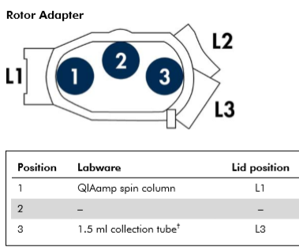

The rotor adapters (with QIAamp spin column and 1,5 ml collection tubes) were placed in the centrifuge and the samples were placed in the shaker, in 2 ml microtubes. Buffers were added in reagent bottles according to the position mentioned in DNA mini kit.

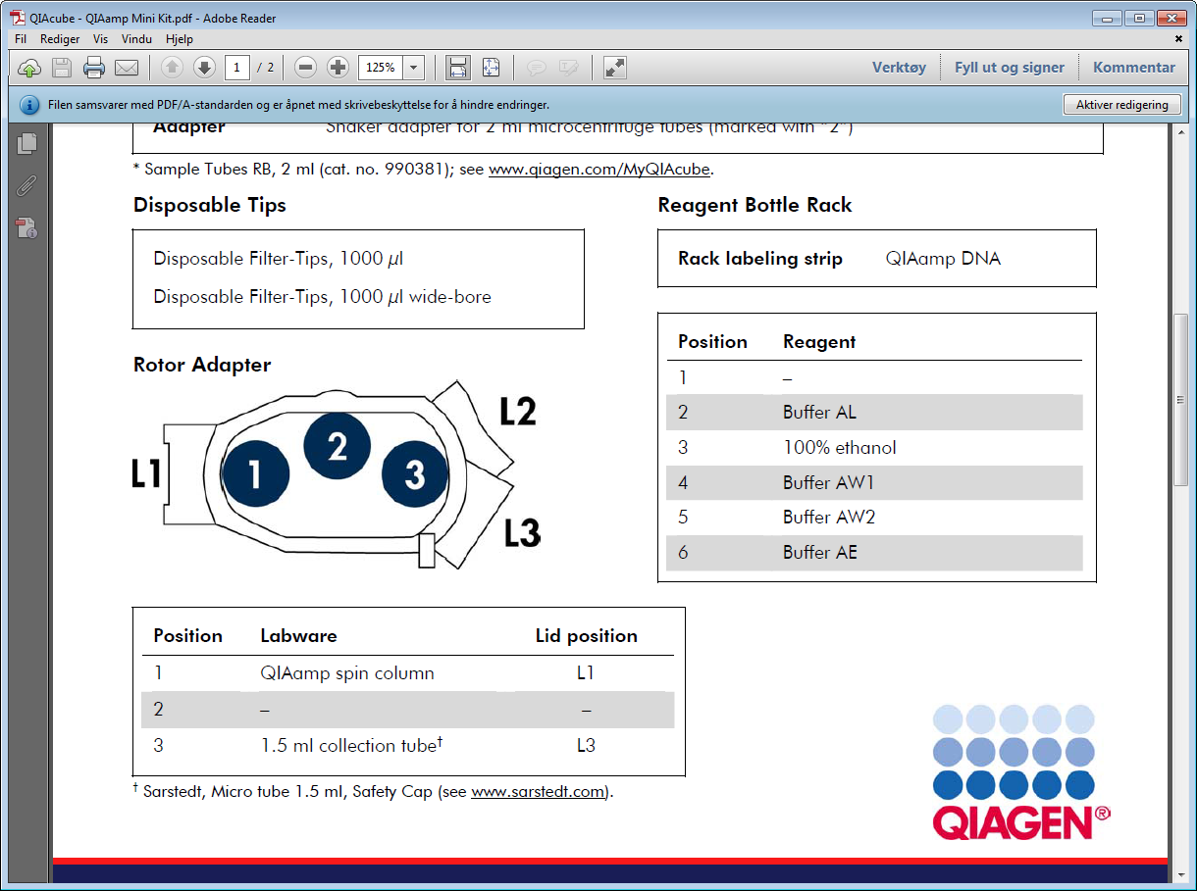

For the DNA Mini kit one row with “ordinary” 1000µl filter tips and one row with wide bore 1000µl filter tips were used as shown in the figure 13(D).

***Appendix 2: Protocol for Babesia real-time PCR master mix***

Real time PCR setup of master mix for detection of *Babesia* with “in-house” Real time PCR machine and Rotor Gene software method

|  |  |  |
| --- | --- | --- |
| Components | 1x sample µL | Final concentration |
| Perfecta Sybrgreen Fastmix (2x) | 10 |  |
| Bdi-F (30 µM) | 0,2 | 0,3 µM |
| Bdi-R (90 µM) | 0.2 | 0,9 µM |
| RNase-free H2O | 4,6 |  |
| Total mix | 15 µL |  |

* PowerUp Sybrgreen Mastermix (Applied Biosystems, Vilnus, Lithuania)

15 µL Mix + 5 µL DNA = 20 µL Total volume

Appendix.3 Protocol for dilution of concentrated forward and reverse primers; Bdi-F (0.3-300µM), Bdi-R (0.9-900µM), respectively.

***PCR condition:***

|  |  |  |
| --- | --- | --- |
| Temperature | Time | Cycles |
| 50℃ | 2min | Hold 1 |
| 95℃ | 2min | Hold 2 |
| 95℃ | 15sec | 45 cycles |
| 60℃ | 1min |
| 72℃ | 30sec |

***Appendix 3: Protocol for dilution of concentrated primers***

**To dissolve primers:**

Formula:

X nMol primer/0,250nmol= Volume of solution

**Bdi-F** 300uM = 0,300 nmol

Concentration nMol/0,300nMol = X water

**Bdi-R** 900 µm = 0,900nMol

Concentration nMol/0,900nmol = X water

**Making 30 µM of stock:**

2 µl from primer + 18 µl water (1:10 dilution)

***Appendix 4: Protocol Pyrosequencing***

Instrument: PyromarkTM Q24 (Biotage), QIAGEN Germany.

Kit: Pyrogold SQA reagents, QIAGEN Germany.

Program: SQA analysis program calibrated for TBEV- Norwegian strand

1. Before going to start pyrosequencing:

* Make a worksheet of sequenced samples with names, PCR tube number and date of PCR analysis before going to start pyrosequencing.
* Turn on heating block 80 ° C 15 minutes before starting pyrosequencing.
* Check once diluted forward primer to 25 microns and include RNase-free water and pyromarks kit.
* Make sure you have all enzymes, substrates and buffers in room temperature on bench.
* Take out washing buffer and place it on the bench with a vacuum machine.

1. Prepare worksheet and Pyromark machine on computer

* First turn on the computer and Pyro mark machine. Select username / Password: CAS1200 / polymer1.
* Start program Pyro Mark Q24 and Pyro Mark Q24 machine and click the new run.
* Give a name to plate_ID
* Right click on track A1 in sheet view, then click load assay and select the desired assay (TBE-cyclic 60-TGAA-pyrosetup). Get assay of file or document.
* Choose Tools-Prerun Information, and the computer calculates the amount of enzyme (E), the substrate (S) and nucleotides (ATCG). Notes amounts of the worksheet
* Save run the file on the USBand transfer to Pyro Mark Q24. Give it a name according to date and samples. Do not press start run.

1. Label PCR strips and prepare Master mix and primer mix

**Preparation of Master mix: (Shake well the beads)**

|  |  |
| --- | --- |
| Component | 1xul |
| RNase free water | 40 |
| Binding buffer | 18 |
| Streptavidin | 2 |

Aliquot 60ul in each tube and mix it well before use.

**Preparation of Primer mix**

|  |  |
| --- | --- |
| Component | 1x ul |
| Annealing buffer | 24.7 |
| Sequencing primer(30uM) | 0.3 |

Aliquot 25ul in each tube.

* Make master mix and primer mix and aliquot master mix in strips.
* Put primer mix in the refrigerator and aliquot 60 μl master mix in strips
* Put arm cap and work in Kojarbenk: Add 20 μl of PCR product wells in strip and place the lid after a strip is completed. Transport the strips using another rack to the workstation, place the rack fastened with tape on shaker and secure it with rubber band) and shake it for 10 minutes (room temperature).
* Aliquot the primer mix in 25 μl each of Pyro Mark Q24 sequencing plate.
* After shaking, open the strips in cabinet (just use hands to take the strips into the cabinet as we have three stripes for a full run.
* Place plate with primer mix in stand with NO.1 top left.

1. Washing of PCR products

* Keep plastic vessels in vacuum workstation pyrosequencing and fill wash buffer, NaOH), sterile water ,70% ethanol.
* Turn on the vacuum machine, check that it works by putting the washing device in the tub with sterile water, and let it run for about 20 seconds.
* Put scrubber in sample tubes for 1 min. Look after the sample is drawn up and the tubes are properly empty. Shake it after some time.
* Put scrubber in 70% ethanol for 5 seconds when the liquid enters the tube.
* Transfer the scrubber to denaturing buffer, NaOH and wash for approximately 5 seconds.
* Transfer the scrubber to WASH wait until you see the fluid enters the hose and wash in approximately 10 sec.
* Lift the scrubber vertically. Set the switch on the washing device in the off position and wait 5 seconds until there is no vacuum longer, turn off the vacuum pump.
* Keep the washing device in the wells of pyrosequencing plate to elute the sample from the filter.
* After 5 minutes discard the strips in yellow bucket in bench.
* Keep pyrosequencing plate on pre-heated block.

Cleaning: Keep scrubber in 1st vessel with water for 10 seconds by shaking it without vacuum. Soak up about 70 ml of water under vacuum. Lift it vertically and hold for 5 seconds to remove remaining liquid. Turn off the washing device and tighten end of the vacuum pump.

1. Start the program:

* Add enzyme (E), substrate (S) and nucleotides (ATCG) which the computer has calculated.
* Put the block in the machine with the label towards you by taking off the bottom and secure it with locking pin.
* Select the correct program and push start run.

1. After pyromark run is complete

* Running file is automatically saved on the USB. Move USB to the PC in room 008.
* Get the run from USB.
* Click "analyzes all the wells”.
* Press report SQA full report, and SQA pyrogram report(landscape). Save it as PDF on F, and print it.
* Throw pyrosequencing plate and clean block properly with sterile water.

***Appendix 5: Modified protocol of primer dilution***

According to dissolving primers formula in Appendix 3:

X nM primer/0,250nmole= Volume of solution

250uM=250pmole/ul=0.250nmole/ul

As Bdi-F 300uM=0.300 nmole

We have 49.3 nmol

49.3nmole/0.300nmole=164.3ul Water

As Bdi-R 900uM=0.900nmol

We have 59.1 nmole

59.1nmole/0.900nmole=65.7 ul Water

***Appendix 6: Protocol for dilution of primers in 10-fold series (10-0 to 10-6)***

PCR tests for diluted primers by 10-fold serial dilution from 10-0 to 10-6 (1:128, 1:1280, 1:12800, 1:128000, 1:1280000, 1:12800000, 1:128000000) with their Ct value.

|  |  |  |
| --- | --- | --- |
| Diluted primers | Ct value | Result by PCR |
| 1:128 | 24.94 | + |
| 1:1280 | 26.82 | + |
| 1:12800 | 30.48 | + |
| 1:128000 | 32.22 | + |
| 1:1280000 | - | - |
| 1:12800000 | - | - |
| 1:128000000 | - | - |

***Appendix 7: RT-PCR report of Brønnøysund samples***

PCR test of 10 nymph tick samples from Brønnøysund with 2 positive control dilutions showing full quantitation concise report with graph.

|  |  |
| --- | --- |
| QIAGEN | [www.qiagen.com](http://www.qiagen.com) |

# Quantitation Report

#### Experiment Information

|  |  |
| --- | --- |
| Run Name | 10 nymph tick samples Brønnøysund with 2 dilutions of positive control (128000,1280000)29.10.20 |
| Run Start | 10/29/2020 11:11:55 AM |
| Run Finish | 10/29/2020 1:14:50 PM |
| Operator | Khansaa |
| Notes | Babesia spp(10 nymph tick samples and 2 dilutions 128000,1280000) |
| Run On Software Version | Rotor-Gene Q Software 2.3.1.49 |
| Run Signature | The Run Signature is valid. |
| Gain Green | 10. |

|  |  |  |  |  |  |  |  |
| --- | --- | --- | --- | --- | --- | --- | --- |
| No. | Color | Name | Type | Ct | Ct Comment | Given Conc (copies/ul) | Calc Conc (copies/ul) |
| 5 |  | N4b (19)T1 | Unknown | 35.28 |  |  |  |
| 6 |  | N4b (19)T2 | Unknown | 33.39 |  |  |  |
| 7 |  | N4b (19)T3 | Unknown | 32.44 |  |  |  |
| 8 |  | N4b (19)T4 | Unknown | 34.07 |  |  |  |
| 9 |  | N4b (19)T5 | Unknown | 34.64 |  |  |  |
| 10 |  | N4b (19)T6 | Unknown | 35.50 |  |  |  |
| 11 |  | N4b (19)T7 | Unknown | 34.63 |  |  |  |
| 12 |  | N4b (19)T8 | Unknown | 34.38 |  |  |  |
| 13 |  | N4b (19)T9 | Unknown | 33.65 |  |  |  |
| 14 |  | N4b (19)T10 | Unknown |  | NEG (NTC) |  |  |
| 17 |  | 128000 | Unknown | 32.94 |  |  |  |
| 18 |  | 1280000 | Unknown |  | NEG (NTC) |  |  |
| 21 |  | N.6 | Unknown |  | NEG (NTC) |  |  |
| 22 |  | N.6 | Unknown |  | NEG (NTC) |  |  |

***Appendix 8: RT-PCR report of Hille samples***

PCR test of 24 nymph tick samples from Hille with 4 positive control dilutions showing full quantitation concise report with graph.

|  |  |
| --- | --- |
| QIAGEN | [www.qiagen.com](http://www.qiagen.com) |

# Quantitation Report

#### Experiment Information

|  |  |
| --- | --- |
| Run Name | Babesia S10(20) Hille25-48 and 1:1280-1:128000013.04.21 |
| Run Start | 4/13/2021 11:22:35 AM |
| Run Finish | 4/13/2021 1:25:04 PM |
| Operator | Khansaa |
| Notes | Babesia S10(20) Hille25-48 and dilutions 13.04.21 |
| Run On Software Version | Rotor-Gene Q Software 2.3.1.49 |
| Run Signature | The Run Signature is valid. |
| Gain Green | 9.33 |
| Machine Serial No. | 120803 |

|  |  |  |  |  |  |  |  |
| --- | --- | --- | --- | --- | --- | --- | --- |
| No. | Color | Name | Type | Ct | Ct Comment | Given Conc (copies/ul) | Calc Conc (copies/ul) |
| 1 |  | S (10)20(25) | Unknown | 31.67 |  |  |  |

|  |  |  |  |  |  |  |  |
| --- | --- | --- | --- | --- | --- | --- | --- |
| No. | Color | Name | Type | Ct | Ct Comment | Given Conc (copies/ul) | Calc Conc (copies/ul) |
| 2 |  | S (10)20(26) | Unknown | 31.42 |  |  |  |
| 3 |  | S (10)20(27) | Unknown | 30.40 |  |  |  |
| 4 |  | S (10)20(28) | Unknown | 33.44 |  |  |  |
| 5 |  | S (10)20(29) | Unknown |  | NEG (Multi Ct) |  |  |
| 6 |  | S (10)20(30) | Unknown | 27.68 |  |  |  |
| 7 |  | S (10)20(31) | Unknown | 29.50 |  |  |  |
| 8 |  | S (10)20(32) | Unknown |  | NEG (Multi Ct) |  |  |
| 9 |  | S (10)20(33) | Unknown | 31.00 |  |  |  |
| 10 |  | S (10)20(34) | Unknown | 36.78 |  |  |  |
| 11 |  | S (10)20(35) | Unknown | 32.61 |  |  |  |
| 12 |  | S (10)20(36) | Unknown | 36.27 |  |  |  |
| 13 |  | S (10)20(37) | Unknown | 35.09 |  |  |  |
| 14 |  | S (10)20(38) | Unknown | 33.80 |  |  |  |
| 15 |  | S (10)20(39) | Unknown | 29.54 |  |  |  |
| 16 |  | S (10)20(48) | Unknown | 32.84 |  |  |  |
| 17 |  | S (10)20(41) | Unknown | 33.50 |  |  |  |
| 18 |  | S (10)20(42) | Unknown | 32.49 |  |  |  |
| 19 |  | S (10)20(43) | Unknown | 34.32 |  |  |  |
| 20 |  | S (10)20(44) | Unknown | 37.06 |  |  |  |
| 21 |  | S (10)20(45) | Unknown | 31.71 |  |  |  |
| 22 |  | S (10)20(46) | Unknown | 31.71 |  |  |  |
| 23 |  | S (10)20(47) | Unknown | 30.84 |  |  |  |
| 24 |  | S (10)20(40) | Unknown | 35.58 |  |  |  |
| 25 |  | 1:1280 | Unknown | 27.82 |  |  |  |
| 26 |  | 1:12800 | Unknown | 27.93 |  |  |  |

-

|  |  |  |  |  |  |  |  |
| --- | --- | --- | --- | --- | --- | --- | --- |
| 27 |  | 1:128000 | Unknown |  |  |  |  |
| 28 |  | 1:1280000 | Unknown |  |  |  |  |
| 32 |  | neg.clean | Unknown |  |  |  |  |
| 33 |  | neg.clean | Unknown |  |  |  |  |

***Appendix 9: RT-PCR report of Haugesund samples***

PCR test of 36 nymph tick samples from Haugesund with two positive control dilutions showing full quantitation concise report with graph.

|  |  |
| --- | --- |
| QIAGEN | [www.qiagen.com](http://www.qiagen.com) |

# Quantitation Report

#### Experiment Information

|  |  |
| --- | --- |
| Run Name | Haugesund samples 61-96(9.11.21) |
| Run Start | 11/9/2021 1:30:47 PM |
| Run Finish | 11/9/2021 3:30:57 PM |
| Operator | Khansaa |
| Notes | Haugesund last 36 samples Babesia and 4 positive control dilutions of Babesia |
| Run On Software Version | Rotor-Gene Q Software 2.3.1.49 |
| Run Signature | The Run Signature is valid. |
| Gain Green | 5.33 |
| Machine Serial No. | 120803 |

-

|  |  |  |  |  |  |  |  |
| --- | --- | --- | --- | --- | --- | --- | --- |
| No. | Color | Name | Type | Ct | Ct Comment | Given Conc (000) | Calc Conc (000) |
| 1 |  | H (19)61 | Unknown | 32.96 |  |  |  |
| 2 |  | H (19)62 | Unknown | 40.64 |  |  |  |
| 3 |  | H (19)63 | Unknown | 37.78 |  |  |  |
| 4 |  | H (19)64 | Unknown | 38.55 |  |  |  |
| 5 |  | H (19)65 | Unknown | 40.08 |  |  |  |
| 6 |  | H (19)66 | Unknown |  | NEG (NTC) |  |  |
| 7 |  | H (19)67 | Unknown | 35.94 |  |  |  |
| 8 |  | H (19)68 | Unknown | 32.63 |  |  |  |
| 9 |  | H (19)69 | Unknown | 38.49 |  |  |  |
| 10 |  | H (19)70 | Unknown | 40.19 |  |  |  |
| 11 |  | H (19)71 | Unknown | 39.41 |  |  |  |
| 12 |  | H (19)72 | Unknown | 28.78 |  |  |  |
| 13 |  | H (19)73 | Unknown | 32.04 |  |  |  |
| 14 |  | H (19)74 | Unknown | 38.65 |  |  |  |
| 15 |  | H (19)75 | Unknown | 34.72 |  |  |  |
| 16 |  | H (19)76 | Unknown | 39.09 |  |  |  |
| 17 |  | H (19)77 | Unknown | 33.91 |  |  |  |
| 18 |  | H (19)78 | Unknown | 36.64 |  |  |  |
| 19 |  | H (19)79 | Unknown | 37.10 |  |  |  |
| 20 |  | H (19)80 | Unknown | 40.90 |  |  |  |
| 21 |  | H (19)81 | Unknown | 33.43 |  |  |  |
| 22 |  | H (19)82 | Unknown | 35.22 |  |  |  |
| 23 |  | H (19)83 | Unknown | 36.39 |  |  |  |
| 24 |  | H (19)84 | Unknown | 35.24 |  |  |  |
| 25 |  | H (19)85 | Unknown |  | NEG (Multi Ct) |  |  |
| 26 |  | H (19)86 | Unknown | 38.37 |  |  |  |
| 27 |  | H (19)87 | Unknown | 36.70 |  |  |  |
| 28 |  | H (19)88 | Unknown | 34.81 |  |  |  |
| 29 |  | H (19)89 | Unknown |  | NEG (NTC) |  |  |

-

|  |  |  |  |  |  |  |  |
| --- | --- | --- | --- | --- | --- | --- | --- |
| No. | Color | Name | Type | Ct | Ct Comment | Given Conc (000) | Calc Conc (000) |
| 30 |  | H(19)90 | Unknown | 34.15 |  |  |  |
| 31 |  | H(19)91 | Unknown | 33.22 |  |  |  |
| 32 |  | H(19)92 | Unknown | 39.89 |  |  |  |
| 33 |  | H(19)93 | Unknown | 33.14 |  |  |  |
| 34 |  | H(19)94 | Unknown | 31.17 |  |  |  |
| 35 |  | H(19)95 | Unknown | 32.19 |  |  |  |
| 36 |  | H(19)96 | Unknown | 34.71 |  |  |  |
| 37 |  | n.c | Unknown |  | NEG (NTC) |  |  |
| 38 |  | n.c | Unknown |  | NEG (NTC) |  |  |
| 39 |  | 1:128 | Unknown | 40.90 |  |  |  |
| 40 |  | 1:1280 | Unknown | 24.86 |  |  |  |

***Appendix 10: Pyrosequencing graph of Brønnøysund sample***

*Pyrosequencing graph of Brønnøysund adult tick sample N4b (19)T12 confirming negative result might be due to high concentration of DNA, problem in cartridge or absence of Babesia species in ticks.*

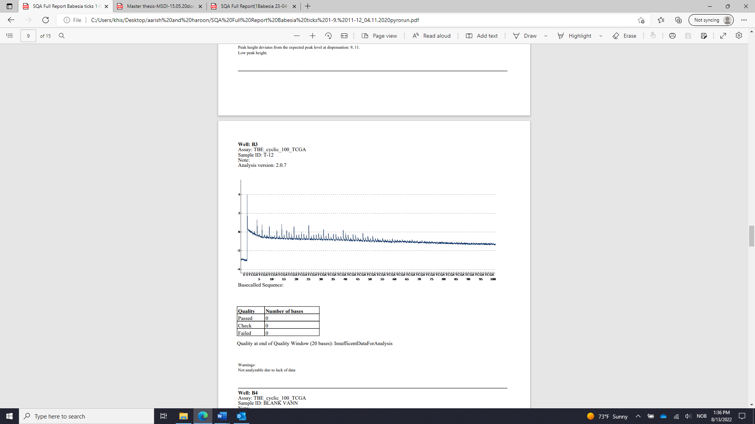

***Appendix 11: List of Brønnøysund and Hille samples with their Ct values used for pyrosequencing***

List of seven nymph tick samples from Brønnøysund and seven nymph tick samples from Hille with Ct value selected for second run of pyrosequencing.

|  |  |  |
| --- | --- | --- |
| Sampling Site | Sample Name | Ct value |
| Brønnøysund | N4b (19)28 | 36.31 |
|  | N4b (19)90 | 35.51 |
|  | N4b (19)77 | 36.31 |
|  | N4b (19)158 | 40.30 |
|  | N4b (19)178 | 33.63 |
|  | N4b (19)105 | 31.41 |
|  | N4b (19)123 | 31.58 |
| Hille | S10(20)24 | 37.30 |
|  | S10(20)44 | 37.06 |
|  | S10(20)48 | 32.84 |
|  | S10(20)51 | 30.33 |
|  | S10(20)52 | 38.16 |
|  | S10(20)62 | 39.73 |
|  | S10(20)66 | 38.24 |

***Appendix 12: Pyrosequencing graph of Hille sample***

*Pyrosequencing graph of Hille nymph tick sample S10(20)52 confirming negative result might be due to high concentration of DNA, problem in cartridge or absence of Babesia species in ticks.*

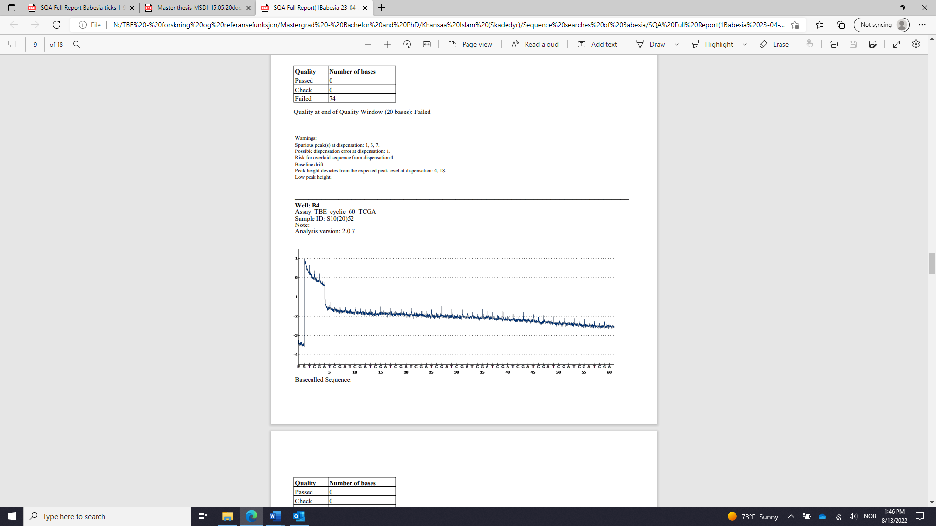

***Appendix 13: Sequence of positive controls of Babesia species analysed by pyrosequencing.***

Babesia 1:1280

CCTTTTAACC CCGGTTCGGG CGAGATGATC GGATTGAATG GATGTT

Babesia 1:12800

CTTACCGTGG CAGTAACGGT TAACGGGGGA ATTAGGGGTT

Babesia 1:128000

CTTACCGTGG CAGTAACGGT TAACGGGGGA ATTAGGT

Babesia 1:1280000

GGTGTGTGTG TGTGTGTGTG TGTGTGTGTG TGTGTTTGTT TT

Babesia 1:12800000

GGTGTGTGTG TGTGTGTGTG TGTGTGTGTG TGTTTTTTTT

***Appendix 14: Blast run on positive sequence confirmed by pyrosequencing to detect similar sequence of Babesia species***

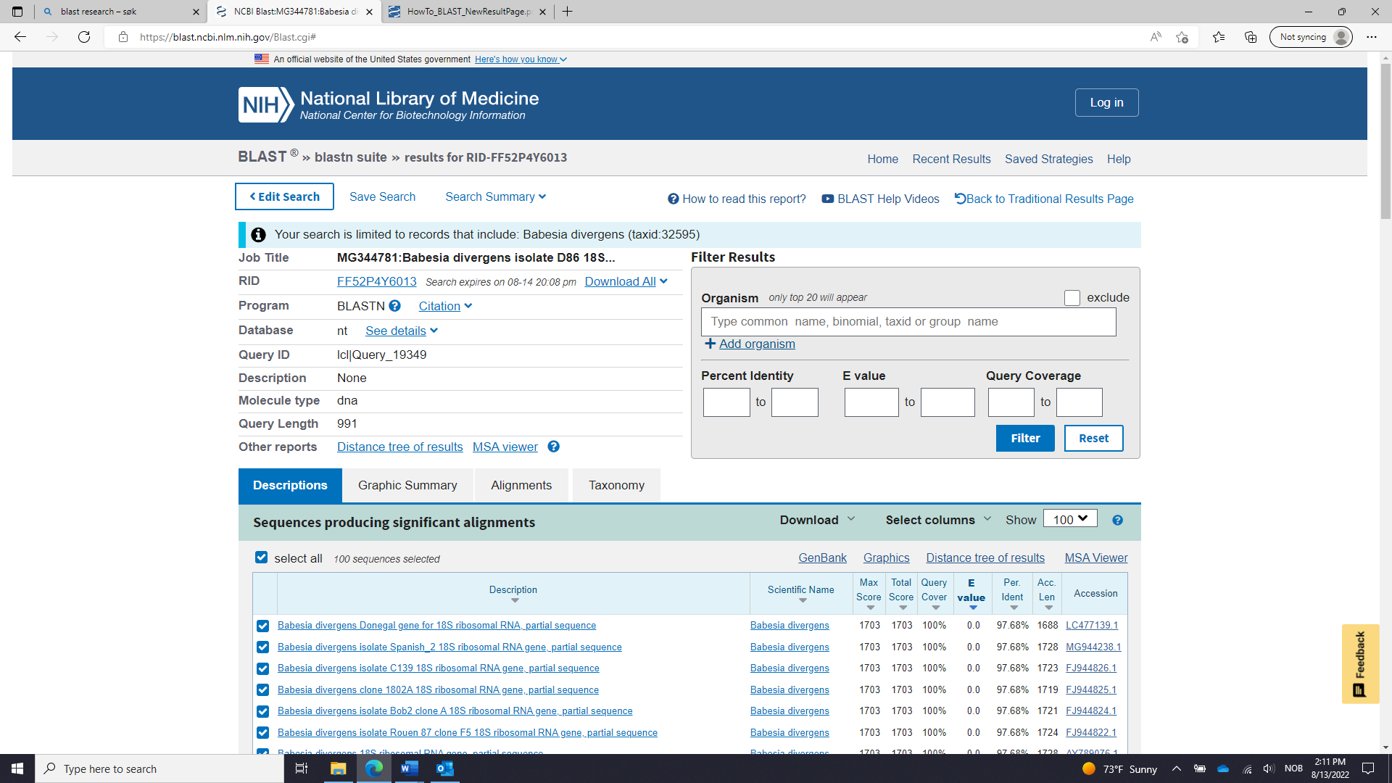

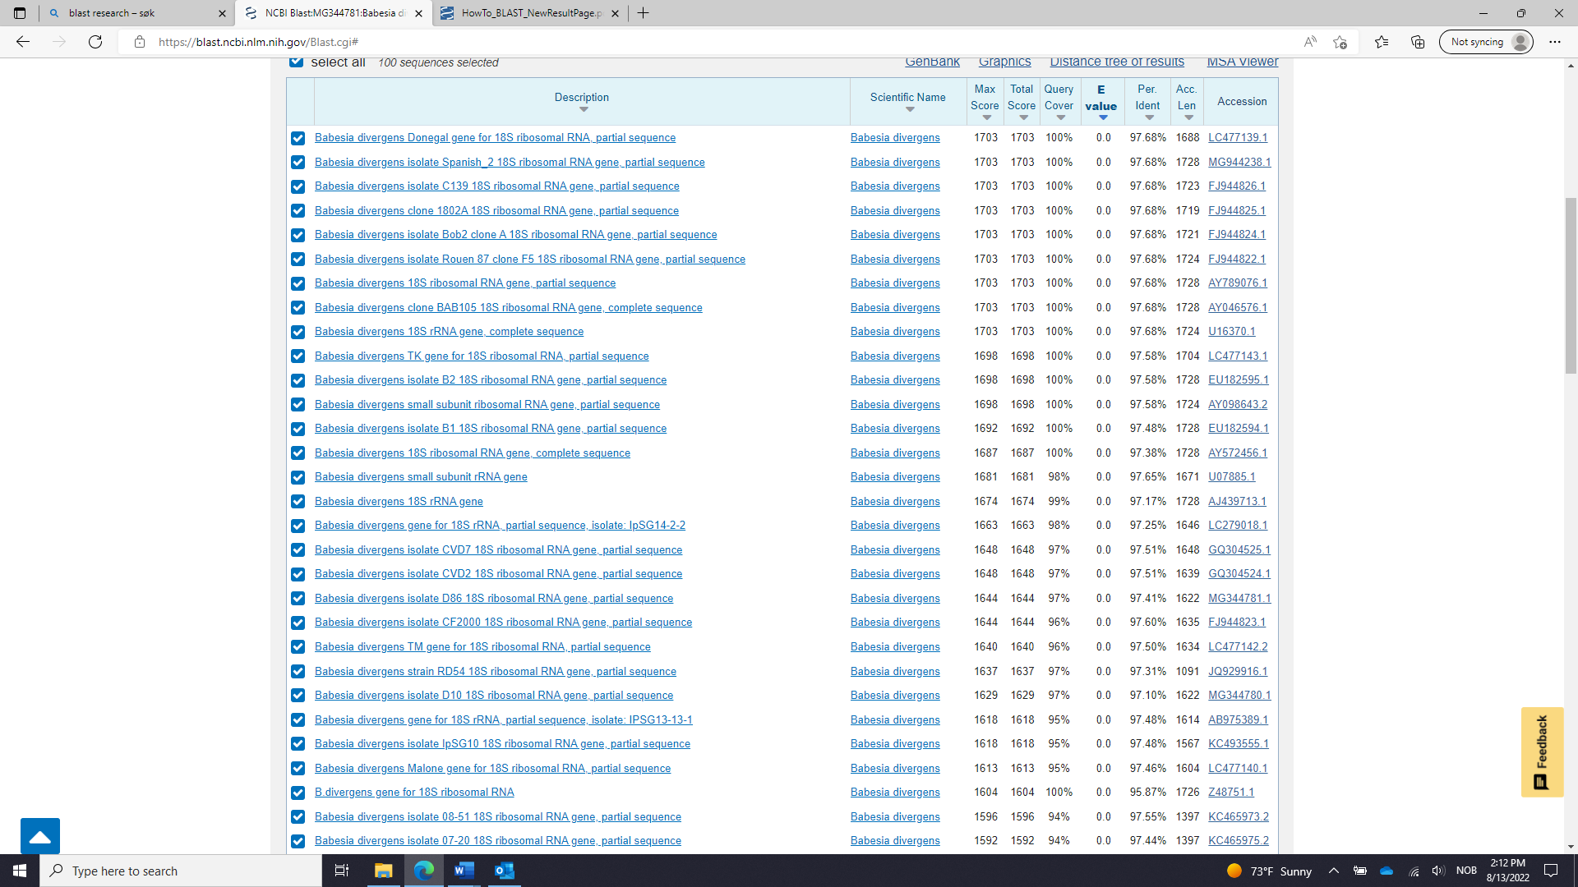

**Babesia sp. EU1 isolate Arnhem 18S ribosomal RNA gene, partial sequence**

GenBank: GQ888709.1

[GenBank](https://www.ncbi.nlm.nih.gov/nuccore/GQ888709.1?report=genbank) [Graphics](https://www.ncbi.nlm.nih.gov/nuccore/GQ888709.1?report=graph)

>GQ888709.1 Babesia sp. EU1 isolate Arnhem 18S ribosomal RNA gene, partial sequence

TGGTTGATCCTGCCAGTAGTCATATGCTTGTCTTAAAGATTAAGCCATGCATGTCTAAGTACAAACTTTT

TACGGTGAAACTGCGAATGGCTCATTACAACAGTTATAGTTTCTTTGGTATTCGTTTTCCATGGATAACC

GTGCTAATTGTAGGGCTAATACAAGTTCGAGGCCTTTTGGCGGCGTTTATTAGTTCTATAACCACCCTTT

TGGTTTTCGGTGATTCATAATAAACTCGCGAATCGCAATTTATTGCGATGGACCATTCAAGTTTCTGACC

CATCAGCTTGACGGTAGGGTATTGGCCTACCGAGGCAGCAACGGGTAACGGGGAATTAGGGTTCGATTCC

GGAGAGGGAGCCTGAGAAACGGCTACCACATCCAAGGAAGGCAGCAGGCGCGCAAATTACCCAATCCTGA

CACAGGGAGGTAGTGACAAGAAATAACAATACAGGGCAATTGTCTTGTAATTGGAATGATGGTGACCTAA

ACCCTCACCAGAGTAACAATTGGAGGGCAAGTCTGGTGCCAGCAGCCGCGGTAATTCCAGCTCCAATAGC

GTATATTAAACTTGTTGCAGTTAAAAAGCTCGTAGTTGAATTTCTGCGTTATCGAGTTATTGACTCTTGT

CTTTAATCGATTTCGCTTTTGGGATTTATCCCTTTTTACTTTGAGAAAATTAGAGTGTTTCAAGCAGACT

TTTGTCTTGAATACTTCAGCATGGAATAATAGAGTAGGACTTTGGTTCTATTTTGTTGGTTTTTGAACCT

TAGTAATGGTTAATAGGAACGGTTGGGGGCATTCGTATTTAACTGTCAGAGGTGAAATTCTTAGATTTGT

TAAAGACGAACTACTGCGAAAGCATTTGCCAAGGACGTTTCCATTAATCAAGAACGAAAGTTAGGGGATC

GAAGACGATCAGATACCGTCGTAGTCCTAACCATAAACTATGCCGACTAGGGATTGGAGGTCGTCATTTT

TCCGACTCCTTCAGCACCTTGAGAGAAATCAAAGTCTTTGGGTTCTGGGGGGAGTATGGTCGCAAGGCTG

AAACTTAAAGGAATTGACGGAAGGGCACCACCAGGCGTGGAGCCTGCGGCTTAATTTGACTCAACACGGG

GAAACTCACCAGGTCCAGACAATGTTAGGATTGACAGATTGATAGCTCTTTCTTGATTCTTTGGGTGGTG

GTGCATGGCCGTTCTTAGTTGGTGGAGTGATTTGTCTGGTTAATTCCGTTAACGAACGAGACCTTAACCT

GCTAACTAGTACCCGTAAAAAGGTTCGTCCGTTACGGTTTGCTTCTTAGAGGGACTTTGCGGCTCTAAGC

CGCAAGGAAGTTTAAGGCAATAACAGGTCTGTGATGCCCTTAGATGTCCTGGGCTGCACGCGCGCTACAC

TGATGCATTCATCGAGTTTAATCCTGTCCCGAAAGGGCTGGGTAATCTTTAGTATGCATCGTGACGGGGA

TTGATTTTTGCAATTCTAAATCATGAACGAGGAATGCCTAGTATGCGCAAGTCATCAGCTTGTGCAGATT

ACGTCCCTGCCCTTTGTACACACCGCCCGTCGCTCCTACCGATCGAGTGATCCGGTGAATTATTCGGACC

GTGGCTTTTCCGATTCGTCGGTTTTGCCTAGGGAAGTCTCGTGAACCTTATCACTTAAAGGAAGGAGAAG

TCGTAACAAGGTTTCCGTAGGTGAA

# Babesia capreoli isolate CVD5 18S ribosomal RNA gene, partial sequence

GenBank: GQ304526.1

[GenBank](https://www.ncbi.nlm.nih.gov/nuccore/GQ304526.1?report=genbank) [Graphics](https://www.ncbi.nlm.nih.gov/nuccore/GQ304526.1?report=graph)

>GQ304526.1 Babesia capreoli isolate CVD5 18S ribosomal RNA gene, partial sequence

GCCATGCATGTCTAAGTACAAACTTTTTACGGTGAAACTGCGAATGGCTCATTACAACAGTTATAGTTTC

TTTGGTATTCGTTTTCCATGGATAACCGTGCTAATTGTAGGGCTAATACAAGTTCGAGGCCTTTTGGCGG

CGTTTATTAGTTCTAAAACCATCCCTTTTGGTTTTCGGTGATTCATAATAAACTTGCGAATCGCAATTTT

TTGCGATGGACCATTCAAGTTTCTGACCCATCAGCTTGACGGTAGGGTATTGGCCTACCGAGGCAGCAAC

GGGTAACGGGGAATTAGGGTTCGATTCCGGAGAGGGAGCCTGAGAAACGGCTACCACATCCAAGGAAGGC

AGCAGGCGCGCAAATTACCCAATCCTGACACAGGGAGGTAGTGACAAGAAATAACAATACAGGGCAATTG

TCTTGTAATTGGAATGATGGTGACCTAAACCCTCACCAGAGTAACAATTGGAGGGCAAGTCTGGTGCCAG

CAGCCGCGGTAATTCCAGCTCCAATAGCGTATATTAAACTTGTTGCAGTTAAAAAGCTCGTAGTTGAATT

TTTGCGTGGTGTAAATATTGACTGATGTCGAGATTGCACTTCGCTTTTGGGATTTTTCCCTTTTTACTTT

GAGAAAATTAGAGTGTTTCAAGCAGACTTTTGTCTTGAATACTTCAGCATGGAATAATAGAGTAGGACTT

TGGTTCTATTTTGTTGGTTTGTGAACCTTAGTAATGGTTAATAGGAACGGTTGGGGGCATTCGTATTTAA

CTGTCAGAGGTGAAATTCTTAGATTTGTTAAAGACGAACTACTGCGAAAGCATTTGCCAAGGACGTTTTC

ATTAATCAAGAACGAAAGTTAGGGGATCGAAGACGATCAGATACCGTCGTAGTCCTAACCATAAACTATG

CCGACTAGGGATTGGAGGTCGTCATTTTTCCGACTCCTTCAGCACCTTGAGAGAAATCAAAGTCTTTGGG

TTCTGGGGGGAGTATGGTCGCAAGGCTGAAACTTAAAGGAATTGACGGAAGGGCACCACCAGGCGTGGAG

CCTGCGGCTTAATTTGACTCAACACGGGGAAACTCACCAGGTCCAGACAATGTTAGGATTGACAGATTGA

TAGCTCTTTCTTGATTCTTTGGGTGGTGGTGCATGGCCGTTCTTAGTTGGTGGAGTGATTTGTCTGGTTA

ATTCCGTTAACGAACGAGACCTTAACCTGCTAACTAGTGTCCGTAAAAAGGTTCGTCCGTTACGGTTTGC

TTCTTAGAGGGACTTTGCGGCTCTAAGCCGCAAGGAAGTTTAAGGCAATAACAGGTCTGTGATGCCCTTA

GATGTCCTGGGCTGCACGCGCGCTACACTGATGCATTCATCGAGTTTTATCCCTTCCCGAAAGGGCTGGG

TAATCTTTAGTATGCATCGTGACGGGGATTGATTTTTGCAATTCTAAATCATGAACGAGGAATGCCTAGT

ATGCGCAAGTCATCAGCTTGTGCAGATTACGTCCCTGCCCTTTGTACACACCGCCCGTCGCTCCTACCGA

TCGAGTGATCCGGTGAATTATTCGGACCGTGGCCTTTCCGATTCGTCGGTTTGGCCTAGGGAAGTCTTGT

GAACCTTATCACTTAAAGGAAGGAGAAGTCGAGCAA